A literature review is a text of a scholarly paper, which includes the current knowledge including substantive findings, as well as theoretical and methodological contributions to a particular topic. Literature reviews are secondary sources, and do not report new or original experimental work.

  Literature review discusses published information in a particular subject area, and sometimes information in a particular subject area within a certain time period. A literaturereview can be just a simple summary of the sources, but it usually has an organizational pattern and combines both summary and synthesis.

Review shows your readers that you have an in-depth grasp of your subject; and that you understand where your own research fits into and adds to an existing body of agreed knowledge.

The review of literature pertaining to the study entitled as “DATA LITARACY AMONG POST GRADUATE STUDENTS IN CALICUT DISTRICT” is presented under the following heads

* Theoretical overview of data literacy
* Studies on data literacy

**Theoretical Overview**

Data literacy is the ability to derive meaningful information from data, just as literacy in general is the ability to derive information from the written word. The complexity of data analysis, especially in the context of big data, means that data literacy requires some knowledge of mathematics and statistics

Twenty-first century citizens must be aware twenty-first century skills in the knowledge-based economy. Information is in abundance, and information is derived from data. Data comes from innumerable producers, through an increasing number of outlets, in diverse formats. The information/data atmosphere in society requires individuals to employ higher-order thinking, which can be challenging to teach, and often involves non-traditional instruction.

Twenty first century skills include critical thinking, problem solving, and computational thinking. Critical thinking is a foundational skill for 21st century thinking and data literacy. Working with data requires the ability to ask the right questions and critically evaluate outcomes. Problem solving requires navigating difficult situations thoughtfully. Computational thinking incorporates a level of both critical thinking and problem solving; Wing describes the fundamental concepts as solving problems, designing systems, and understanding human behavior.

A consistent level of data literacy education across the workforce would have a positive impact on employers, addressing the skills gap and the variance in data-related skills with which students enter the workforce. Acquiring data skills informally can be very difficult, and results in consistencies in practice and skill. As there is currently not a great deal of information about the specific expectations of employers in various industries and sectors, it is important to consult broadly when designing data literacy courses. The feedback available to date suggests that graduates are expected to be adaptive, with skills that have transferrable application in data, technologies, and methods. There is also a focus on data management, and the related information and knowledge management skills. Data must be findable and usable for subsequent analysis and synthesis; data not effectively managed from the point of collection becomes progressively more expensive to manage.

Data literacy, and the set of learning outcomes that align with data literacy, is being recognized internationally as a necessary skill in the twenty-first century. Teaching data literacy early develops foundational knowledge, which provides a basis on which to build disciplinary or domain specific skills and abilities. It also encourages cross-disciplinary thinking and applications, which can help students break out of academic work, and enable creative and critical thinking.

Institutions must consider data literacy in its national context, identify how and where elements of data literacy are being taught in their existing courses and programs, systematically identify and fill gaps in this teaching , and help students recognize data literacy as a transferable skill.

Libraries can play a significant role in helping Students gain understanding of Real-world numbers, statistics, Charts, graphs, and visualizations. Libraries are unique cross disciplinary pollinators. It can fill the gaps between subject areas and help students gain skill in comprehending and critically evaluating data at home, at school, and in life. We collectively refer to these skills as data literacy

We can define data as

1. Information represented numerically via raw numbers, percentages, percentiles, Average (mean, median, mode), etc.

2. Information that can be used algorithmically to determine Compatibility (OK Cupid), Fitness levels (Fit bit), personality (Buzz Feed quizzes), etc.

3. Numerical information rendered visually (charts, graphs, coded maps, tables, etc.) to aid in pattern-finding and Comprehension.

Michael Bowen and Anthony Bartley Said that “Data literacy is important For your students because data Are used to argue and persuade People to, among other things, vote For political agendas or lease a Car. An improved understanding of data practices means that better Questions can be asked”

**American library association identified six significant themes to consider about data literacy** which is given as follows

1. **Statistical Literacy**

Students must critically “read,” contextualize, and interpret raw and synthesized data. Discerning

Correlation from causation; recognizing the difference in the meaning of mean, median, and

Mode; understanding what margin of error signifies in polling data; and recognizing potential biases in collected data, among other skills, are critical for readings scholarly research, understanding arguments in popular media, and interpreting government documents.

For example: Statistics flood news articles, Face book feeds, and scholarly journals etc

1. **Data Visualization**

Having skills to create and comprehend mapped data, graphs, pie charts, and emerging forms of visualizations will help students effectively navigate visually rich information sets

**3. Data in Argument**

Our students can assemble random bits of factual data. However, it takes far more skill to

Understand how data is used—both informational and persuasively— to support arguments in resources students examine, and then for students to create viable arguments themselves. These

Arguments could take the form of statistics embedded as evidence in a research paper, shared charts and graphs with tweaked or non standardized elements, advertising, or info graphics.

**4. Big Data and Citizen Science**

More and more data is being collected, often without citizens’ knowledge, via frequent shopper Cards, step counters, social media, and more. Some data is life-saving, such as DIY systems that help parents monitor their children’s Type 1 diabetes by transferring insulin data temporarily and anonymously online .Careful human interpretationof big data is required for positive outcomes to be achieved.

One student-friendly entry point for interacting with big data is citizen science.

**5. Personal Data Management**

From Google’s personalized search results to Face book’s custom ads, students have daily experience, captured as their clicks and likes are converted into actionable data. While students might like seeing relevant ads or music recommendations that match their favorites, few know it is because of the breadcrumb trail they leave behind. Students may think the website CNN.com is serving up the news to them, but they are usually unaware that as many as fourteen bots are following their actions and converting their clicks into data

School librarians have long taught digital citizenship and the importance of being cautious about personal information shared online. As students use the open Web for research, they need to be aware that even if they do not enter their names or phone numbers online, information about them their search habits, their choices of which WebPages to visit may be attaching themselves to their Internet cookies or Google account

**6. Ethical Data Use**

Data is not inherently good or bad, but it can be framed, edited, manipulated, or otherwise

Modified for unethical purposes

**Data Literacy for Student Achievement**

Data literacy plays important role in student’s achievements. Since the passage of the No Child Left Behind legislation (2001), school districts have used student assessment scores to track and report areas of strength and weakness to the public. More recently, the U.S. Department of Education announced its hope to increase state-wide initiatives that promote data-informed decision making in public schools. In November 2009 Education Secretary Arne Duncan announced the final application for the Race to the Top Fund, a statewide competition to link student performance data with student achievement. States responded to the competition by creating longitudinal data systems that track student achievement. In January 2010, the House and Senate of the Tennessee General Assembly passed a bill that allows Tennessee’s Value Added student achievement data (TVASS) to be used as part of teachers‟ evaluations. In March 2010, The U.S. Department of Education announced that two states, Tennessee and Delaware, won the first round of Race to the Top grant money, an award based partially on their use of student achievement data in school reform.

In October 2009, Duncan had focused his comments on teacher education programs. In a press release Duncan suggested that teacher education programs should be accountable for student outcomes. He cited the accountability model used in Louisiana in which student test scores could be linked to teachers, who are then linked with the institution in which they received their teacher training . Accountability for student test scores, it seems, has come home to teacher training institutions. As a result, teacher education programs will benefit by directly addressing student achievement as an intended outcome of the training they provide to candidates.

**The U. S. Department of Education (2009)** investigated a study onData Literacy for Student Achievement. They cited the following essential skills for data informed decision making by teachers.

***Data Literacy Skills***

|  |  |  |  |
| --- | --- | --- | --- |
| Data Comprehension | | Manipulates data from a complex graph to support reasoning | |
| Maps between the data and a prose representation of the data | |
| Maps between a figure and a prose representation of the data | |
| Understands a histogram as distinct from a bar graph | |
| Interprets a contingency table | |
| Evidences data comprehension monitoring. | |
| Data Interpretation | Understands the advantages and disadvantages of using disaggregated subgroup data vs. individual student data. | | |
| Attends to distribution and extreme quartiles, not just mean or portion above cut score | | |
| Appreciates effect of a few extreme scores on the mean | | |
| Realizes that more items on a scale or members in a sample produce more precise, reliable estimates. | | |
| Understands measurement error and variability; results not identical on every testing. | | |
| Understands that student cohorts differ from year to year. | | |
| Data Use | | | Understands how to differentiate instruction based on data | |
| Understands value of formative assessments | |
| Seeks subscale and item data that can be mapped to the curriculum. | |

**Books Related to Data Litaracy**

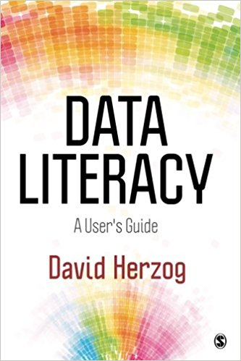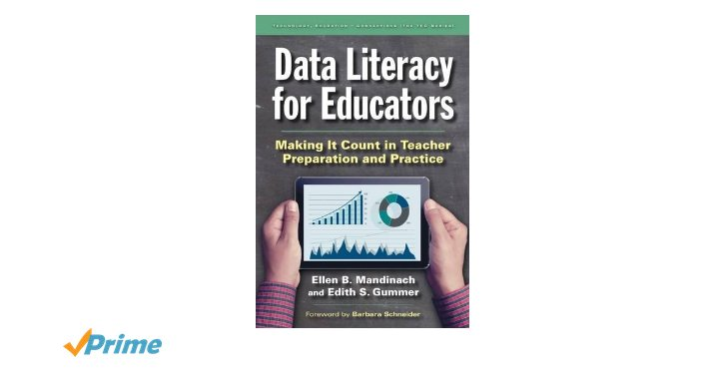

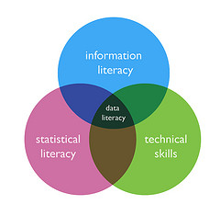

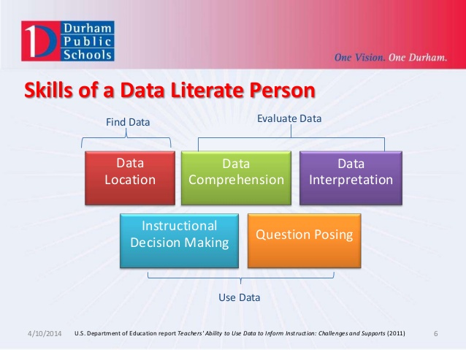

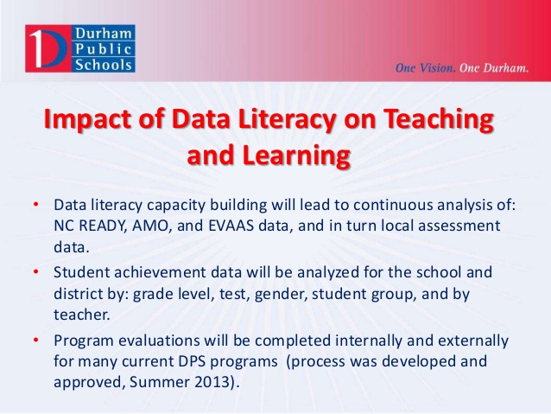

The major key components of effective data use are use as follows

* **Continuously:** using data as part of daily routines and on an ongoing basis, rather than as a one-time even
* Access: know the multiple types of data available (including but not limited to assessment data), understand which data are appropriate to address the question at hand, and know how to get the data (through electronic or other sources)
* Interpret: take data and analyze and/or synthesize them to turn them into information appropriate for addressing the given problem or question
* Act: take relevant information and apply it to generate further questions and/or apply it to decision-making appropriate to the given question
* Communicate: share data points and the informa­tion synthesized from relevant data with stakeholders including parents, students, peers, principals, and others as applicable, to generate further questions, inform decision-making, or provide a better understanding of learning

In the present study the five components of data literacy are:-

1. Continuously

2. Communicate

3. Interpret

4. Acces

5 .act

Relating to the each component of data literacy, the investigator prepared 10 items for each component’s

Data have been used in education for many years. Good teachers and administrators have been using data to inform their practice and make decisions. Diverse sources of data are particularly important in every academic discipline.

**Studies on Data Literacy**

Data-literate educators continuously, effectively, and ethically access, interpret, act on, and communicate multiple types of data from state, local, classroom, and other sources to improve outcomes for students in a manner appropriate to educators’ professional roles and responsibilities. In addition to state policies that are creating a charge for more and better data use, emerging evidence suggests that students have the training and skills needed to make use of data. So many studies are conducted related to data literacy

Ellen B. Mandinach, Edith S. Gummer (2016)” What does it mean for teachers to be data literate: Laying out the skills, knowledge, and dispositions”. In this article it reveals that Data use has become an emphasis in education but few educators have received sufficient training or preparation pertaining to data literacy skills. This article lays out the framework, identifying the specific knowledge, skills, and dispositions teachers need to use data effectively and responsibly. It concludes with a call to schools of education and teacher preparation programs to begin to integrate data literacy into curricula and practical experiences

Ridsdale et al (2010) investigated Knowledge synthesis report (strategies and best practices in data literacy education ). This report and other resources intended to assist in data literacy education .They reveals that, for the benefits of students, employers and society data literacy must be recognized as a necessary civic skill. This recognition should come from all levels of government, and from post-secondary institutions.

Daniel R.Zalles (2010) carried out a study on “designs for assessing foundational data literacy. He suggested that Working with data is central to scientific inquiry, in the geo sciences. Technological advances in data access and data visualization have created unprecedented Opportunities for students and teachers to use real data sets as vehicles to understanding and applying the epistemologies and research practices of the different geo scientific Disciplines. At the same time, immersing students in data as a vehicle for improved Geosciences education has its risks.

Milo Schield (2004) in an article ‘information literacy, statistical literacy and data literacy’. It includes a brief description about information literacy, statistical literacy and data literacy and inter relationship between these. They concluded that while all students deal with information have a need for information literacy, those students in majors that also require a course in data analysis or statistics typically have a need for data literacy. Such majors are often found in the social sciences and business. The study reveals that students need training in how to obtain and manipulate data.

Hogenboom,  et al (2011) explained in a report ‘shows me the data! Partnering with instructors to teach data literacy ’. They concluded that data services requires librarians to take a leadership role in advocating for true teaching partnerships, where instructors and librarians collaborate closely to create rich learning experiences for students. This study reveals that librarian can play an important role to improve data literacy

Brennan et al (2015) investigated ’ Ethical and appropriate data use requires data literacy’. It discusses about data literacy and ethics,an assessment of data use practices and their conclusion. They revealed that Data literacy is a critical part of effective teaching, and as the proliferation of data increases. Parent and public concerns about the safety of data remain the ethical use of data must be a focus for teachers. Teachers are the front-line communicators to parents and their communities about education. But as parents and the public at large express concerns over data use in education, they’re also demonstrating that they don’t fully trust educators to Use data in ways that benefit students.

**Conclusion**

The reviewing of related literature helped the investigator to know about the various studies conducted in the area of data literacy. It helps the investigator to know various tools and techniques used to measure the constructs and different components included in the preparation of tools. Investigator decided to conduct a study based on the variable data literacy, is found an important area to be studied and investigated. Several studies were conducted on data literacy and other variables. But no studies were conducted in post graduate students with the sub samples Gender, Locale of the college, Type of management of the college, Subject of specialization. So the investigator gets inspired to find out the data literacy among post graduate students.

.