**EFFECTIVENESS OF CONCEPT MAPPING ON SCIENTIFIC CREATIVITY AMONG SECONDARY SCHOOL STUDENTS**

**FOUSIYA KUVERI**

**Dissertation**

**Submitted to the University of Calicut**

**In partial fulfilment of the requirements for the Degree of**

**MASTER OF EDUCATION**



**FAROOK TRAINING COLLEGE**

**UNIVERSITY OF CALICUT**

**2013**

**DECLARATION**

I, **Fousiya Kuveri**, do hereby declare that this dissertation, **“EFFECTIVENESS OF CONCEPT MAPPING ON SCIENTIFIC CREATIVITY AMONG SECONDARY SCHOOL STUDENTS”** has not been submitted by me for the award of any Degree, Diploma, Title or Recognition before.

Farook Training College **FOUSIYA KUVERI**

Date: 30-10-2013

**Dr. K. VIJAYAKUMARI**

**Associate Professor**

**Farook Training College**

**Calicut**

**CERTIFICATE**

I, Dr. K. VIJAYAKUMARI., do hereby certify that this dissertation, **“EFFECTIVENESS OF CONCEPT MAPPING ON SCIENTIFIC CREATIVITY AMONG SECONDARY SCHOOL STUDENTS"** is a record of bonafide study and research carried out by FOUSIYA KUVERI under my supervision and guidance. The report has not been submitted by her for the award of any Degree, Diploma, Title or Recognition before.

**Dr. K. VIJAYAKUMARI**

Farook Training College,  ***(Supervising Teacher)***

Date: 30-10-2013

**Acknowledgement**

At the very outset the investigator thanks to **God**, the most merciful and most gracious, who enabled her successfully to complete the task.

The investigator underlines that the sense of profound indebtedness which undoubtedly owes to her supervising teacher, **Dr. Vijayakumari. K.** Associate Professor, Farook Training College, cannot be expressed in words. She has been an unending source of inspiration, a spring of corrective suggestions and invaluable advice and encouragement which have been boost for the investigator from the beginning to the end.

The investigator expresses her thanks to **Prof. A. Faziluddin**, Principal, Farook Training College, for providing all necessary facilities and encouragement to conduct the study.

The investigator wishes to expresses her gratitude to **Mrs. Shrividhya. M.P.** for giving permission to use the standardised tool for her study.

The investigator is greateful to **Dr.Manoj Praveen**, Associate Professor, Farook Training College and **Mr. Anees Mohammed.C,** Assistant Professor, Farook Training College for their valuable suggestions and instructions in the study.

The investigator expresses her thanks to the Heads, Teachers and Students of T.S.S.Vadakkangara and G.V.H.S.S.Makkaraparamba for their cooperation and help in data for conduction of the study.

The investigator would also be thankful to all teaching and non teaching faculties of Farook Training College for their support and encouragement during the study.

The investigator expresses her sincere thanks to **Mr.Balu,** Bina Photostat, Chenakkal for DTP and binding works.

The investigator acknowledges the immense moral support and encouragement received from her family and friends who have been a constant source of inspiration for the study.

Farook Training College

Date : 30-10-2013 **FOUSIYA KUVERI**

**CONTENTS**

**LIST OF TABLES**

**LIST OF FIGURES**

**LIST OF APPENDICES**

|  |  |  |
| --- | --- | --- |
| **Chapter** | **Title** | **Page No.** |
| I | **INTRODUCTION** | 1 – 14 |
| II | **REVIEW OF RELATED LITERATURE** | 15 – 54 |
| III | **METHODOLOGY** | 55 – 77 |
| IV | **ANALYSIS** | 78 – 92 |
| V | **SUMMARY, CONCLUSION AND SUGGESTIONS** | 93 – 103 |
|  | **BIBLIOGRAPHY** |  |
|  | **APPENDICES** |  |

**LIST OF TABLES**

|  |  |  |
| --- | --- | --- |
| **Table No.** | **Title** | **Page No.** |
| 1 | Scoring scheme for originality - Scientific Creativity Test | 64 |
| 2 | Weightage to objectives - Achievement Test in Chemistry | 66 |
| 3 | Weightage to content - Achievement Test in Chemistry | 66 |
| 4 | Weightage to form of questions - Achievement Test in Chemistry | 67 |
| 5 | Blue print - Achievement Test in Chemistry | 68 |
| 6 | Difficulty index and discriminating power - Achievement Test in Chemistry | 71 |
| 7 | Details of participants for the study | 73 |
| 8 | Data and Results of test of significance of mean gain scores on Scientific Creativity and its components between experimental and control groups | 80 |
| 9 | Data and Results of ANCOVA for Scientific Creativity with initial level of Achievement in Chemistry as covariate | 82 |
| 10 | Data and Results of ANCOVA for Scientific Creativity with pre-test score of Scientific Creativity as covariate | 84 |
| 11 | Data and Results of test of significance of difference in the mean gain scores of Scientific Creativity and its components for boys and girls in the experimental group | 85 |
| 12 | Data and Results of One-tailed test of significance of difference in the mean score of Scientific Creativity and its components for pre-test and post-test in the experimental group | 87 |
| 13 | Effect size of Concept Mapping on Scientific Creativity | 89 |

**LIST OF FIGURES**

|  |  |  |
| --- | --- | --- |
| **Figure No.** | **Title** | **Page No.** |
| 1 | Hierarchy Concept Map | 20 |
| 2 | Spider Concept Map | 21 |
| 3 | Flow chart Concept Map | 22 |
| 4 | System Concept Map | 22 |
| 5 | Picture landscape Concept Map | 23 |
| 6 | Multidimensional Concept Map | 24 |
| 7 | Mandala Concept Map | 25 |
| 8 | Scientific Structure Creativity Model (SSCM) | 34 |

**LIST OF APPENDICES**

|  |  |
| --- | --- |
| ***Appendix No.*** | ***Title*** |
| I | An Introductory Lesson Plan for Concept Mapping |
| II | Lesson Plans based on constructivist approach with concept mapping in the consolidation stage |
| III | Scientific Creativity Test |
| IV | Achievement Test in Chemistry |
| V | Achievement Test in Chemistry- Scoring Key and Marking Scheme |
| VI | Achievement Test in Chemistry- Question wise Analysis |
| VII | Concept Maps Prepared by Students |

CHAPTER I

**INTRODUCTION**

* + - * **Need and significance of the study**
      * **Statement of the problem**
      * **Definition of key terms**
      * **Variables of the study**
      * **Objectives**
      * **Hypotheses**
      * **Methodology**
      * **Scope and limitations of the study**
      * **Organization of the report**

**INTRODUCTION**

Education has been recognized as a fundamental right and it is viewed as a process of human resource development where the knowledge, skills and capabilities are sharpened to achieve a wide range of objectives. Through education an individual is enabled to function according to the expectations of the society as well as according to their capabilities. Locke (1969) stated ‘plants are developed by cultivation and men by education’.

The aim of education is to develop an integrated personality, suitably stuffed and equipped from all dimensions, viz; physical, mental, moral, emotional and vocational. The knowledge that is gathered in schools should be capable of being used for all the life situations, service to society and helping to improve the deplorable conditions of ones own country.

With its accelerating importance in the society, science has become an increasingly important part of general knowledge. Scientific education is best fostered as part of a general emphasis on intellectual activity. The scientific and technological advancement of today is a long journey from the Stone Age to the Space Age. The development of industries and discovery of atomic energy opened up many possibilities for further advancement in space research and gigantic communication media networks. There are computers accelerating the pace of research for the welfare and betterment of human life.

Due to progress of civilization, modern world has become highly complex and needs a large number of creative persons to meet multidimensional challenges emerging in the society. Not only the survival, but also future prosperity of the society depends upon creative vision and its implementation. The complex society, being technical and scientific, also needs a good number of scientifically tempered and skilled persons who may effectively contribute to its development. These two prime requirements of the society obviously suggest the importance of fostering creative thinking in the field of science, in general. Students are the future citizens and potentiality of this important resource influences the progress of the nation significantly. Therefore, encouraging students’ creativity in the context of learning science is highly necessary. Creativity has the scope to be investigated in the context of learning. Guilford, one of the pioneers in the field of scientific research on creativity, emphasized on cultivation of creativity among school children.

In the context of learning, in institution particularly, creativity is considered in relation to a specific domain (domain of specific task, content knowledge etc.). Therefore, though most of the earlier researches on creativity recognized it as domain independent, but learning related creativity is domain specific by nature; its functioning in one domain is unique and psychologically differs from that of other. Alexander and Amabile (1983) emphasized the need for specific domain or discipline-based knowledge and skills for fostering creative thinking in learning. Morten and Vanesa (1981) pointed out that each individual subject should emphasize creativity within an agenda reflecting characteristics of each, indicating also the domain specific nature of learning based creativity. This is why domain –specific creativity is gradually receiving more and more attention of researchers, working in the field of creativity in the context of school education.

Scientific creativity is such a domain specific creativity which is the focal theme of the present investigation. The emerging trend of the context specific research on creativity, and the felt need of studying creativity particularly in science education lead science educators consider studying creativity in scientific context separately, where the knowledge of creativity, in general, is inadequate. Creativity in science education, to be called precisely as ‘Scientific creativity’ thus has emerged as an independent field of creativity research, rather being considered only as a mere application of creativity in scientific endeavor, and is drawing increasing attention of science educators. The creativity processes includes four characteristics. First, they always involve thinking or behaving imaginatively. Second, this imaginative activity is purposeful, that is, it is directed to achieving an objective. Third, these processes must generate something original. Fourth, the outcome must be of value in relation to the objective.

If the country is to produce scientists of the caliber of Sir C.V Raman, H.J Bhabha etc. there must be a revolution in School and Universities   
with respect to teaching of science. It is true that one cannot progress without breaking traditions, cutting across conventional boundaries and fostering creative thinking of the child by challenging their imaginations will cause an overall improvement of the child in the right direction. The old notion that creativity is a gift of God has now given way to the fact that creativity is a basic ability present in all human beings. Every child has some capacity for producing novel ideas. So, it is the responsibility of teachers and parents to promote creativity.

In the lecture-oriented teaching of science there is very little chance to discover the creative potentials of the children. The discovery and development of creative genius of youth should be of prime importance in the educational system. Teachers and educators, therefore, have a great responsibility to children and society to see that this ability is manifested to the maximum of the individual’s potential. Timperley and Robinson (2000) suggest that teachers may need to be helped to take a more creative approach to tackling the variety of demands placed on them.

To foster creative expressions among children teachers have to use various styles and strategies. These strategies not only develop the creative and innovative abilities of pupils but also give a way of motivative teaching.

**NEED AND SIGNIFICANCE OF THE STUDY**

The best use of scientific creative talent is important for any developing country. But the cultivation of creativity is one of the neglected area in education. As a result many creative talents do not flowerfully. Hence it is a major function of the school to identify and nurture them properly. An average teacher is neglecting the creative child or not identifying them so that they end in themselves without grooming.

Use of a special strategy for developing scientific creativity is difficult in the usual classroom teaching. In regular classrooms academic achievement is emphasized and the evaluation is always based on content knowledge. Creativity is always neglected –while teaching and evaluating. But if a teacher is enthusiastic, together with regular teaching-learning processes, special strategies or techniques can be incorporated with no additional experiences or resources. Concept Maps are diagrammatic representations which show meaningful relationships between concepts in the form of propositions which are linked together by words, circles and cross links. Novak (1962) suggests concept mapping method as a better way to achieve meaningful learning.

Concept Maps play a role in learning, teaching, curriculum and governance. For the learner, they help to make evident the key concepts and propositions to be learned, and also suggest linkages between the new and that what a student already knows. For the teacher, Concept Map can be used to determine pathways or organizing meanings and for negotiating meanings with students as well as to point out students’ misconceptions. With respect to governance Concept Maps help students to understand their role as learners; they also clarify the teachers’ role and create a learning atmosphere of mutual respect. When students construct Concept Map from verbal material they can encode that material in long term memory visually as well as verbally (Novak and Gowin, 1984).

Review of related literature in the area of creativity revealed that many studies are conducted in the area but mainly correlational in nature. Studies to foster creativity include special strategies or learning packages (Cognitive Acceleration through Science Education (CASE) Program, Synectics Model of Teaching, Curriculum Reform Program). No special attempts are found to be made in which some simple strategies of teaching or learning like Concept Mapping together with the regular classroom teaching can foster creativity.

As per the theoretical aspects Concept Mapping may stimulates students’ brain and hence foster creativity. The present study attempts to find out the effectiveness of Concept Mapping in developing Scientific Creativity by integrating it with regular classroom teaching.

**STATEMENT OF THE PROBLEM**

The present study is entitled as “EFFECTIVENESS OF CONCEPT MAPPING ON SCIENTIFIC CREATIVITY AMONG SECONDARY SCHOOL STUDENTS”.

**DEFINITION OF KEY TERMS**

The definitions of key terms used in the statement of the problem are given below.

**Effectiveness**

The term “Effect” literally means, something brought about by a cause or agent (The illustrated Heritage dictionary and information Book, 1977). Effectiveness is the quality of being a power to produce consequences. In the present study effectiveness means the change brought by Concept Mapping on Scientific Creativity.

**Concept Mapping**

Concept Mapping is a technique for representing knowledge in graphs. It is the process of developing concept maps.

Concept Maps are diagrammatic representations which show meaningful relationships between concepts in the form of propositions which are linked together by words, circles and cross links.

**Scientific Creativity**

Scientific Creativity is a specific creative expression, unique production in science and technology and unique scientific process responsible for some creative contribution in the field of science and technology.

In the present study scientific creativity means the total score obtained by a respondent in the Test of Scientific Creativity which includes three components namely fluency, flexibility and originality.

**VARIABLES SELECTED FOR THE STUDY**

The dependent variable of the study is Scientific Creativity. The independent variable is teaching strategy with the conventional method of teaching in the control group and Concept Mapping integrated with the conventional method in the experimental group.

The initial level of Achievement in Chemistry and that of Scientific Creativity were taken as covariates.

**OBJECTIVES**

* 1. To find out whether experimental group has higher mean gain score of Scientific Creativity than control group.
  2. To find out whether Concept Mapping contribute to Scientific Creativity when the initial level of Achievement in Chemistry is taken as a covariate.

3. To find out whether Concept Mapping contribute to Scientific Creativity when the pre-test score of Scientific Creativity is taken as a covariate.

4. To find out whether there is gender difference in the mean gain score of Scientific Creativity in the experimental group.

5. To find out whether the post-test score on Scientific Creativity of the experimental group is greater than the pre-test score.

6. To find out the effect size of Concept Mapping on Scientific Creativity.

**HYPOTHESES**

The major hypothesis of the study is “Concept Mapping contributes significantly to Scientific Creativity”. The minor hypotheses connected to the major hypothesis are;

1. The experimental group has significantly higher mean gain score of Scientific Creativity than the control group.

2. Concept Mapping has significant contribution to Scientific Creativity when the initial level of Achievement in Chemistry is taken as a covariate.

3. Concept Mapping has significant contribution to Scientific Creativity when the pre-test score of Scientific Creativity is taken as a covariate.

4. There is no significant gender difference in the mean gain score of Scientific Creativity in the experimental group.

5. The mean post-test score on Scientific Creativity of the experimental group is significantly greater than the mean pre-test score.

6. The effect size of Concept Mapping on Scientific Creativity is high.

**METHODOLOGY**

**Participants**

The study was conducted on two groups of students of standard IX of two schools in Mankada Subdistrict under Malappuram Educational district. The intact group of standard IX-H of T.S.S Vadakkangara was taken as experimental group and the intact group of standard IX-F of G.V.H.S.S Makkaraparamba as control group.

**Tools Used for the Study**

The following tools were used for collecting relevant data for the study

1. An introductory lesson plan for Concept Mapping

2. Lesson plans based on constructivist approach (for the control group) and Concept Mapping in the consolidation stage (for the experimental group)

3. Test of Scientific Creativity

4. Achievement Test in Chemistry

**Statistical Techniques Used**

The following statistical techniques were used for the analysis of collected data.

1. One-tailed test of significance of difference between two means for large independent groups

2. Analysis of Covariance (ANCOVA)

3. Two-tailed test of significance of difference between two means for small independent groups

4. One-tailed test of significance of difference between two means for large dependent groups

5. Cohen’s‘d’ for measuring the effect size

**SCOPE AND LIMITATIONS OF THE STUDY**

The present study tries to explore the effectiveness of Concept Mapping on Scientific Creativity among secondary school students.

The investigator made the students to prepare Concept Maps which will improve long term information retention among students. It can be used to measure the long term retention of students’ memory and transfer of knowledge in problem solving activities. Concept Maps stimulate student’s brain and hence foster creativity.

The study was conducted on a representative sample of 87 standard IX students from two different schools in Mankada Subdistrict under Malappuram Educational district. The investigator took maximum precautions to make the study as precise as possible and objective. But some unavoidable limitations were crept into the study. They are listed below.

1. The sample for the study was restricted two schools of Malappuram district.

2. There are several strategies to promote Scientific Creativity, but the investigator concentrated on Concept Mapping only.

3. Even though the study was aimed for the secondary school pupils, the study was conducted on students belonging to one educational level .i.e. standard IX only due to practical difficulties.

4. The experimental and control groups were selected randomly and the schools thus selected was one Govt. and the other Aided. Though the two schools have same level of performance some extraneous variables may be intervening the influence of which are not controlled.

Even though there are some limitations the result derived from the present study are valuable enough for further research and innovation.

**ORGANISATION OF THE REPORT**

The organization of the present research report is as follows. Each chapter is explained in the relevant subunits.

**Chapter 1 INTRODUCTION**

Need and Significance

Statement of the Problem

Definition of Key Terms

Variables of the Study

Objectives of the Study

Hypotheses

Methodology

Scope and Limitations of the Study

Organisation of the Report

**Chapter 2 REVIEW OF RELATED LITERATURE**

Theoretical Frame work of the Variable

Review of Related Literature

**Chapter 3 METHODOLOGY**

Variables of the Study

Objectives of the Study

Hypotheses

Design of the Study

Tools Used for the Study

Participants for the study

Data collection Procedure, Scoring and   
 Consolidation of Data

Statistical Techniques Used for Analysis

**Chapter 4 ANALYSIS**

Analysis of the Data

Results and Discussion

Tenability of Hypotheses

**Chapter 5 CONCLUSIONS AND SUGGESTIONS**

Findings of the Study

Suggestions for further Research

Educational Implications

CHAPTER II

**REVIEW OF RELATED LITERATURE**

* **Theoretical overview**
* **Review of the related studies**

**REVIEW OF RELATED LITERATURE**

Review of related literature is an important aspect of any investigation. As Best and Kahn (2001) note “since effective research is based upon past knowledge, review of related literature helps to eliminate the duplication what has been done and provides useful hypotheses and helpful suggestions for significant investigation.”

Review of related literature helps the researcher to acquaint himself with current knowledge in the field or area in which he is going to conduct his research. Through the review of related literature, the researcher can take decisions about the methodology, the tools and instruments for the study.

In this chapter the investigator presents the theoretical outline of the variables, Concept Mapping and Scientific Creativity and review of previous studies related to the variables. These are presented in two sections. viz;

A. Theoretical overview of the variables

B. Review of related studies

**A. THEORETICAL OVERVIEW**

The theoretical overview of Concept Mapping and Scientific Creativity are given below.

**Concept Mapping**

Concept Maps are diagrammatic representations which shows meaningful relationships between concepts in the form of propositions which are linked together by words, circles and cross links. Concepts are arranged hierarchically with the super ordinate concepts at the top of the map, and subordinate at the bottom which are less inclusive than higher ones. “Cross links” are used to connect different segments of the concepts, which indicate syntheses of related concepts, a new interpretation of old ideas, and some degree of creative thinking. Propositions are statements about some object or event in the universe, either naturally occurring or constructed. Propositions contain two or more concepts.

Concept Map was first introduced as a systematic way of learning in 1960’s by Novak but was developed as a teaching strategy during early 1980’s. His work was based on the Ausubel’s assimilation theory of cognitive learning. The fundamental idea in Ausubel’s assimilation theory is that learning takes place by the assimilation of new concepts and propositions into existing concept and propositional frame works held by the learner. This knowledge structure as held by a learner is also referred to as the individual cognitive structure. This theory emphasizes meaningful learning in which the concept that the learnt knowledge is fully understood by the individual and that the individual knows how that specific fact relates to other stored facts.

Concept Maps are spatial representations of concepts and their interrelationships that are intended to represent the knowledge structures that humans store in their mind (Beissner and Yacci, 1993).

Wellington (2000) describes a science concept map as a powerful metacognitive learning strategy, which will encourage meaningful verbal learning of the students. It reduces short term memory and also an effective tool in reducing anxiety of learning. Its purpose is to relate science words or phrases to one another in a scientifically valid form. The value of concept mapping for learning has been discussed extensively and there is research evidence that, with regular use, concept mapping is an activity that helps pupils to make significant improvements in their learning of science.

Concept Map has been used to help teachers and students to build an organized knowledge base in a given discipline (Pankratius, 1990) or on a given topic (Kopec, Wood and Brodg, 1990).

Novak and Gowin (1984) argued that Concept Maps produced by students could be used as good evaluation tools. They identified in many cases, Concept Maps have greater sensitivity as measuring devices and in their opinion Concept Maps are more valuable than the common evaluation devices such as objective tests and essays. Teacher can examine how well a student understands science by observing the sophistication of their Concept Maps. Highly sophisticated maps show highly integrated knowledge structures, which are important because they facilitate cognitive activities, such as problem solving, etc.

Oversby (2002) states that Concept Mapping is an excellent formative assessment tool. The reason for this is that the discussion, sharing and questioning of ideas in the initial formulation of the map (say at the beginning of teaching a topic), together with the possible review and amendment (either during or at the end of a topic) gives much more insight into pupils’ initial and developing understanding of the science concepts being taught than many forms of summative test-type assessment.

Stars and Krajcik (1990) have used Concept Maps as a means of developing curriculum plans and sequences, and have found that teachers value the structure that the use of the lesson sequences. This has, involved the structure of hierarchies based around the major concepts in a given area and identification of related, subordinated concepts.

Concept Maps give students an opportunity to: 1) Think about the connections between the science terms being learnt 2) Organize their thoughts and visualize the relationships between key concepts in a systematic way and 3) reflect on their understanding. Students also articulate and challenge their thoughts about science when they discuss their maps with each other.

**Steps involved in Constructing Concept Maps**

There is a systematic procedure for constructing concept maps. The steps in general are the following.

1. Position the topic at the head of the map.

2. Arrange the other concepts beneath it on several levels-more inclusive, general, abstract concepts at higher level and the more specific, concrete concepts at lower level.

3. Arrange the concepts so that ideas go directly under ideas that they are related to.

4. Beneath the last row, examples to the concepts are given sometimes.

5. Draw lines from upper concepts to lower concepts, which they are related to.

6. Do the same for any related concepts that are on the same level.

**Types of Concept Maps**

There are four major categories of Concept Maps. These are distinguished by their different format for representing information. Examples of the various types of Concept Maps are presented on the following.

1. Hierarchy Concept Map

The hierarchy concept map presents information in a descending order of importance. The most important information is placed on the top. Distinguishing factors determine the placement of the information.

# Example:

Atom

Is indicated as

-

Outside the nucleus

which are

Orbits

revolve in

Negatively charged

Negligible Mass

which are

have

Protons

Neutrons

Nucleus

contains

=

Electrons

is

+

which have

No charge

Mass of I unit

Positively charged

is made up of

Electrically neutral

Mass number

which have

Mass of I unit

Is indicated as

+

*Figure* 1: Hierarchy Concept Map

**2. Spider Concept Map**

The Spider Concept Map is organized by placing the central theme or unifying factors in the centre of the map. Outwardly radiating sub- themes surround the centre of the map.

Example:

*Figure* 2: Spider Concept Map

3. Flow Chart Concept Map

The Flow Chart Concept Map organizes information in a linear format.

Example:

Nucleus have a +ve charge and electrons have –ve charge

Nucleus contains proton and neutron

Nucleus and electrons

Is made up of

Atom

Atom is electrically neutral

*Figure* 3: Flow Chart Concept Map

4. System Concept Map

System Concept Map organizes information in a format which is similar to a flow chart with addition of ‘INPUTS’& OUTPUTS’.

Example:

Electrically neutral

is

**Atom**

*Figure* 4: System Concept Map

Special Concept Maps include the following format types.

5. Picture landscape Concept Map

These concept maps present information in a landscape format.

Example: 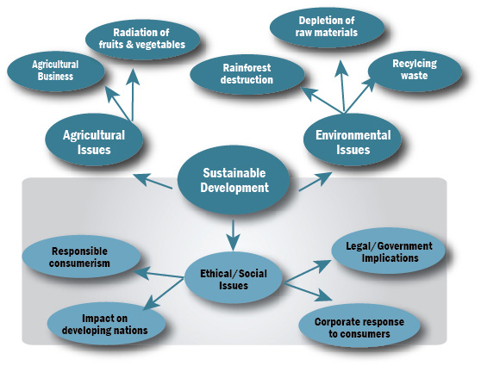

*Figure* 5: Picture Landscape Concept Map

6. Multidimensional (3D) Concept Map

It describes the flow or state of information or resources which are too complicated for a simple two dimensional map.

Example:

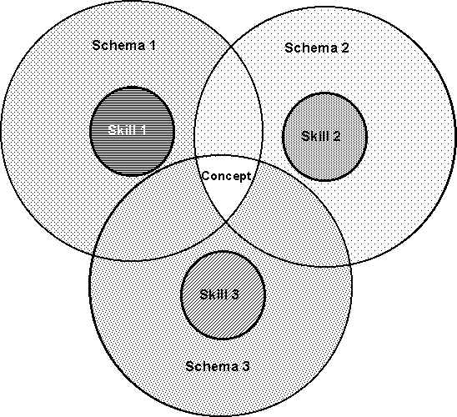

*Figure* 6: Multidimensional Concept Map

7. Mandala Concept Map

Information is presented within a format of interlocking geometric shapes. A “telescoping” factor creates compelling visual effects which focus the attention and thought processes of the viewer.

Example:

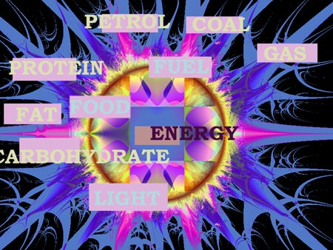

*Figure* 7: Mandala Concept Map

Concept Mapping technique is a better way to achieve meaningful leaning (Novak, 1983, Tan, 1990). It is an active, creative, visual and spatial learning activity in which concepts are organized according to their hierchical relationship. Students relate and integrate the concepts that will be recorded in the map. This improves long term information retention reduces verbal retention of non-meaningful information, and improves transfer knowledge in future problem solving activities. A very high level of meaningful learning is the expression of creativity.

Scientific Creativity

Definition of Creativity

Creativity, although recently much emphasized in research, has been of the most neglected topics in the history of psychology. Creative people were thought to be geniuses, who possessed some rare, innate qualities that raised them above the non-creative mass of humanity. Creative thinking is the highest of mental functions and creative production is the peak of human achievement. Later concept of creativity sticks on the idea of ‘originality’ , ‘progressiveness’ , ‘novelty’ or anything that deviate from the norm .

Scientific research in the area of creativity led to deeper understanding and a more realistic approach. It gives educationists the idea that all are born with creative potentials and if given proper environment this potential can be nurtured. Also tools and techniques for measurement of creativity were developed which made identification of extent of creativity among children possible so that it can be nurtured to its full potential through appropriate measures.

The term creativity stands for a cognitive ability to think divergently and produce a number of flexible and original responses to specified stimulus situations. Even though there are a number of definitions to creativity, there is no single universally accepted one. Some widely accepted definitions considered creativity as a product, a process or an experience. Some definitions are formulated in terms of a manifest product as it is novel and useful. Other definitions are formulated in terms of a subjective experience as it is inspired and immanent.

Thurstone (1953) was of the opinion that an action is creative if the thinker reaches the solution in a sudden closure which necessarily implies some novelty to him.

An Omnibus definition of creative thinking is that the product have novelty and value for the thinker or the culture , thinking is unconventional, highly motivated and persistent, or the great intensity , the task involves a clear formulation of an initially vague and undefined problem (Newell, Shaw and Simon, 1962) .

Torrance (1960) defined creative thinking as “ the process of sensing gap or disturbing , missing elements, forming ideas or hypotheses concerning them; testing these hypotheses; and communicating the results, possibly modifying and retesting hypotheses” while other researchers consider spontaneity, divergent thinking, openness to experience and absence of defensiveness as distinctive attributes of creative thinking.

Ausubel (1963) defined creativity as a generalized constellation of intellectual abilities, personality variables and problem solving traits.

According to Wallach and Kogan (1965) creativity lies in producing more associations, and in producing more that are unique.

Levin (1978) considered that “creativity is the ability to discover new solutions to problems or to produce new ideas, inventions or works of art. It is a special form of thinking”.

According to Sternberg (1984) creativity is a process which results in a novel work that is accepted as tenable to useful or satisfying to a group of people at some point in time.

Creativity is athinking and responding process that involves connecting with our previous experience, responding to stimuli (objects, symbols, ideas, people, situations) and generating at least one unique combination (Parnes 1963, stated in Isenberg & Jalongo, 1997).

The more accepted concept of creativity is that of Torrance and according to him, central features of creativity are fluency, flexibility and originality. ‘Fluency means the number of original ideas produced, Flexibility is the ability to ‘change tack’, not to be bound by an established approach after that approach is found no longer to work efficiently. Originality can be explained statistically: an answer which is rare, which occurs only occasionally in a given population, would be considered as original’ (Hu & Adey, 2002).

Some approaches to creativity are explained below.

**Associationism**

For associationists, thought is a chain of stimulus response connection. Mednick (1962) defines creativity as involving the formulation of associations between stimuli and responses which are characterized by the fact that the elements linked together are not normally associated. A problem initiates a succession of previously learned responses to tryout in the new situation. There is no fundamental difference between the higher and lower mental functions, between trial and errors, logical or creative thought. The more mutually remote the combinatory elements, the more creative the process or solution (Mednick, 1976).

**Gestalt theory**

Creative thinking is primarily a reconstruction of Gestalt’s or patterns that are structurally defient. Creative thinking usually begins with a problematic situation which is incomplete in some way. The thinker grasps this problem as a whole. Then the dynamics of the problem itself, the force and tensions with it, set up similar lines of stress within his mind. By following these lines of stress, the thinker arrives at a solution which rescores the harmony of the whole. Throughout this process the creative person satisfies an inborn urge to grasp a whole pattern and restores it to order.

Another view of creativity by Guilford(1950) as factor analytic theory represent IQ metric as one of the many factors and not necessarily even the most important one. He disaggregated the factors of intellect, distinguishing especially between convergent and divergent thinking. Convergent thinking is the generation of new information maximally dependent on know information as in most intelligence test problems where the only acceptable solution is a single already known solution. Divergent thinking is the generation of new information minimally dependent on known information and the acceptable responses to a given problem may be a variety of emergent solutions characterized by fluency, flexibility, originality and elaboration, which are said to be the principal components of creativity. Later Guilford added two more components and considered as aptitude traits.

**Creativity in Science**

Being creative in science is tough and requires brain power. Creativity involves seeing new patterns and connections, putting together parts to make a whole and breaking the whole to make new parts. It is viewing something from a different perspective, considering possibilities or alternatives, or thinking unconventionally- thinking straight when the pattern is fuzzy, thinking non-linearly when the pattern seems straight. The creative process in science begins with the mental processing of a lot of information gathered from the physical world ends with a tangible result- new knowledge, a new creation, product or discovery. For all these, one needs a superior mind or a powerful brain with a dense circuit of highly interconnected neurons that can process numerous stimuli and generate equally numerous responses quickly, almost instantaneously.

**Concept of Scientific Creativity**

Scientific Creativity is the ability to find new problems and the ability to formulate hypotheses; it usually involves some addition to our prior knowledge. Scientific Creativity is defined by Moravcsik (1981) as: “Scientific creativity may be viewed as the attainment of new and novel steps in realizing the objectives of science. Scientific Creativity can manifest itself “in the conception of new ideas contributing to Scientific knowledge itself, in the formation of new theories of science, in the devising of new experiments to probe nature’s law, in the development scientific ideas applied to particular domains of practical interest , in the realization of new organizational features of scientific research and of scientific community , in the novel implementation of plans and blueprints for scientific activities , in trail-blazing undertakings to transmit the scientific outlook into the public mind, and in many other realms”.

First scientific explanation of creativity is given by Guilford, explained the construct of creativity in general, in relation to the model of structure of intellect (SOI-Model). According to Guilford, the mind or intellect consists of 150 different abilities. These falls into two main classes, small class memory ability, and much larger one of thinking ability.

Guilford’s divergent thinking abilities have been distinguished into 3- categories. They are figural, symbolic and semantic. The three categories are divided into six kinds of products. They are units (U), classes(C), relations (R) systems (S), transformations (T) and implications (I). In divergent production units, classes, systems and implications have figural, symbolic and semantic factors, where as relations have only symbolic and semantic factors. Transformations have only figural and semantic factors. Guilford presented the following factors in the group of creativity. They are (1) fluency (2) flexibility (3) originality (4) elaboration (5) redefinition (6) sensitivity to problems.

Therefore, though divergent production was the key concept of Guilford to describe the operational construct of creativity, convergent production was also considered as one of the components of the construct. Sternberg (1985) also recognized the importance of convergent thinking in addition to divergent thinking in the same relation.

Idea of Guilford on creativity also influenced the research works on Scientific Creativity a lot. Misra explained scientific creativity in the light of Guilford; considered it in relation to divergent thinking and defined the concept in the way as Torrance defined creativity (general). Misra defined ‘Scientific Creativity’ as- “a process of becoming sensitive to problems related to science; deficiencies, gaps, missing elements, disharmonies and so on scientific knowledge ; identifying the difficulty; searching for solutions ; making guesses or formulating hypotheses about deficiencies; testing and retesting of these hypotheses and possibly modifying and retesting them, and finally communicating the result”.

Moravcsik has explained scientific creativity by saying- “it can explain itself in comprehending the new ideas and concepts added to scientific knowledge, in formulating new theories in science, finding new experiments, preventing the natural laws, in recognizing new regulatory properties of scientific research and scientific group, in giving the scientific activity plans and projects originality and many other ideas”.

Hu & Adey (2002), being influenced by Guilford, explained Scientific Creativity in relation to a three dimensional model named-‘Scientific Structure Creativity Model’ (SSCM) having the dimensions: Scientific Process (scientific thinking and scientific imagination), Personality trait (fluency, flexibility and originality) and Scientific Product (technical product, scientific knowledge, scientific phenomenon, scientific problem). Scientific Creativity, according to Hu & Adey is “a kind of intellectual trait or ability producing a certain product that is original and has social or personal value, designed with a certain purpose in mind, using given information”. Attempt of Hu & Adey is comprehensive as it considered Scientific Creativity as a process, person, and also a product. The three dimensional Scientific Structure Creativity Model (SSCM) is shown in figure 8.

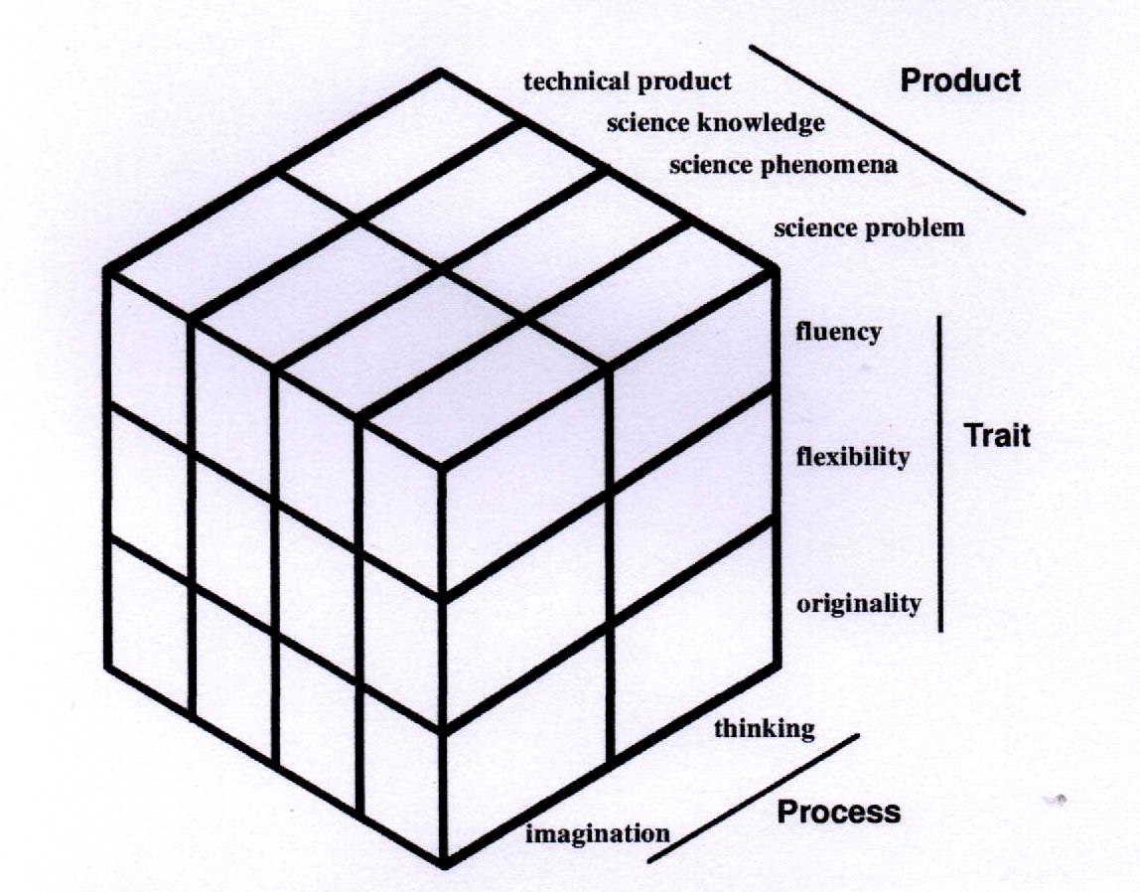

*Figure* 8: Scientific structure creativity model

In the light of exploration of creativity in the literature, Scientific Creativity can be defined as a kind of intellectual trait or ability producing or potentially producing a certain product that is original and has social or personal value, designed with a certain purpose in mind, using given information. This definition may be elaborated with a set of hypotheses about the Structure of Scientific Creativity:

1. Scientific Creativity is different from other creativity since it is concerned with creative science experiments, creative scientific problem finding and solving, and creative science activity.
2. Scientific Creativity is a kind of ability. The structure of Scientific Creativity itself does not include non-intellectual factors, although non- intellectual factors may influence Scientific Creativity.
3. Scientific Creativity must depend on scientific knowledge and skills.
4. Scientific Creativity should be a combination of static structure and developmental structure. The adolescent and the mature scientist have the same basic mental structure of Scientific Creativity but that of the latter is more developed.
5. Creativity and analytical intelligence are two different factors of singular function originality from mental ability.

Additionally, Mansfield and Buse (1981) addressed their five stages of creative process in science fields:

1. The selection of the problem sensitively.
2. Extended efforts to solve the problem.
3. Deciding and using experimental, methodological and cognitive skills.
4. Changing the decisions according to the hypotheses in the 3rd item above.
5. Verification and elaboration needs repeating the experiment.

In summary, the aspects of Scientific Creativity are: being sensitive to any problem, ability to product new ideas which are technologically accepted , ability to wonder, understanding the world around, ability to problem solving, seeking solutions, designing experiments, imagination, identifying difficulties, making predictions or hypothesizing etc.

# B. REVIEW OF RELATED STUDIES

# Studies Related to Concept Mapping

Bris and Sarah (1991) investigated the use of concept mapping on college students for meaningful learning of Biology. The results showed that concept maps have greater effect on meaningful learning of Biology.

Kishore (2000) conducted a study on “Teaching science through Concept Maps at upper primary level” and found that it is quite appropriate to use concept maps so that the interrelationship between concepts stands out and become clear to students. It will also help students to process and organize information from the text books into concept maps to gain better understanding of the textual material.

Brandt (2001) examined whether the construction of integrated knowledge structures by students can be stimulated by concept mapping and by better visualization of concepts and their interrelationships. A significant positive effect of extra attention to visualization on the learning achievement of students was found.

Patnakar and Padmini (2005) studied concept mapping and commented that the hierarchical structure for a particular domain of knowledge depends on the content. They opined that concept maps could be used as evaluation tools by constructing them with reference to the question that we ask or seek, to answer through the organization of knowledge.

Esen and Omer (2005) investigated the effect of conceptual change text accompanied with concept mapping instruction, compared to traditional instruction on VIIth grade students’ understanding of Solution concepts and their attitude towards science as a school subject. It is observed that conceptual change text accompanied with concept mapping instruction caused a significantly better acquisition of scientific conceptions repeated to Solution concept and produced significantly higher positive attitude towards science as a school subject than the traditional instruction .

A study by Stone and Kevin (2005) on “concept mapping in problem based learning: a cautionary tale” yielded to the following findings. Students who individually used concept mapping for planning, study and revision have, on average, better scores in the battery of assessment tests than those who used only the group concept map arising from each scenario. As student knowledge and understanding increased, the maps for successively more complex scenarios contain more nodes and inter- linkages. Students with the fullest (most complete) maps would be those who did best in their final assessment.

Rao (2006) conducted a Quasi-experimental study on effect of concept mapping in science on science achievement, cognitive skills and attitude of students. The result of the study revealed that concept mapping as an instructional tool has had an effect on the achievement of students and their cognitive skills in science. The students also reflected a positive attitude towards concept mapping as an effective instructional tool.

A study by Boujaoude and Attich (2007) on Effectiveness of using Concept Maps as study tools on Achievement in Chemistry reveals that concept maps are successful tools in helping low and high achievers in Chemistry too improve their grades. Students exhibited positive attitudes toward using concept maps in Chemistry.

Hulya and Kamile(2007) studied the effects of cooperative, individual concept mapping and traditional teaching methods on learning strategy used . One hundred and twenty Vth graders enrolled in an elementary school in Turkey participated in this research. Data were collected by the learning strategy inventory and in-depth interview protocols with the participants. It is interred that cooperative and individual concept mapping conditions promoted the use of effective learning strategies more than traditional teaching.

Chiou (2008) examined whether concept mapping can be used to help students to improve their learning achievement and interest. The experimental data revealed that adopting a concept mapping strategy can significantly improve students’ learning achievement and enhanced their interest compared to using a traditional expository teaching method.

David and Kinchin (2008) explored how concept mapping can be used to measure prior knowledge and how simple mapping exercises can promote the integration of teachers’ and students ‘ understandings in ways that are meaningful. Findings revealed that, concept mapping method facilitates quick and easy measures of student knowledge – change so that teachers can identify the parts of the curriculum that are being understood and those that are not.

Ercan and Omer(2008) conducted a quasi- experimental study to investigate the effect of instruction (Application) including interactive computer animation accompanied by teacher and student prepared concept map on Biology achievement of primary school students’ during instruction as well as revealing attitudes towards science as a school subject. Results indicate that the experimental group had significantly higher scores than the control group in the Biology Achievement Test. Regarding students attitude towards science as a school subject , there was no significant difference between the experimental and control group in the pre-test and post-test results . There was a statistically significant difference between the gain scores of the control group and the experimental group in favour of the experimental group.

Shujen and Yegmin (2008) used an online Concept Mapping Activity (CMA) featuring peer learning to enhance learning achievement in concept application. Students who participated in the Online CMA could latter apply the concepts with significantly higher performance and greater fidelity than those who did not. Findings of the study advance CMA for concept learning and application by integrating new features in to CMA that motivate students to adopt learning approaches and develop effective cognitive information processing ability for better concept application.

Erdogan and Yavuz (2009) compared the effects of paper based and computer based concept mappings on computer hard ware achievement, computer anxiety and computer attitude of the VIIIth grade secondary school students. The findings indicate that paper based and computer based concept mapping strategies produced better results than the conventional method. However, the effect of paper based and computer based concept mapping strategies were not significantly different.

Ozmen , Gokhan and Richard (2009) compared the effects of a concept mapping enhanced Laboratory experience on Turkish high school students’ understanding of science concepts. The study were conducted on a sample of 59 students. Findings indicate that concept mapping in conjunction with laboratory activities is more enjoyable, helps student to link concepts and reduce their alternative conceptions.

Two experiments by Alexander and Gurlitt (2010) investigated the effects of characteristic features of concept mapping used for prior knowledge activation, and how different concept mapping tasks lead to substantial differences in cognitive processes, leaning outcomes, and perceived Self-Efficacy. Results showed substantial differences in learning outcomes and perceived Self-Efficacy in favour of the label-provided-lines prior knowledge activation task. The findings are congruent with coherence effects found in text –comprehension research and support the position that concept mapping should not be seen as a unitary method but be differentiated according to the specific task to be completed.

Okoye and Rose (2010) examined the effect of concept mapping and problem solving teaching strategies on Achievement in Biology among Nigerian secondary school students. The result showed that the experimental group is significantly better in their achievement than the control group and that gender does not affect students’ Achievement in Biology in general.

A study by Syh-Jong (2010) on “The impact on incorporating collaborative concept mapping with co-teaching techniques in elementary science classes” revealed that the collaborative concept mapping is highly effective in incorporating with co-teaching techniques in elementary science classes.

Yunus Karakuyu (2010) examined the effect of concept mapping on attitude and achievement in a physics course. The aim of this study was to investigate the effect of students’ concept mapping on their physics achievement and attitudes towards physics lesson. Fifty eight standard IX students from Turkey were participated in this study and results revealed that drawing concept map of instruction was more effective than traditional instruction in improving physics achievement of the participating students.

An experimental study conducted by Naseema and Noushad (2011) on the effectiveness of concept mapping technique on the achievement in geography of standard VIII pupils revealed that pupils taught through concept mapping technique have more achievement in geography than pupils taught through conventional method.

Paulette (2011) examined the relationship between concept mapping and science achievement of 70 IIIrd grade students. A statistically significant effect was found within subjects’ main effect across time and between subjects main effect by group. Findings provide a direction for facilitating social change by recognizing conceptual structures that enable students to distinguish the interrelatedness between new and existing knowledge for learning.

Sreeja (2011) conducted a Quasi-experimental study to investigate the effectiveness of Concept Mapping on Achievement in Mathematics of IXth standard students. Findings revealed that, students taught through Concept Mapping have high Achievement in Mathematics than students taught through conventional method.

Two experiments by Joshua, Keith, Jennifer and Thomas (2012) explored the use of concept map to improve metacomprehension accuracy among VIIth grade students. In the first experiment, metacomprehension was marginally better for a concept mapping group than for a reading group. In the second experiment, metacomprehension accuracy was significantly greater for a concept mapping group than for a control group, while a group of students who were given already constructed concept maps had accuracy between these two groups. In both experiments, control groups had poor metacomprehension accuracy.

Jung-Chuan, Chun-Yi and I-Jung (2012) investigated the effects of different teaching strategies (text-based concept mapping vs. image-based concept mapping) on the learning outcomes and cognitive process of Mobile learners. The results showed that 1) there was no significant difference in students’ learning achievements 2) the group using image-based concept mapping showed higher level than the text-based group in the dimension of understanding and creating and 3) the image-based concept mapping strategy was more complete and diverse than the text-based concept mapping strategy.

Kumar (2012) studied the application of constructivist approach through individual and cooperative modes of spider and hierarchical concept maps to achieve meaningful learning on science concepts. Sixty four VIIth grade students from an Indian Eementary School participated in the study. Results indicated that both cooperative modes of spider and hierarchical concept maps were significantly better than individual learning in science concept.

Kuo-Hung, Chi-Cheng, Shi-Jer, Yue and Chien-Jung (2012) investigated 42 undergraduate students’ perception of concept maps as a learning tool where knowledge transfer is the goal. Students who perceive concept mapping more positively tend to perform knowledge transfer better than those who perceive concept mapping less positively. The results revealed that positive concept mapping perception is helpful for knowledge transfer in five learning strategies: acquisition, communication, application, acceptance and assimilation.

Mathew (2012) conducted an experimental study on Effectiveness of collaborative Concept Mapping Technique on Achievement in Chemistry at secondary level. The results indicate that collaborative concept mapping technique has significant effect on achievement in chemistry at secondary level.

Mostafaei and Gaderi (2012) examined the effect of concept mapping instruction on the academic achievement of students in the History course. The subjects consisted of 43 high school male students. They were divided in to two groups and their progress examined by pre-test and post-test measurements. The experimental results showed that subjects in the experimental group performed significantly better than control group.

Srinivasalu (2012) examined the effectiveness of concept mapping on achievement of students. Forty VIIIth graders enrolled in a state syllabus secondary school in Bangalore city participated in this research. Findings revealed that, students taught through concept mapping have high achievement in history and students taught through traditional method have average academic achievement in history.ie. the academic achievement of the experimental group in history higher than that of the control group.

Stephanie, Monroe-Ossi, Heather, Sharon and Cheryl (2012) examined the use of concept mapping for formative and summative assessment of Northeast Florida middle school students’ knowledge of human geography. The study documented the use of concept mapping for assessment of VIIth graders achievement of a specific lesson and for students’ human geography achievement across with all implementation grades. Concept mapping results provided insight into aspects of the curriculum and instruction.

Barbara, Janis and Susan (2013) conducted a study to examine content knowledge changes following two weeks of professional development that included scientific research with University scientists. Concept maps with two cohorts of teachers were used to assess changes in science teacher knowledge. Quantitative and qualitative scoring methods indicate that concept maps are effective for assessing teacher knowledge gains from professional development programme.

Gafoor and Ragisha (2013) reported an article named “Concept Mapping-an effective mode to impart content knowledge for elementary student teachers”. They concluded that, if concept mapping applied in teacher education will turn an efficient and helpful means for future teachers to retain long-term conceptual knowledge and engage in more complex thinking and improved reasoning that in turn brings in qualitative improvement in school education.

A case study by Remadevi and Kumar (2013) aimed at finding the effectiveness of concept mapping as a teaching strategy compared to the traditional method of teaching. Results revealed that concept mapping is more effective than the conventional method of teaching. Concept mapping creates ‘minds-on’ environment in the classroom and fosters constructivism in science learning.

**Studies Related to Scientific Creativity**

Bharadwaj (1985) reported that age, sex and intelligence affect the creativity components and the discerned facts will provide a better future in the domain of creativity along with better guideline to the adolescence future perspectives.

Sukla and Sharma (1987) administered a scientific creativity scale on 230 urban, rural and refuge students in middle school to test for fluency, flexibility and originality. The results indicate that the lowest scores came from tribal pupils and that rural pupils scored higher fluency than the refuge.

Jayasree (1988) conducted a study on effect of select attitude variables on creativity of secondary school students. The study shows that the effects of attitude towards problem solving, attitude towards mathematics and attitude towards education on creativity are significant.

Ashalatha (1990) in a study found that high, average and low groups of creative pupils differ in the problem solving ability.

Sreekala (1991) conducted a study to find out the effect of attitude variables and intelligence on creativity. She found that attitude variables and intelligence are significantly related to creativity.

Padhi (1992) found that creativity components that are fluency, flexibility and originality were high level predictors in the solution for all academic achievement and academic self –concept components.

Prasad (1993) examined the sex difference in creativity among 40 boys and 40 girls of VIth standard in two Navodaya Vidyalas of Orissa. Torrance Test of Creative Thinking was used to collect the data. Findings indicate that the girls did not differ significantly in all the variables of verbal creativity except the measures of originality from the boys.

Chogd, Weiping, Adey, Philip and Jiliang (2003) conducted a study on the influence of Cognitive Acceleration through Science Education (CASE) program on the Scientific Creativity of secondary school students. Scientific Creativity is measured by the Scientific Creativity Test. Results indicate that the program did promote the overall development of Scientific Creativity although the effects on different aspects of Scientific Creativity varied.

Skaria (2003) investigated the relationship between self concept and teaching efficiency with creativity among 150 student teachers. Test of creative thinking was used to collect the data. A positive and significant correlation has been found between creativity and self concept of student teachers. In the case of teaching efficiency also a positive significant relationship was found out with creativity and its components.

Chi-Kuang, Bernard and Kuang-yiao (2005) investigated the effectiveness of Industrial Engineering and Management (IE&M) Curriculum Reform Program in fostering student’s creativity. One hundred and seventy seven IE and undergraduates from Yuan-Ze University Participated in the study, and Torrance Tests of Creative Thinking (TTCT) were used to measure changes in their creativity. The results showed that the students, after completing this reformed curriculum program, had significantly improved their creativity.

Leikin and Lev (2007) introduced multiple solution tasks as a tool for measuring Mathematical Creativity on school children. Students from three ability groups –gifted, (non-gifted) proficient, and regular were asked to solve problems in different ways. Non-gifted proficient students and their gifted peers differed in solutions of the non –conventional task but manifested similar results when dealing with the conventional one. Students from these two groups differed meaning fully in all the parameters from regular students.

Hilal and Omer (2008) explored the effect of Scientific Process Skills Education on students’ Scientific Creativity, Science Attitudes and Achievements in science. The sample consisted of 40 VIIth Grade students of an elementary school in Buca District of Izmir Province, Turkey. The data collection tools include the “combination of Force and Motion … the Energy”, Chapter Achievement Scale, the science Attitude scale, and the scientific creativity scale. It was found out that the Scientific Process Skill Education increased the students’ achievements and scientific creativities; no meaningful progress was made on their attitudes towards science when compared to the teacher–centred method.

An experimental study by Meera and Menon (2008) was conducted with a one group pre-test, post-test experimental design to find out the effectiveness of Synectics Model of teaching on the creativity of 39 higher secondary students. The study indicated that high intelligent group differed in their creative performance from low intelligent group. It was found that the creativity of students can be changed by teaching through Synectics Model.

A survey by Vasugi and Kalavathy (2008) measured the Scientific Creativity among 200 high school students of Dindingal District. A verbal fest of Scientific Creativity was administered to collect the data. The study reveals that Scientific Creativity of high school students differs significantly with respect to living place, medium of instruction, type of school, educational qualification of parents and income. There is a significant relationship between Scientific Creativity and Achievement in Science.

The relationship of teachers Epistemological Beliefs, Motivation and Goal orientation to their instructional practices that foster student creativity were examined by Eunsook, Stephanie and Masy (2009). Teachers’ perceived instructional practices that facilitate the development of multiple perspectives in problem solving, transfer, task commitment, Creative skill use, and collaboration were measured as indicators of their effort to foster creative thinking in students. Teachers learning goal orientation was the most significant teacher attribute that demonstrated significant impacts on all five creativity- fostering instructional practices. Teachers with sophisticated beliefs about knowledge and with high intrinsic motivation for creative work also reported supporting student creativity through some of their instructional practices. However, teachers’ motivation for challenging work, beliefs about learning, or performance goals did not significantly predict most of the creativity- fostering instructional practices.

syh-Jong (2009) investigated how Web-Based Technology could be utilized and integrated with real life scientific materials to stimulate the creativity of secondary school students . Certified science teacher and 31 VIIth graders participated in the study. The results showed that there is a need to chance students’ expression of sensitivity, fluency, flexibility, originality and elaboration of Scientific Creativities. Students’ creativity was motivated by the online interactivities and the teacher’s inquiry.

Talawar and Kavitha (2010) explored the relationship between Mathematical Creativity and Achievement in Mathematics of 600 students of different English medium schools in Bangalore. It was found that there is a significant positive relationship between mathematical creativity and Achievement in Mathematics.

Creativity of Senior Secondary School students in relation to their emotional intelligence was compared by Shilpa (2011). The data was collected from 400 adolescence students. The obtained results showed that the high emotionally intelligent adolescence had obtained higher score on all the dimensions of creativity as compared to their low emotionally intelligent counter parts.

A study of creativity in relation to socio economic status of 200 high school students by Upadhyaya (2011) indicates that there is no significant difference in the creativity level of students at different socio economic status level.

A comparative study was conducted by Yadav and Wadhwa (2011) on Creativity and Academic Achievement of adolescence studying in English medium and Hindi medium schools. The findings of the study reveal that the girls and boys of English medium school possess more creativity and they are good achievers than the girls and boys of Hindi medium school. There is no impact of creativity on academic achievement.

Gangadhararao (2012) compared the scientific creativity of Navodaya students and Private students. A standardized test namely Verbal Test of Scientific Creativity (VTSC) was administered on a sample of 207 students at secondary level. It was observed that in the total sample, the originality factor was dominant and factor of flexibility was the least. It is also inferred that students of Navodaya schools are better in their Scientific Creativity level than that of private students.

Rawat and Kumar (2012) examined the originality component of Scientific Creativity talent of elementary stage students of Himachal Pradesh. By using Verbal Test of Scientific Creativity, data required for the study was collected from a sample of 1120 students. A significant difference in the originality of Elementary students of rural and urban areas was found. The elementary students of Government school are more flexible in the Scientific Creative talent.

Jayaram (2013) conducted a study on “Qualifications, teaching experience and creativity score among secondary school students”. The results indicate that graduate and post- graduate teachers do not differ significantly in creativity scores. Professional qualifications and teaching experience too do not make for differences in creativity scores.

**Conclusion**

In this chapter the investigator tried to give a brief account of Concept Mapping and Scientific Creativity and the related studies. Review of related literature reveals that the influence of Concept Mapping on Achievement in various subjects, interests, attitudes, etc.is established among students, especially at primary level.

The area of Scientific Creativity is also well studied, but are mainly correlational studies indicating relation with intelligence and achievement. Some studies established the success of some special program in fostering Creativity (Cognitive Acceleration through Science Education (CASE) program, Synectics Model of Teaching, Curriculum Reform Program). But no attempts were found to be reported in the development of creativity in the normal classroom teaching-learning process. The review of related literature made the investigator highlight the importance of studying the effectiveness of Concept Mapping on Scientific Creativity of secondary school students.

CHAPTER III

**METHODOLOGY**

* **Variables of the study**
* **Objectives**
* **Hypotheses**
* **Design of the study**
* **Tools used for the study**
* **Participants for the study**
* **Data collection procedure, scoring   
   and consolidation of data**
* **Statistical techniques used for   
   analysis**

METHODOLOGY

Methodology is a process which reveals all the methods and techniques followed by the researcher during the course of research work. The success of any research work depends largely upon the suitability of the methods, tools and techniques followed by the researcher in collecting and processing data. Thus the role of methodology is to carry on the research work in a scientific and valid manner.

The present study is an attempt to find out the effectiveness of Concept mapping in fostering scientific creativity among secondary school students. Methodology of the study is presented below under the following heads viz;

1. VARIABLES
2. OBJECTIVES
3. HYPOTHESES
4. DESIGN OF THE STUDY
5. TOOLS USED FOR THE STUDY
6. PARTICIPANTS FOR THE STUDY
7. DATA COLLECTION PROCEDURE, SCORING AND CONSOLIDATION OF DATA
8. STATISTICAL TECHNIQUES USED FOR ANALYSIS

# A. VARIABLES

The dependent variable of the study is Scientific Creativity. The independent variable is teaching strategy with the conventional method of teaching in control group and Concept Mapping integrated with the conventional method in the experimental group.

The initial level of Achievement in Chemistry and that of Scientific Creativity was taken as covariates.

**B. OBJECTIVES**

1. To find out whether experimental group has higher mean gain score of Scientific Creativity than control group.

2. To find out whether Concept Mapping contribute to Scientific Creativity when the initial level of Achievement in Chemistry is taken as a covariate.

3. To find out whether Concept Mapping contribute to Scientific Creativity when the pre-test score of Scientific Creativity is taken as a covariate.

4. To find out whether there is gender difference in the mean gain score of Scientific Creativity in the experimental group.

5. To find out whether the post-test score on Scientific Creativity of the experimental group is greater than the pre-test score.

6. To find out the effect size of Concept Mapping on Scientific Creativity.

**C. HYPOTHESES**

The major hypothesis of the study is “Concept Mapping contributes significantly to Scientific Creativity”. The minor hypotheses connected to the major hypothesis are;

1. The experimental group has significantly higher mean gain score of Scientific Creativity than the control group.

2. Concept Mapping has significant contribution to Scientific Creativity when the initial level of Achievement in Chemistry is taken as a covariate.

3. Concept Mapping has significant contribution to Scientific Creativity when the pre-test score of Scientific Creativity is taken as a covariate.

4. There is no significant gender difference in the mean gain score of Scientific Creativity in the experimental group.

5. The mean post-test score on Scientific Creativity of the experimental group is significantly greater than the mean pre-test score.

6. The effect size of Concept Mapping on Scientific Creativity is high.

**D. DESIGN OF THE STUDY**

The present study attempts to find out the effectiveness of concept mapping on fostering scientific creativity among secondary school students and hence is Quasi-experimental with the pre-test post-test non-equivalent group design. The design of the study is illustrated below.

O1 X O2

O3 C O4

Where,

O1, O3 are pre-tests

O2, O4 are post-tests

X- Application of experimental treatment

C- Application of control treatment

This design was used because the experimental and control groups were two intact groups selected randomly from two schools of equal performance level. Analysis of covariance was used with the pre-test score on Achievement in Chemistry and in scientific creativity as covariates.

**E. TOOLS USED FOR THE STUDY**

The following tools were used for collecting relevant data for the study,

1. An introductory lesson plan for Concept Mapping

2. Lesson plans based on constructivist approach (for the control group) and Concept Mapping in the consolidation stage (for the experimental group)

3. Test of Scientific Creativity

4. Achievement Test in Chemistry

**An Introductory Lesson Plan for Concept Mapping**

In order to familiarize the students of experimental group with the process of concept mapping, a lesson plan was prepared on the basis of various types of concept map. Various concept maps like spider concept map, hierarchy concept maps, flow chart concept map, system concept maps etc. were demonstrated using the concept ‘water’.

Lesson plan is attached as Appendix-I

**Lesson Plans Based on Constructivist Approach (for the control group) and Concept Mapping in the Consolidation Stage (for the experimental group)**

Lesson plan for teaching the topic ‘Nature of Elements’ and ‘Separation of Mixtures’ at IX standard were prepared in the constructivist format which is currently practiced in schools of Kerala. For the preparation of lesson plans thorough content analysis was done and curricular objectives were listed with the help of teachers Handbook. Then the content was divided meaningfully for different periods which resulted in 15 lessons of 45 minutes duration. Lesson plans for each content was developed in prescribed format. The format of the lesson plan is given below.

**Content analysis**

**Curricular objectives**

Curricular objectives are the broad aims of the lessons and are concerned with what the lessons will cover. They provide the teacher with the goal of the teaching learning process. They answer the questions, “what the students are supposed to know or be able to do once the unit or lesson is complete”? Curricular objectives provide the students direction and a goal for learning.

**Concepts/ Understandings**

A concept is a generalized idea suggested to the individual by object, symbol or situation. It is rather an understanding of almost indefinable something.

**Resources/ learning materials**

Learning materials are devices used in classroom to make teaching learning process effectively. They assist a teacher in providing suitable learning experiences to learners, in the form of audio or visual perceptions so as to help them acquire new information more effectively. Such experience would help to make impression meaningful and long lasting and to develop various skills.

**Process skills**

When children interact with things in their environment in a scientific manner, using process skills like observing, questioning, hypothesizing, interpreting etc. are developed. The more they develop these skills the more they can learn through the activities. Process skills are thus the route by which children explore and given evidence which they use in developing ideas.

**Previous knowledge/ Pre-requisites**

To satisfy the maxim of teaching from known to unknown, the teacher has to judiciously decide upon the previous knowledge. It is the knowledge acquired by the learner, which has direct connection with the present knowledge, so that proper linking of the new knowledge can be made with the past. If gaps are identified these have to be filled in using appropriate strategies. This will act as an anchor for the presentation of new materials.

**Steps of lesson planning**

**Introduction**

Each lesson starts with suitable introduction, to inspire and motivate the students to learn the content. Teacher introduces the lessons through different activities like puzzling questions, checking previous knowledge, telling stories, demonstrating and observing.

**Content development**

To enable the student to take an active part throughout the teaching learning process, the teacher prepares activities relevant to the topic. The teacher serves as a guide to encourage and clarify the doubt raised by the students.

**Reflection**

In this stage each group of students are expected to present their experiences. Here teacher gives an overview of what the students got from the experiences.

**Consolidation**

Students were enabled to apply the rules, formulae or generalizations that they have learnt in order to solve the problem. Thus the knowledge they acquired became more meaningful and permanent in mind.

**Follow up activity**

Follow up activities were provided to reflect what students acquired from the class room. In this stage the teacher gives problems or situations to solve in order to apply the learnt content, mainly as home assignments.

For the experimental group during the consolidation stage students are asked to draw concept maps based on their learning or modify the previous one. Lesson plans are attached as Appendix-II

**Test of Scientific Creativity**

In this study, Scientific Creativity is the dependent variable and it is measured by Scientific Creativity Test developed by Srividhya and Vijayakumari. The test measures the three components of creativity namely fluency, flexibility and originality. The test items are related to science concepts. The test contains 10 items based on concepts of Chemistry, Physics and Biology. For each item, the respondent has to write as many responses as he can within the time limit given for that item. Altogether the test takes 1 hour 30 minutes for its completion.

**Scoring procedure**

The Scientific Creativity test has been scored mainly for 3 factors of creativity, viz; fluency, flexibility, originality. Each item of the test receives 3 types of scores and the sum of all the 3 scores for all the item of the test is defined as the total score of Scientific Creativity.

Fluency score: For each item the relevant response (excluding those repeated in an identical form) are counted and each response is assigned 1 score, the total scores obtained from all the items is the total frequency score of the individual.

Flexibility score: The responses are classified into categories and 1 score is assigned for each category. No additional score is assigned for more than one response in a category.

Originality score: It is based on different degrees of uncommonness of the response as shown in Table 1.

Table 1

*Scoring scheme for originality*

|  |  |  |
| --- | --- | --- |
| No. | Grouping in terms of uncommonness of response | Scores |
| 1 | Responses given by less than 10 percentage in the sample | 5 |
| 2 | Responses given by 10 to 15 percentage in the sample | 4 |
| 3 | Responses given by 15 to 20 percentage in the sample | 3 |
| 4 | Responses given by 20 to 25 percentage in the sample | 2 |
| 5 | Responses given by 25 to 30 percentage in the sample | 1 |
| 6 | Responses given by more than 30 percentage in the sample | 0 |

The total of these scores for the items is taken as the total score of originality. The scoring procedure reveals that there is no maximum score for creativity, but the minimum is zero. A copy of the Scientific Creativity Test is added as Appendix- III.

**Reliability**

Test-retest reliability coefficient was calculated and obtained value is 0.92 which indicates that the test scores are reliable.

**Validity**

The test has validity as it is prepared based on the procedure of construction of Scientific Creativity Test explained by Torrance (1990).

**Achievement Test in Chemistry**

The test of Achievement in Chemistry was constructed and standardized by the investigator to use as a pre-test. The procedure adopted for the construction and standardization of Achievement test in chemistry is described in this section.

**Planning of the test**

An objective type test for duration of 10 minutes on ‘Nature of Elements’ and ‘Separation of Mixtures’ of standard IX was planned to construct in order to measure the initial Achievement level of students in the concerned topics.

**Preparation of the test**

Items for the Achievement test in chemistry were prepared on the basis of instructional objectives. When the test was prepared, due weightage was given to objectives and contents.

**Weightage to objectives**

The weightage given to the categories of objectives under cognitive domain are knowledge, understanding and application. The weightage given to different objective for the achievement tests are given below in Table 2.

Table 2

*Weightage to objectives*

|  |  |  |  |
| --- | --- | --- | --- |
| Sl.No. | Objectives | Marks | Percentage |
| 1  2  3 | Knowledge  Understanding  Application | 6  10  4 | 30.00  50.00  20.00 |
|  | Total | 20 | 100 |

**Weightage to content**

The investigator analysed the two topics and tried to give adequate weightage to each topic. The weightage given to each topic is given in Table 3.

Table 3

*Weightage to content*

|  |  |  |  |
| --- | --- | --- | --- |
| Sl.No. | Content (Topic) | Marks | Percentage |
| 1  2 | Nature of Elements  Separation of Mixtures | 8  12 | 40.00  60.00 |
|  | Total | 20 | 100 |

**Weightage to form of questions**

Types of questions included are multiple choice and completion type, the total number of questions being 20. The weightage given to different form of questions are given below in Table 4.

Table 4

*Weightage to form of questions*

|  |  |  |  |  |
| --- | --- | --- | --- | --- |
| Sl. No | Form of questions | Number of questions | Marks | Percentage |
| 1  2 | Multiple choice type  Completion type | 10  10 | 10  10 | 50.00  50.00 |
| Total | | 20 | 20 | 100 |

**Blue print of the question paper**

The blue print is a three dimensional chart showing the weightage given to the objectives, content and the form of questions in terms of marks. The blue print for the Achievement test in Chemistry incorporating weightage given to instructional objectives, content and form of questions given in Table 5.

Table 5

*Blue print of the Achievement test*

|  |  |  |  |  |
| --- | --- | --- | --- | --- |
| Objectives | Knowledge | Understanding | Application | Total marks |
| Objective type  Questions  Content |
| Nature of Elements | 1(1) | 1(3) | 1(4) | 8 |
| Separation of Mixtures | 1(5) | 1(7) | _ | 12 |
| Grand total | 6 | 10 | 4 | 20 |

The figure inside the parenthesis indicates the number of questions and the figure outside the parenthesis indicates the total marks.

Based on the blue print, the investigator prepared 10 multiple choice items and 10 completion type items representing each objective and subjected to expert’s scrutiny and criticism. After necessary modifications and corrections 20 items were selected for the draft test.

**Try out**

The draft test with 10 multiple choice and 10 completion type items was tried out by the investigator on a representative sample of 100 standard IX students of Farook Higher Secondary School. The draft test and response sheets were given to the students. The test included all the necessary guidelines about the test and additional information, were given by the investigator. Scoring was done and the total score for each response sheet was calculated.

**Item analysis**

For item analysis, the procedure suggested by Ebel and Frisbie (1991) was used. The selected response sheets were arranged in the ascending order to the scores. The lower 27 percentage and upper 27 percentage sheets separated. For the selection of the items in the final test, the difficulty index and discriminating power of each item calculated.

**Difficulty Index (DI)**

The following formula suggested by Ebel (1991) was used to calculate the difficulty index of each item.

DI = 

Where,

U = the number of correct responses in the upper group.

L = the number of correct responses in the lower group

N = the number of students in each group

**Discriminating Power (DP)**

The higher the average discrimination index for items in a test, the more variable the scores are likely to be and more reliable the scores are expected to be (Ebel, 1991)

Formula used for calculating the discriminating power is the following

Discriminating power = 

Where,

U = the number of correct responses in the upper group

L = the number of correct responses in the lower group

N = the number of students in each group

The difficulty index and discriminating power of each item are given in Table 6.

Table 6

*Difficulty index and discriminating power*

|  |  |  |  |  |  |
| --- | --- | --- | --- | --- | --- |
| Item No. | U | L | DI | DP | Selected  items |
| 1  2  3  4  5  6  7  8  9  10  11  12  13  14  15  16  17  18  19  20 | 21  19  22  17  19  18  18  16  16  18  16  17  22  15  19  16  17  19  18  16 | 11  11  11  9  10  10  9  7  8  9  8  6  11  7  8  8  6  6  7  5 | 0.59  0.56  0.61  0.48  0.54  0.52  0.50  0.43  0.44  0.50  0.43  0.43  0.61  0.41  0.50  0.44  0.43  0.46  0.46  0.39 | 0.37  0.30  0.41  0.30  0.33  0.30  0.33  0.33  0.30  0.33  0.30  0.41  0.41  0.30  0.41  0.30  0.41  0.48  0.41  0.41 | *  * *  *  *  *  * * *  *  *  *  *  *  *  *  *  *  *  * |

**Preparation of the Scoring key**

To attain the objectivity, scoring should be made strictly in accordance with predesigned scheme of evaluation. For this a scoring key was prepared.

**Question wise analysis**

In order to avoid all loopholes, the investigator prepared a table containing all relevant details of the test. This is done by making an analysis of each item in terms of content, objective, specification, form of questions, marks and estimated time.

The Final Test, Scoring Key and Question Wise Analysis are given as Appendix-IV, V and VI respectively.

**Reliability of the test**

The reliability of the test was established by test-retest method. For this Achievement test was administered on a sample of 33 students of IX standard. After three week the same test was administered to the same students. After scoring the relationship between the two sets of scores was calculated using Pearson’s product-moment coefficient of correlation. The coefficient obtained is 0.79 which indicate the test scores are consistent over time.

**Validity of the test**

The test has content validity as it was prepared after thorough analysis of the selected content area. Suggestions of experts were sought and incorporated in the test.

**F. PARTICIPANTS FOR THE STUDY**

The study was conducted on two groups of students of standard IX of two schools in Mankada Subdistrict under Malappuram Educational district. The intact group of standard IX-H of T.S.S Vadakkangara was taken as experimental group and the intact group of standard IX-F of G.V.H.S.S Makkaraparamba as control group. The details of the participants included in the study are given as Table 7.

Table 7

*Details of participants for the study*

|  |  |  |  |
| --- | --- | --- | --- |
| Group | Boys | Girls | Total |
| Experimental | 20 | 16 | 36 |
| Control | 35 | 16 | 51 |

**G. DATA COLLECTION PROCEDURE, SCORING AND CONSOLIDATION OF DATA**

The investigator selected randomly two schools from a list of schools with approximately equal standard of performance in Mankada Subdistrict under Malappuram Educational district. Thus the investigator decided to conduct the experimental study in two schools viz; T.S.S Vadakkangara and G.V.H.S.S Makkaraparamba. The Headmasters of the two schools were contacted and permission for taking classes was sought. One division of standard IX was allotted for the investigator from each school. After getting permission, the investigator contacted the concerned teachers of the two classes and the purpose and nature of study was explained. After discussing with the teachers, the topics that are to be taken in the class was decided and lesson plans were prepared.

During data collection period the investigator measured the initial level of Achievement in Chemistry and Scientific Creativity of both experimental and control groups using appropriate tools. Concept mapping was introduced in the experimental group and actual lessons were started in the control group. After completion of each lessons, students of experimental group were asked to prepare the concept map/modify the earlier concept map whereas in the control group, review questions were asked at the closure of the lesson.

In this way the investigator completed 15 lessons based on the two units viz; ‘Nature of Elements’ and ‘Separation of Mixtures’ of standard IX in the two groups. After completing the 15 lessons, Scientific Creativity of both experimental and control groups was measured. The response sheets were scored according the scoring key prepared for the tests. Incomplete data were avoided and this resulted in 36 participants in the experimental group and 43 participants in the control group.

The data collected were analyzed using appropriate statistical technique according to the objectives of the study.

**H. STATISTICAL TECHNIQUES USED FOR ANALYSIS**

The following statistical techniques were used for the analysis of collected data.

**One-tailed test of significance of difference between two means for large independent groups**

The critical value is calculated by the formula

 (Garrette, 2007)

Where, M1- mean of the first group

M2- mean of the second group

and Standard error 

 = standard deviation of the first group,

= standard deviation of the second group,

N1= size of group1,

N2= size of group 2.

**Analysis of Covariance (ANCOVA)**

ANCOVA uses the principles of partial correlation with analysis of variance.

The present study being Quasi-experimental, to remove the effect of variables which may modify the relation of the categorical independence to the final Scientific Creativity score, ANCOVA was used.

**Two-tailed test of significance of difference between two means for small independent groups**

The critical value is calculated by the formula

(Garrette, 2007).

Where M1- mean of the first group

M2- mean of the second group

and Standard error 

 =standard deviation of the first group,

= standard deviation of the second group,

N1=size of group1,

N2= size of group 2.

**One-tailed test of significance of difference between two means for large dependent groups**

The critical value is calculated by the formula

 (Garrette, 2007).

Where, M1- mean of the first group

M2- mean of the second group

and Standard error 

 = standard deviation of the first group,

= standard deviation of the second group,

N1= size of group1,

N2= size of group 2.

r = coefficient of correlation

**Cohen’s‘d’ for measuring the effect size of the treatment variable**

Cohen’s ‘d’ = , (Daniel, 2004)

Where, M1- mean of the first group

M2- mean of the second group

 = standard deviation of the first group,

 = standard deviation of the second group

Effect size, r = 

An r greater than or equal to 0.8 is considered as high, greater than 0.5 as medium and greater than 0.2 as small.

CHAPTER III

**ANALYSIS**

* **Objectives**
* **Hypotheses**
* **Results and Discussion**
* **Tenability of Hypotheses**

**ANALYSIS**

The main purpose of the present study was to find out the effectiveness of Concept Mapping on Scientific Creativity among secondary school students. The collected and tabulated data were analysed in accordance with the objectives of the study. Details of the analysis of the data are presented in this chapter.

**OBJECTIVES**

1. To find out whether experimental group has higher mean gain score of Scientific Creativity than control group.

2. To find out whether Concept Mapping contribute to Scientific Creativity when the initial level of Achievement in Chemistry is taken as a covariate.

3. To find out whether Concept Mapping contribute to Scientific Creativity when the pre-test score of Scientific Creativity is taken as a covariate.

4. To find out whether there is gender difference in the mean gain score of Scientific Creativity in the experimental group.

5. To find out whether the post-test score on Scientific Creativity of the experimental group is greater than the pre-test score.

6. To find out the effect size of Concept Mapping on Scientific Creativity.

**HYPOTHESES**

The major hypothesis of the study is “Concept Mapping contributes significantly to Scientific Creativity”. The minor hypotheses connected to the major hypothesis are;

1. The experimental group has significantly higher mean gain score of Scientific Creativity than the control group.

2. Concept Mapping has significant contribution to Scientific Creativity when the initial level of Achievement in Chemistry is taken as a covariate.

3. Concept Mapping has significant contribution to Scientific Creativity when the pre-test score of Scientific Creativity is taken as a covariate.

4. There is no significant gender difference in the mean gain score of Scientific Creativity in the experimental group.

5. The mean post-test score on Scientific Creativity of the experimental group is significantly greater than the mean pre-test score.

6. The effect size of Concept Mapping on Scientific Creativity is high.

Interpretation and discussion of results obtained through statistical analysis of the data collected are presented as follows.

**A. COMPARISON OF MEAN GAIN SCORES OF SCIENTIFIC CREATIVITY OF EXPERIMENTAL AND CONTROL GROUPS**

The mean gain scores of experimental and control groups on Scientific Creativity and its components were compared using the One-tailed Test of significance of difference between means for large independent groups. The details of the analysis are given as Table 8.

Table 8

*Test of significance of mean gain scores on Scientific Creativity and its components between experimental and control groups*

|  |  |  |  |  |  |
| --- | --- | --- | --- | --- | --- |
| Variable | Group | N | Mean | Standard deviation (σ) | t- value |
| Gain Creativity | Experimental  Control | 36  43 | 48.25  2.65 | 23.59  2.27 | 11.55 |
| Gain fluency | Experimental  Control | 36  43 | 24.53  1.60 | 12.78  1.80 | 10.67 |
| Gain flexibility | Experimental  Control | 36  43 | 16.72  0.74 | 9.65  0.85 | 9.90 |
| Gain originality | Experimental  Control | 36  43 | 7.00  0.30 | 4.19  0.51 | 9.53 |

Table 8 shows that the critical ratio obtained for gain Scientific Creativity score is 11.55. Since the test is One-tailed, the required value for significance at 0.01 level is 2.33. As the calculated value is greater than the tabled value for significance at 0.01 level, the hypothesis that ‘experimental group has higher mean gain score of Scientific Creativity than control group’ is accepted i.e. the mean gain score of Scientific Creativity is significantly higher for the experimental group than the control group.

In the case of mean gain score of fluency, the calculated value is 10.67 which is greater than the value required for significance at 0.01 level (2.33). Hence the experimental group is significantly higher than the control group in the mean gain score of fluency.

The critical ratio obtained in the case of flexibility is 9.90 which is greater than the tabled value for significance at 0.01 level (2.33). This indicates that the experimental group is significantly higher than the control group in the mean gain score of flexibility.

In the case of mean gain score of originality, the calculated value is 9.53 which is greater than the value required for significance at 0.01 level (2.33). Hence the experimental group is significantly higher than the control group in the mean gain score of originality.

**B. ANCOVA (ANALYSIS OF COVARIANCE)**

**ANALYSIS OF COVARIANCE (ANCOVA) OF SCIENTIFIC CREATIVITY WITH INITIAL LEVEL OF ACHIEVEMENT IN CHEMISTRY AS COVARIATE**

ANCOVA is used to know whether Concept Mapping has significant effect on Scientific Creativity when the variation due to the initial level of Achievement in Chemistry is removed. Details of ANCOVA with initial level of Achievement in Chemistry as covariate is given as Table 9.

Table 9

*ANCOVA for Scientific Creativity with initial level of Achievement in Chemistry as covariate*

|  |  |  |  |  |
| --- | --- | --- | --- | --- |
| Source variation | Sum of squares | df | Mean square | F-value |
| Intercept | 10964.54 | 1 | 10964.54 |  |
| Achievement (initial level) | 38332.42 | 1 | 38332.42 | 27.90 |
| Group | 83681.99 | 1 | 83681.99 | 60.91 |
| Error | 104417.84 | 76 | 1373.92 |  |
| Total | 1043575.00 | 79 |  |  |

The F-value obtained in ANCOVA when initial level of Achievement in Chemistry was taken as covariate is 60.91with the F-value for the covariate 27.90. Hence the experimental and control groups differ significantly in the Scientific Creativity score after the variation due to the covariate initial level of Achievement in Chemistry has been removed.

Though ANCOVA is a Two-tailed Test, as it was found that the experimental group has a higher mean score in Scientific Creativity, the finding that the two groups differ significantly in their Scientific Creativity mean scores when the variation due to the covariate initial level of Achievement in Chemistry is removed, it can be considered as the experimental group has significantly higher Scientific Creativity score when the variation due to initial level of Achievement in Chemistry is removed. That is, Concept Mapping has significant contribution to Scientific Creativity when the initial level of Achievement in Chemistry is taken as a covariate.

**ANALYSIS OF COVARIANCE (ANCOVA) OF SCIENTIFIC CREATIVITY WITH PRE-TEST SCIENTIFIC CREATIVITY SCORE AS COVARIATE**

ANCOVA is used to know whether Concept Mapping has significant effect on Scientific Creativity when the variation due to the pre-test Scientific Creativity score is removed. Details of ANCOVA with pre-test score of Scientific Creativity as covariate is given as Table 10.

Table 10

*ANCOVA for Scientific Creativity with pre-test score of Scientific Creativity as covariate*

|  |  |  |  |  |
| --- | --- | --- | --- | --- |
| Source variation | Sum of squares | df | Mean square | F-value |
| Intercept | 3029.81 | 1 | 3029.81 |  |
| Creativity  (pre-test) | 3066.78 | 1 | 3066.78 | 14.02 |
| Group | 27404.30 | 1 | 27404.31 | 125.26 |
| Error | 16627.74 | 76 | 218.78 |  |
| Total | 103807.00 | 79 |  |  |

The F-value obtained in ANCOVA when pre-test score of Scientific Creativity was taken as covariate is 125.26 with the F-value for the covariate 14.02. Hence the experimental and control groups differ significantly in the Scientific Creativity score after the variation due to the covariate pre-test score of Scientific Creativity has been removed.

Though ANCOVA is a Two-tailed test, as it was found that the experimental group has a higher mean score in Scientific Creativity, the finding that the two groups differ significantly in their Scientific Creativity mean scores when the variation due to the covariate pre-test score of Scientific Creativity is removed, it can be considered as the experimental group has significantly higher Scientific Creativity score when the variation due to pre-test score of Scientific Creativity is removed. That is, Concept Mapping has significant contribution to Scientific Creativity when the pre-test score of Scientific Creativity is taken as a covariate.

**C. COMPARISON OF MEAN GAIN SCORES OF BOYS AND GIRLS IN THE EXPERIMENTAL GROUP**

The mean gain scores of Scientific Creativity and its components for boys and girls in the experimental group were compared using the Two-tailed Test of significance of difference between means for small independent samples. The details of the analysis is given as Table 11.

Table 11

*Test of significance of difference in the mean gain scores of Scientific Creativity and its components for boys and girls in the experimental group*

|  |  |  |  |  |  |
| --- | --- | --- | --- | --- | --- |
| Variable | Gender | N | Mean | Standard deviation (σ) | t- value |
| Gain Creativity | Boys  Girls | 20  16 | 59.55  46.06 | 22.54  21.60 | 1.82 |
| Gain fluency | Boys  Girls | 20  16 | 28.05  26.25 | 11.46  13.31 | 0.43 |
| Gain flexibility | Boys  Girls | 20  16 | 22.40  14.12 | 9.95  9.01 | 2.58 |
| Gain originality | Boys  Girls | 20  16 | 9.10  5.68 | 4.21  3.17 | 2.68 |

Table 11 shows that the critical ratio obtained for gain creativity score is 1.82. Since the test is Two-tailed, the required value for significance at 0.05 level for 34 degrees of freedom is 2.03. As the calculated value is less than the tabled value for significance at 0.05 level, the hypothesis that ‘there is no significant gender difference in the mean gain score of Scientific Creativity in the experimental group’ is accepted. This suggests that there is no significant difference in the mean gain scores of Scientific Creativity for boys and girls in the experimental group. That is, both boys and girls benefited from the Concept Mapping in Scientific Creativity.

In the case of mean gain score of fluency, the calculated value is 0.43 which is less than the tabled value for significance at 0.05 level (2.03). This indicates that there is no significant difference in the mean gain score of fluency for boys and girls in the experimental group.

The critical ratio obtained in the case of flexibility is 2.58 which is greater than the tabled value for significance at 0.05 level (2.03). This indicates that significant gender difference exist in the gain flexibility score.

A close observation of the mean gain scores revealed that in the case of mean gain score of originality, critical ratio obtained is 2.68 which is greater than the value required for significance at 0.05 level for 34 degrees of freedom is 2.03. This indicates that significant gender difference exist in the mean gain score of originality.

**D. COMPARISON OF MEAN SCORES OF PRE-TEST AND POST-TEST IN THE EXPERIMENTAL GROUP.**

The mean scores of experimental group on the pre-test and post-test scores of Scientific Creativity and its components was studied and compared by using the One-tailed Test of significance of difference between two means for large dependent samples. The details of the analysis is given as Table 12.

Table 12

*One-tailed Test of significance of difference in the mean score of Scientific Creativity and its components for pre-test and post-test in the experimental group*

|  |  |  |  |  |  |  |
| --- | --- | --- | --- | --- | --- | --- |
| Variable |  | N | Mean | Standard deviation (σ) | r | t- value |
| Scientific  Creativity | Post-test  Pre-test | 36  36 | 142.64  89.08 | 52.83  39.28 | 0.92 | 14.06 |
| Fluency | Post-test  Pre-test | 36  36 | 80.86  53.61 | 25.15  21.26 | 0.87 | 13.44 |
| Flexibility | Post-test  Pre-test | 36  36 | 45.58  26.86 | 18.86  11.75 | 0.87 | 10.91 |
| Originality | Post-test  Pre-test | 36  36 | 16.19  8.61 | 10.95  8.05 | 0.95 | 11.05 |

Table 12 shows that the critical ratio obtained for mean scores of Scientific Creativity is 14.06 which is greater than the value required for significance at 0.01 level (2.33). Hence mean score of Scientific Creativity in the post-test significantly higher than that in the pre-test.

In the case of mean score of fluency, the calculated value is 13.44 which is greater than the value required for significance at 0.01 level (2.33). This indicates that the mean post-test score of fluency is significantly higher than the pre-test mean score of fluency.

The critical ratio obtained in the case of flexibility is 10.91 which is greater than the tabled value for significance at 0.01 level. This indicates that the mean post-test score of flexibility is significantly higher than the pre-test mean score of flexibility.

In the case of mean score of originality, the calculated value is 11.05 which is greater than the value required for significance at 0.01 level. This indicates that the post-test mean score of originality is significantly higher than that of pre-test mean score.

**E. EFFECT SIZE OF CONCEPT MAPPING ON SCIENTIFIC CREATIVITY**

In order to know the effect size of Concept Mapping on Scientific Creativity, Cohen’s ‘d’ was calculated and effect size (r) was calculated. The values obtained for Scientific Creativity and its components are given as Table 13

Table 13

*Effect size of Concept Mapping on Scientific Creativity*

|  |  |  |
| --- | --- | --- |
| Variable | Cohen’s ‘d’ | Effect size (r ) |
| Gain Creativity | 2.72 | 0.8 |
| Gain fluency | 2.51 | 0.78 |
| Gain flexibility | 2.34 | 0.76 |
| Gain originality | 2.29 | 0.75 |

Cohen’s ‘d’ for Scientific Creativity is 2.72 and effect size (r) is 0.8 which indicates that effectiveness of Concept Mapping on Scientific Creativity is high.

Cohen’s ‘d’ for fluency is 2.51 and effect size (r) is 0.78 which indicates that effectiveness of Concept Mapping on fluency (component of Scientific Creativity) is also high.

A Cohen’s ‘d’ of 2.34 and effect size (r) of 0.76 indicates Concept Mapping has almost high effect size on flexibility.

In the originality, Cohen’s ‘d’ is 2.29 and effect size (r) is 0.75 indicates that the effect size of Concept Mapping on originality is approximately high.

**TENABILITY OF HYPOTHESES**

The tenability of hypotheses was examined based on the findings of the study. The major hypothesis states that,

* “Concept Mapping contributes significantly to Scientific Creativity”.

Findings revealed that students taught through Concept Mapping differ significantly in their Scientific Creativity from that of control group. Therefore hypothesis is accepted.

1. The first hypothesis states that “The experimental group has significantly higher mean gain score of Scientific Creativity than the control group”.

The finding reveals that the mean gain scores of Scientific Creativity and its components significantly higher for the experimental group than the control group. Thus the first hypothesis is accepted.

2. The second hypothesis states that “Concept Mapping has significant contribution to Scientific Creativity when the initial level of Achievement in Chemistry is taken as a covariate”.

The study reveals that the experimental and control groups differ significantly in their mean Scientific Creativity score when variation due to the initial level of Achievement in Chemistry is removed. That is Concept Mapping has significant contribution to Scientific Creativity when the initial level of Achievement in Chemistry is taken as a covariate. Hence the second hypothesis is accepted.

3. The third hypothesis states that “Concept Mapping has significant contribution to Scientific Creativity when the pre-test score of Scientific Creativity is taken as a covariate”.

The study reveals that the experimental group has significantly higher Scientific Creativity score than control group when the variation due to the pre-test score of Scientific Creativity is removed. That is Concept Mapping has significant contribution to Scientific Creativity when the pre-test score of Scientific Creativity is taken as a covariate. Hence the third hypothesis is accepted.

4. The fourth hypothesis states that “There is no significant gender difference in the mean gain score of Scientific Creativity in the experimental group”.

It was found that the difference in the mean gain scores of Scientific Creativity for boys and girls in the experimental group is not significant. And also there is no significant difference in the mean gain score of Scientific Creativity component, fluency for boys and girls in the experimental group. But there is significant gender difference in the mean gain score of other components of Scientific Creativity, viz; flexibility, originality. Hence the fourth hypothesis is partially substantiated.

5. The fifth hypothesis states that “The mean post-test score on Scientific Creativity of the experimental group is significantly greater than the mean pre-test score”.

The study reveals that mean scores of Scientific Creativity and its components, fluency, flexibility and originality in the post-test is significantly greater than that in the pre-test. Hence the fifth hypothesis is accepted.

6. The sixth hypothesis states that “The effect size of Concept Mapping on Scientific Creativity is high”.

The finding reveals that effectiveness of Concept Mapping on Scientific Creativity is high. Also the components (fluency, flexibility, and originality) of Scientific Creativity are influenced by Concept Mapping with high effect size.

As the minor hypotheses are substantiated except one which is only partially substantiated, the major hypothesis that “Concept Mapping contributes significantly to Scientific Creativity” can be substantiated.

CHAPTER V

**SUMMARY, CONCLUSION AND SUGGESTIONS**

* + - * + **Findings of the study**
        + **Suggestions for further research**
        + **Educational implications**

**SUMMARY, CONCLUSION AND SUGGESTIONS**

This chapter provides an overview of the significant aspects of the stages of conducting the study, study in retrospect, major findings of the study, educational implications, conclusion and suggestions for further research in the area.

1. **STUDY IN RETROSPECT**

The present study was entitled as “EFFECTIVENESS OF CONCEPT MAPPING ON SCIENTIFIC CREATIVITY AMONG SECONDARY SCHOOL STUDENTS”.

**B**. **VARIABLES**

The dependent variable of the study is Scientific Creativity. The independent variable is teaching strategy with the conventional method of teaching in control group and Concept Mapping integrated with the conventional method in the experimental group.

The initial level of Achievement in Chemistry and that of Scientific Creativity was taken as covariates.

**C. OBJECTIVES**

1. To find out whether experimental group has higher mean gain score of Scientific Creativity than control group.

2. To find out whether Concept Mapping contribute to Scientific Creativity when the initial level of Achievement in Chemistry is taken as a covariate.

3. To find out whether Concept Mapping contribute to Scientific Creativity when the pre-test score of Scientific Creativity is taken as a covariate.

4. To find out whether there is gender difference in the mean gain score of Scientific Creativity in the experimental group.

5. To find out whether the post-test score on Scientific Creativity of the experimental group is greater than the pre-test score.

6. To find out the effect size of Concept Mapping on Scientific Creativity.

**D. HYPOTHESES**

The major hypothesis of the study is “Concept Mapping contributes significantly to Scientific Creativity”. The minor hypotheses connected to the major hypothesis are;

1. The experimental group has significantly higher mean gain score of Scientific Creativity than the control group.

2. Concept Mapping has significant contribution to Scientific Creativity when the initial level of Achievement in Chemistry is taken as a covariate.

3. Concept Mapping has significant contribution to Scientific Creativity when the pre-test score of Scientific Creativity is taken as a covariate.

4. There is no significant gender difference in the mean gain score of Scientific Creativity in the experimental group.

5. The mean post-test score on Scientific Creativity of the experimental group is significantly greater than the mean pre-test score.

6. The effect size of Concept Mapping on Scientific Creativity is high.

**E. METHODOLOGY**

**Design of the Study**

The present study attempts to find out the effectiveness of Concept Mapping on Scientific Creativity among secondary school students and hence is Quasi-experimental with the pre-test, post-test non-equivalent group design.

This design was used because the experimental and control groups were two intact groups selected randomly from two schools of equal performance level. Analysis of covariance was used with the initial level of Achievement in Chemistry and in Scientific Creativity as covariates.

**Participants for the Study**

The study was conducted on two groups of students of standard IX of two schools in Mankada Subdistrict under Malappuram Educational district. The intact group of standard IX-H of T.S.S Vadakkangara was taken as experimental group and the intact group of standard IX-F of G.V.H.S.S Makkaraparamba as control group.

**Tools Used for the Study**

The following tools were used for collecting relevant data for the study

1. An introductory lesson plan for Concept Mapping

2. Lesson plans based on constructivist approach (for the control group) and Concept Mapping in the consolidation stage (for the experimental group)

3. Test of Scientific Creativity

4. Achievement Test in Chemistry

**Statistical Techniques Used**

The following statistical techniques were used for the analysis of collected data.

1. One-tailed test of significance of difference between two means for large independent groups

2. Analysis of Covariance (ANCOVA)

3. Two-tailed test of significance of difference between two means for small independent groups

4. One-tailed test of significance of difference between two means for large dependent groups

5. Cohen’s‘d’ for measuring the effect size

**F. MAJOR FINDINGS OF THE STUDY**

Analysis was done to find out the effectiveness of Concept Mapping on Scientific Creativity among secondary school students. Following are the major findings of the study.

1. The mean gain scores of experimental and control groups on Scientific Creativity and its components were compared and the results obtained are,

i. The mean gain score of Scientific Creativity is significantly higher for the experimental group than the control group (t=11.55, P ≤ 0.01).

ii. The experimental group is significantly higher than the control group in mean gain scores of fluency (t=10.67, P ≤ 0.01).

iii. The mean gain score of flexibility is significantly higher for experimental group than the control group (t=9.90, P ≤ 0.01).

iv. The mean gain score of originality is significantly higher for experimental group than the control group (t=9.53, P ≤ 0.01).

2. ANCOVA is used to know whether Concept Mapping has significant effect on Scientific Creativity when the variations due to the initial level of Achievement in Chemistry and the pre-test score of Scientific Creativity are removed. The results obtained are,

i. Experimental and control groups differ significantly in their mean Scientific Creativity score when variation due to the initial level of Achievement in Chemistry is removed.

ii. Experimental and control groups differ significantly in their mean Scientific Creativity score when variation due to the pre-test score of Scientific Creativity is removed.

3. The mean gain scores of Scientific Creativity and its components for boys and girls in the experimental group were compared and the results obtained are,

i. The difference in mean gain scores of Scientific Creativity for boys and girls in the experimental group is not significant (t=1.82, P 0.05).

ii. There is no significant difference in the mean gain score of fluency for boys and girls in the experimental group (t=0.43, P 0.05).

iii. There is significant difference in the mean gain score of flexibility for boys and girls in the experimental group (t=2.58, P ≤ 0.05).

iv. There exists significant gender difference in the mean gain scores of originality in the experimental group (t=2.68, P ≤ 0.05).

4. The mean scores of Scientific Creativity and its components for pre-test and post-test in the experimental group were compared and the results obtained are,

i. Mean score of Scientific Creativity in the post-test is significantly higher than that in the pre-test for the experimental group (t =14.06, P 0.01).

ii. Mean post-test score of fluency, in the experimental group is significantly higher than the pre-test mean score of fluency (t=13.44, P  0.01).

iii. In the experimental group mean post-test of flexibility is significantly higher than the mean pre-test score of flexibility (t=10.91, P  0.01).

iv. Post-test mean score of originality is significantly higher than that of pre-test mean score of the experimental group (t=11.05, P  0.01).

5. In order to know the effect size of Concept Mapping on Scientific Creativity, Cohen’s ‘d’ was calculated and the effect size (r) was calculated. The results obtained are,

i. Effect size of Concept Mapping on Scientific Creativity is high (d=2.72, r=0.8).

ii. The effect size of concept mapping on fluency is also high (d=2.51, r =0.78).

iii. Concept Mapping has almost high effect size on flexibility (d=2.34, r=0.76).

iv. Effect size of Concept Mapping on originality is approximately high (d=2.29, r=0.75).

**G. CONCLUSION**

The study can be concluded as follows;

1. The mean gain score of Scientific Creativity and that of its components are significantly higher for the experimental group compared to the control group.

2. Concept Mapping has significant effect on Scientific Creativity when the variations due to the initial level of Achievement in Chemistry and the pre-test score of Scientific Creativity are removed.

3. The difference between mean gain scores of Scientific Creativity for boys and girls in the experimental group is not significant. That is both boys and girls are benefited from the Concept Mapping in Scientific Creativity. Also, there is no significant difference in the mean gain score of Scientific Creativity component, fluency for boys and girls. But there is significant gender difference in the mean gain scores of other components, flexibility and originality for boys and girls.

4. The mean scores of Scientific Creativity and its components in the post-test is significantly greater than in the pre-test in the experimental group. This ensures the change in the post-test scores is purely due to the treatment received by the groups.

5. The effect size of Concept Mapping on Scientific Creativity is found to be high. So Concept Mapping is effective in fostering Scientific Creativity among secondary school students.

**H. EDUCATIONAL IMPLICATIONS**

Present study establishes effectiveness of Concept Mapping on Scientific Creativity among secondary school students. Findings of the study revealed that Concept Mapping is highly effective to develop Scientific Creativity. Also Concept Mapping can bring changes in the ability of producing original ideas which are of various nature among boys than girls. This made the investigator to suggest the following for the improvement of education system.

i. As creativity is a neglected part in our normal classrooms, teachers must be made aware the need of scientifically creative children in the society and the importance of Scientific Creativity. They must be given in-service programmes regarding this and orientation in different strategies for developing creativity may be given.

ii. Concept Mapping is found to be significantly contributing to Scientific Creativity, so theoretical and practical knowledge of Concept Mapping must be included in the curriculum of pre-service and in-service training programmes.

iii. The multiple use of Concept Mapping like learning, teaching, memorization, evaluation, administration etc. must be made clear to teachers so that they can practice it in their class room.

iv. Girl students may be encouraged to involve more in the process of preparing concept maps so that they can also develop original, variety of ideas.

v. Concept Mapping is a technique that can be used in classrooms without any further resources and it helps the learner to develop better study habits, so teachers and students must be encouraged to use the same in their teaching learning process.

**I. SUGGESTIONS FOR FURTHER RESEARCH**

The findings of the study and the limitations encountered helped the investigator to suggest the following for further research in this area.

1. The present study is confined to a small sample. The study can be replicated on a large sample.

2. The secondary level students are the participants of this study. The study can be extended to primary and higher level education also.

3. Effectiveness of Concept Mapping on self regulated learning and self-efficacy of students can be studied.

4. Concept Mapping as a teaching-learning strategy is used in the present study. Its evaluational and administrational aspects also may studied.

5. How Concept Map help the students foster Scientific Creativity may be studied involving more related variables and higher level statistics.

6. Effectiveness of Concept Mapping in the development of affective outcomes of learning may be studied.

**BIBLIOGRAPHY**

BIBLIOGRAPHY

Aggarwal, J.C. (2007). *Teacher and education in a developing society* (4th ed). New Delhi: Vikas publishers.

Aktamis, H., & Ergin, O. (2008). The effect of scientific process skills education on students’ scientific creativity, science attitudes and academic achievements. *Asia- Pacific Forum on Science Learning and Teaching*, 9(1), 18-26.

Amabile, T.M. (1983). *The social psychology of creativity*. New York: Springerverlag.

Ausubel, D.P. (1963). The psychology of meaningful verbal learning. *An Introduction to School Learning*. New York: Grune.

Ausubel, D.P. (1986). *Educational psychology: A cognitive view*. New York: Holt, Rinehart and Winston.

Barbara, G.A., Ian, A., Janis, S.L., & Susan, W.E. (2013). Mapping changes in science teachers’ content knowledge: concept maps and authentic professional development. *Journal of Science Education and Technology*, 3(2), 54-61.

Beissner, J., & Yacci, C. (1993). Moving learners towards independence: the power of scaffolded instruction. *The Reading Teacher, 44*(9), 648-655.

Best, J.W., & Kahn, J.V. (2009). *Research in education* (10th ed). New Delhi: Prentice Hall of India Private Limited.

Bharadwaj, R. (1985). Intelligence, sex and age as correlators to the components of creativity. *Asian Journal of Psychology of Education*, 16(1), 41-46.

Boujaoude, S., & Attich, M. (2008). The effect of using concept maps as study tools on achievement in Chemistry*. Euracia Journal of Mathematics, Science & Technology Education*, 4(3), 233-246.

Brandt, L. (2001). The impact of concept mapping and visualization on the learning of secondary school chemistry students. *International Journal of Science Education*, 20(3), 244-256.

Bris, K.E., & Sarah, D.T. (1991). A Comprehensive use of Concept Mapping in design, instruction and assessment. *Journal of Educational* *Research*, 9(4), 36‑40.

Chiou, C.C. (2008). The effect of concept mapping on students’ learning achievements and interests. *Innovations in Educational and Teaching International,* 45(4), 375-387.

Cohen, J. (1988). *Statistical analysis for the behavioural sciences* (2nd ed). Hillsdale, NJ: Lawrence Eas/baum Associates.

Daniel, M. (2004). *Doing Quantitative Research to Education with SPSS*. New Delhi: Sage Publications.

Ferguson, G.A. (1979). *Statistical analysis in psychology and education*. New York: Tata McGraw Hill.

Franklin, J. (1990). Concept maps as reflectors of conceptual understanding. *Research in Science Education*, 13, 19‑26.

Garret, H.E. (1998). *Statistics in Psychology and Education*. New Delhi: Paragon International Publishers.

Good, C.V. (1973). *Dictionary of education*. New York: McGraw-Hill.

Guilford, J.P. (1959). Three faces of intellect. *American Psychology*, 14.

Guilford, J.P. (1967). *The nature of human intelligence*. New York: McGraw-Hill.

Hawak, R.H. (1986). The effects of graphical post organisation strategies on learning from knowledge maps. *Journal of Experimental Education*, 67: 101‑112.

Heijden, D. (1996). Cognitive and affective outcomes of learning from knowledge maps. *Contemporary Educational Psychology*, 21: 94‑101.

Holly, A.F., & Sereace, D. (1984). Knowledge maps and the presentation of related information domains. *Journal of Experimental Education*, 61: 5‑18.

Hu, W., & Adey, P.A. (2002). A scientific creativity test for secondary school students. *International Journal of Science Education*, 24(4): 389-403.

Jayaram, K. (2013). Qualifications, teaching and creativity score among secondary school teachers. *Experiments in Education*, 41(2), 21-27.

Jayasree, S.U. (1988). *Effect of select attitude variables on creativity among secondary school pupils* (Unpublished Masters Dissertation). University of Calicut.

Jena, A.K. (2010). Concept Maps in Teaching Biology in relation to achievement in chemistry. *Journal of Psychological Researches,* 54(2), 112-115.

Jena, A.K. (2010). Concept maps in teaching Biology. *Edutracks,* 10(2), 24‑31.

Kilik, M. (2013). Concept mapping as a tool for meaningful learning in chemistry education. *Edutracks*, 12(8), 17-24.

Kishore, L. (2000). Teaching Science through Concept maps at Upper primary level. *University News Journal of Teacher Education,* 37, 60‑63.

Koul, L. (1997). *Methodology of educational Research* (4th ed). New Delhi: Vikas.

Kumar, R. (2009). *Research Methodology* (2nd ed). New Delhi: Pearson.

Lin, C., Hu, W., Adey, P., & Shen, J. (2003). The influence of CASE on Scientific creativity. *Research in Science Education*, 33(2): 143-162.

Liversidge, T., Cochrane, M., Kerfoot, B., & Thomas, J. (2009). *Teaching Science*. Sage Publications India private Limited.

Mackinnon, D.W. (1961). *The creative person*. New York.

Meera, K.P., & Menon, S. (2008). Effectiveness of Synectics model of teaching on the creativity of higher secondary school students. *International Educator*, 20(1), 220-226.

Mehdi & Baqer (1989). *Verbal and non-verbal tests of creative thinking*. Agra: National Psychological Corporation.

Mohan, R. (2007). *Innovative Science Teaching* (3rd ed). New Delhi: Prentice Hall.

Moravcsik, M.J. (1981). Creativity in science education. *Science Education*, 65(2), 221-227.

Mostafaei, A.M., & Gaderi, D. (2012). Effect of concept mapping instruction on the academic achievement of students in the history course. *Annuals of Biological Research*, 3(7), 3686-3690.

Mukhopadhyay, R., & Sen, M.K. (2013). Scientific creativity- A new Emerging field of research: some considerations. *International Journal of Education and Psychological Research*, 2(1), 1-9.

Naseema & Noushad, P.P. (2011). Concept mapping: A strategy of enhance achievement in Geography of standard VIII pupils. *Endeavors in Education*, 2(2), 41‑46.

Newell, A., Shaw, J.C., & Simon, H.A. (1962). “*The process of creative thinking” in Gruber, H.E., Terrel, G., & Wertheimer, M. (eds.), Contemporary approaches to creative thinking* . New York.

Novak, J.D. (1990). Concept mapping: A useful tool for science education. *Journal of Research in Science Teaching*, 27: 937‑949.

Novak, J.D., & Gowin, D.B. (1984). *Learning how to Learn*. New York: Cambridge University Press.

Novak, J.D., & Gowin, D.B. (1984). *Learning how to learn*. New York: Cambridge University Press.

Novak, J.D., & Musonda, D. (1991). A twelve year longitudinal study of science concept learning. *American Educational Journal*, 28: 117‑153.

Okoye, N.S., & Rose, O.N. (2010). *The effect of concept mapping and problem solving teaching strategies on achievement in biology among Nigerian secondary school students*. Retrieved from Eric Database. (EJ930626).

Passi, B.K. (1972). “*An exploratory study of creativity and its relationship with intelligence and achievement in school subjects at higher secondary stage*” (Doctoral Dissertation). Punjab University.

Patankar, P.S., Baviskar, C.R., & Padmini, M.S. (2005). Concept mapping: a new technique for science education*. Edutracks*, 10(4), 20-22.

Pekmez, E.S., Aktamis, H., & Taskin, B.C. (2009). Exploring scientific creativity of 7th grade students. *Journal of Gafqaz University*, 6, 204-214.

Prakash, V. (2007). *Creative learning- a hand book for teachers and trainers*. Viva Books Private Limited.

Prasad, B.A. (1993). Sex difference in creativity: a study in Navodaya vidyalayas. *Indian Educational Abstracts*, 19(2), 46-48.

Rao, M.P. (2006). Effect of concept mapping in science on science achievement, cognitive skills and attitude of students. *Educational Abstracts*, 19(2), 20-25.

Rawat, T.C., & Kumar, S. (2012). Examining the originality component of scientific creativity talent of elementary stage students of Himachal Pradesh. *An International Journal of Education*, 3(2), 55-62.

Remadevi, K., & Kumar, U.L. (2013). Concept mapping in science class: A case study among students of standard VIII. *Experiments in Education*, 36(2), 33-38.

Shrivastava. (2002). Concept Mapping in Science Teaching. *School Science*, 15(4), 42.

Sreeja, T.P. (2011*). Effectiveness of concept mapping on achievement in mathematics of IXth standard students* (Unpublished M.Ed Dissertation). University of Calicut.

Stephanie, W., Heather, M.O., Sharon, C., & Cheryl, F. (2012). Concept mapping strategies: content, tools and assessment for human geography. *Journal of Geography*, 11(3), 16-20.

Sternberg, R.J. (1985). *Beyond IQ: a triachic theory of intelligence*. London: Cambridge University Press.

Stone, H.J., & Kevin, H.O. (2005). Concept mapping in problem based learning: a cautionary tale. *Chemistry Education Research and Practice*, 7(2), 84-95.

Sukla, J.P., & Sharma, V.P. (1987). A cross cultural study of scientific creativity. *Indian Journal of Applied Psychology*, 24(2), 101-106.

Syh-Jong, J. (2010). The impact on Incorporating Collaborative Concept mapping with co-teaching techniques in elementary science classes. *School Science and Mathematics*. 110(2), 86‑97.

Talawar, M.S., & Madhusudhanan, K. (2010). Mathematical creativity among secondary school students: A study. *International Educator*, 22, 42-47.

Thurstone, L.L. (1938). *Primary mental abilities*. Chicago: University of Chicago Press.

Tiwari, D. (2006*). Encyclopedic Dictionary of Education*. New Delhi: Crescent.

Torrance, E.P. (1962). *Guiding creative talent*, Englewood Cliffs. NJ: Prentice Hall.

Torrance, E.P. (1967*). Creativity in its educational implications*. John Willey and Sons.

Upadhyay, S.K. (2011). A study of creativity in relation to socio-economic status of high school students. *Journal of Educational Research and Extension*, 48(1), 105-112.

Vasugi, K., & Kalavathy, K.P. (2008). Scientific creativity among high school students of Dindigul District: Survey. *Experiments in Education*, 10(3), 11-14.

Wadhwa, S., & Yadav, S.K. (2011). Creativity and academic achievement of adolescence studying in English medium and Hindi medium schools- A comparative study. *Journal of Educational Research and Extension*, 48(1), 119-124.

Willerman, D.A., & Hary, M.U. (1991). Effects of knowledge map characteristics in information processing. *Contemporary Educational Psychology*, 17: 136‑155.

Yadav, S.K., & Wadhwa, S. (2011). Creativity and academic achievement of adolescents studying in English medium and Hindi medium schools. *Journal of Educational Research and Extension*, 48(1), 119-125.

**WEBSITES**

Karakuyu, Y. (2010). *The effect of concept mapping on attitude and achievement in physics course* (Doctoral Dissertation, Mustafa Kemal University, Turkey). Retrieved from [www.academic](http://www.academic)journals.org/pdf.

Patrick, O.A. (2011). *Concept mapping as a study skill: effects of students achievement in Biology* (Doctoral Dissertation, Delta state University, Nigeria). Retrieved from <http://www.krepublishers.com/journals/pdf>.

Easy calculation.com(stat/effe-size/php).

http://classes.aces.uiuc.edu/ACES100/Mind/CMap.html

https://teal.ed.gov/documents/TEAL-Effective lesson planning,

http://cmap.ihmc.us/publications/research papers/theorycmaps/theoryunderlyingconceptmaps.htm

http://uwf.edu/jgould/ConceptMappingIntro.pdf

http://www.ncrel.org/sdrs/areas/issues/content/cntareas/science/sc7conc.htm

[www.intel.in/.../dep-strategies-maps.pdf](http://www.intel.in/.../dep-strategies-maps.pdf)

APPENDICES

**APPENDIX - III**

**SCIENTIFIC CREATIVITY TEST**

**Dr. K.Vijayakumari** **Shrividhya**

**Associate Professor** **M.Ed Student (IGNOU)**

**\nÀt±i§Ä**

imkv{Xhpambn _Ôs¸« Nne Bib§fmWv Xmsg sImSp¯ncn¡p¶Xv. CXnÂ ]¯v tNmZy§Ä DÄs¡mÅp¶p. D¯csagptX­ coXn amXrIbmbn \ÂInbn«p­vv. Hmtcm tNmZyhpw {i²m]qÀÆw hmbn¨p a\Ênem¡n D¯c§Ä FgpXWw. Hmtcm tNmZyhpw F{X kab¯n\pÅnÂ FgpXn XoÀ¡Wsa¶v AXmXp tNmZy¯n\p t\sc sImSp¯n«p­v.. Hmtcm tNmZy¯n\pw A²ym]nI Start F¶p ]dbpt¼mÄ am{Xw D¯csagpXn XpS§pIbpw Stop ]dbpt¼mÄ \nÀ¯pIbpw thWw. A\phZn¨n«pÅ kab¯n\pÅnÂ HmtcmtNmZy¯n\pw Ignbp¶nSt¯mfw hyXykvXamb D¯c§Ä FgpXm³ {ian¡patÃm.

Time: 1.30 hr.

**amXrI:þ**

]£n arKmZnIÄ¡v Hcp Znhkw kwkmc tijn e`n¨p F¶p k¦ev]n¡pI. At¸mÄ temIw F§s\bncn¡pw?

**D¯c§Ä**

1. dnbmenän tjmIÄ hÀ²n¡pw.
2. i_vZ aen\oIcWw hÀ²n¡pw.
3. ]pXnbkulrZ§Ä krjvSn¡m³ km[n¡pw.
4. IpäIrXy§Ä I­p]nSn¡m³ Ffp¸amIpw.
5. samss_ensâ Zpcp]tbmKw hÀ²n¡pw.
6. amwkmlmc§fpsS e`yXbnÂ Ipdhp hcpw.
7. ]£n arKmZnIfpsS ]p¯³ kwLS\IÄ cq]s¸Spw.
8. AhbpsS Zp:J§fpw kt´mj§fpw aäpÅhcpambn ]¦phbv¡m³ km[n¡pw.

apXembh…..

1. s]s«¶v `qKpcpXzmIÀjW _ew CÃmXmIp¶ AhØ k¦ev]n¡pI. F´mbncn¡pw `mhn PohnXw? (8 minutes)
2. Hcp ]q«v IqSpXÂ D]tbmK{]Zhpw at\mlchpw B¡p¶Xns\¡pdn¨v km[yamhp¶ coXnIÄ FgpXpI? (10 minutes)
3. \n§fpsS `mh\bnse tX§bnSÂ b{´w F§s\sbÃmamhmw. Nn{X§Ä hc¨v {][m\s¸« `mK§fpsS [À½w FgpXpI?   
    (15 minutes)
4. ac¯SnbpsS ]camh[n km[yamb D]tbmK§sf¡pdn¨v FgpXpI?   
    (6 minutes)
5. ac§fpw sNSnIfpw Hcp Znhkw Nen¡m³ XpS§p¶Xv k¦ev]n¡pI.

At¸mÄ temIw F§s\bncn¡pw? (7 minutes)

1. a\pjyicocw HmIvknP\p ]Icw ImÀ_¬ssU HmIvsskUv D]tbmKn¡phm³ XpS§p¶Xns\¡pdn¨v k¦ev]n¡pI F´mbncn¡pw ^ew? (8 minutes)
2. PeanÃm¯ Hcp temIs¯¡pdn¨v k¦ev]n¡pI. A§s\bpÅ HchØbnÂ A\pIqe hn]coX ^e§sf¡pdn¨v FgpXpI?   
    (7 minutes)
3. lrZb¯nsâbpw hr¡bptSbpw [À½§Ä ]ckv]cw amäp¶Xns\¡pdn¨v k¦ev]n¡pI. F¦nÂ a\pjy³ t\cnSm\pÅ {]iv\§Ä Fs´ms¡bmbncn¡pw? (9 minutes)
4. a\pjy\nÂ amäw hcp¯m³ \n§Äs¡mchkcw In«n F¶v k¦ev]n¡pI. \n§Ä hcp¯m³ Dt±in¡p¶ amä§Ä Fs´ms¡bmbncn¡pw? (7 minutes)
5. kqcysâ hen¸w s]s«¶v Npcp§n Hcp _nµphnsâ hen¸¯nte¡v BIp¶Xv k¦ev]n¡pI. AXnsâ A\´c^e§sf¡pdn¨v FgpXpI?   
    (8 minutes)

**APPENDIX – VII**

**CONCEPT MAPS PREPARED BY STUDENTS**

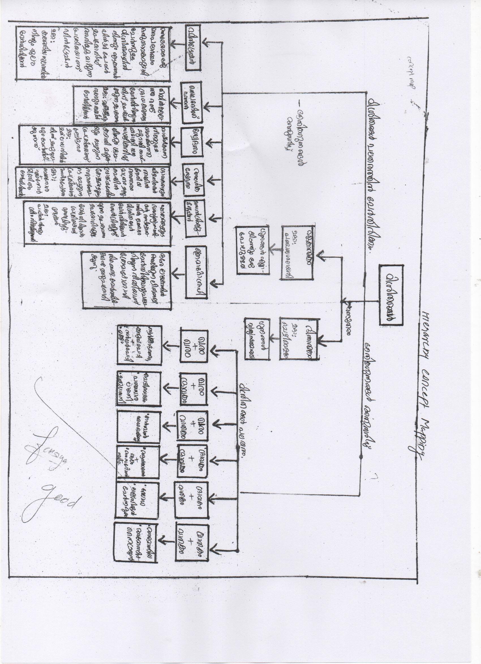

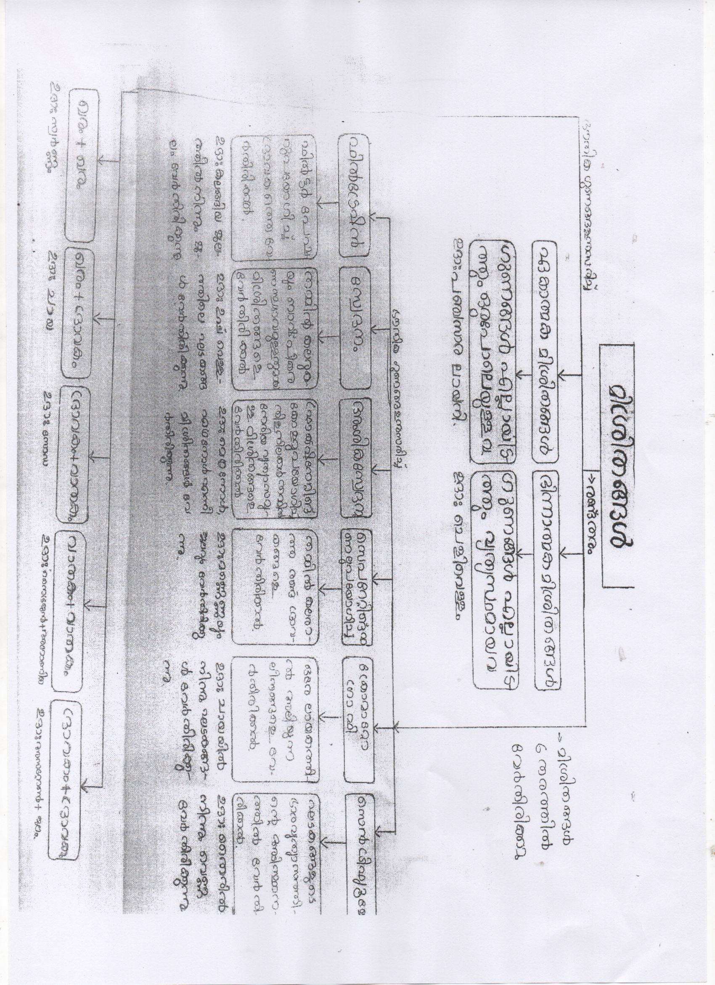

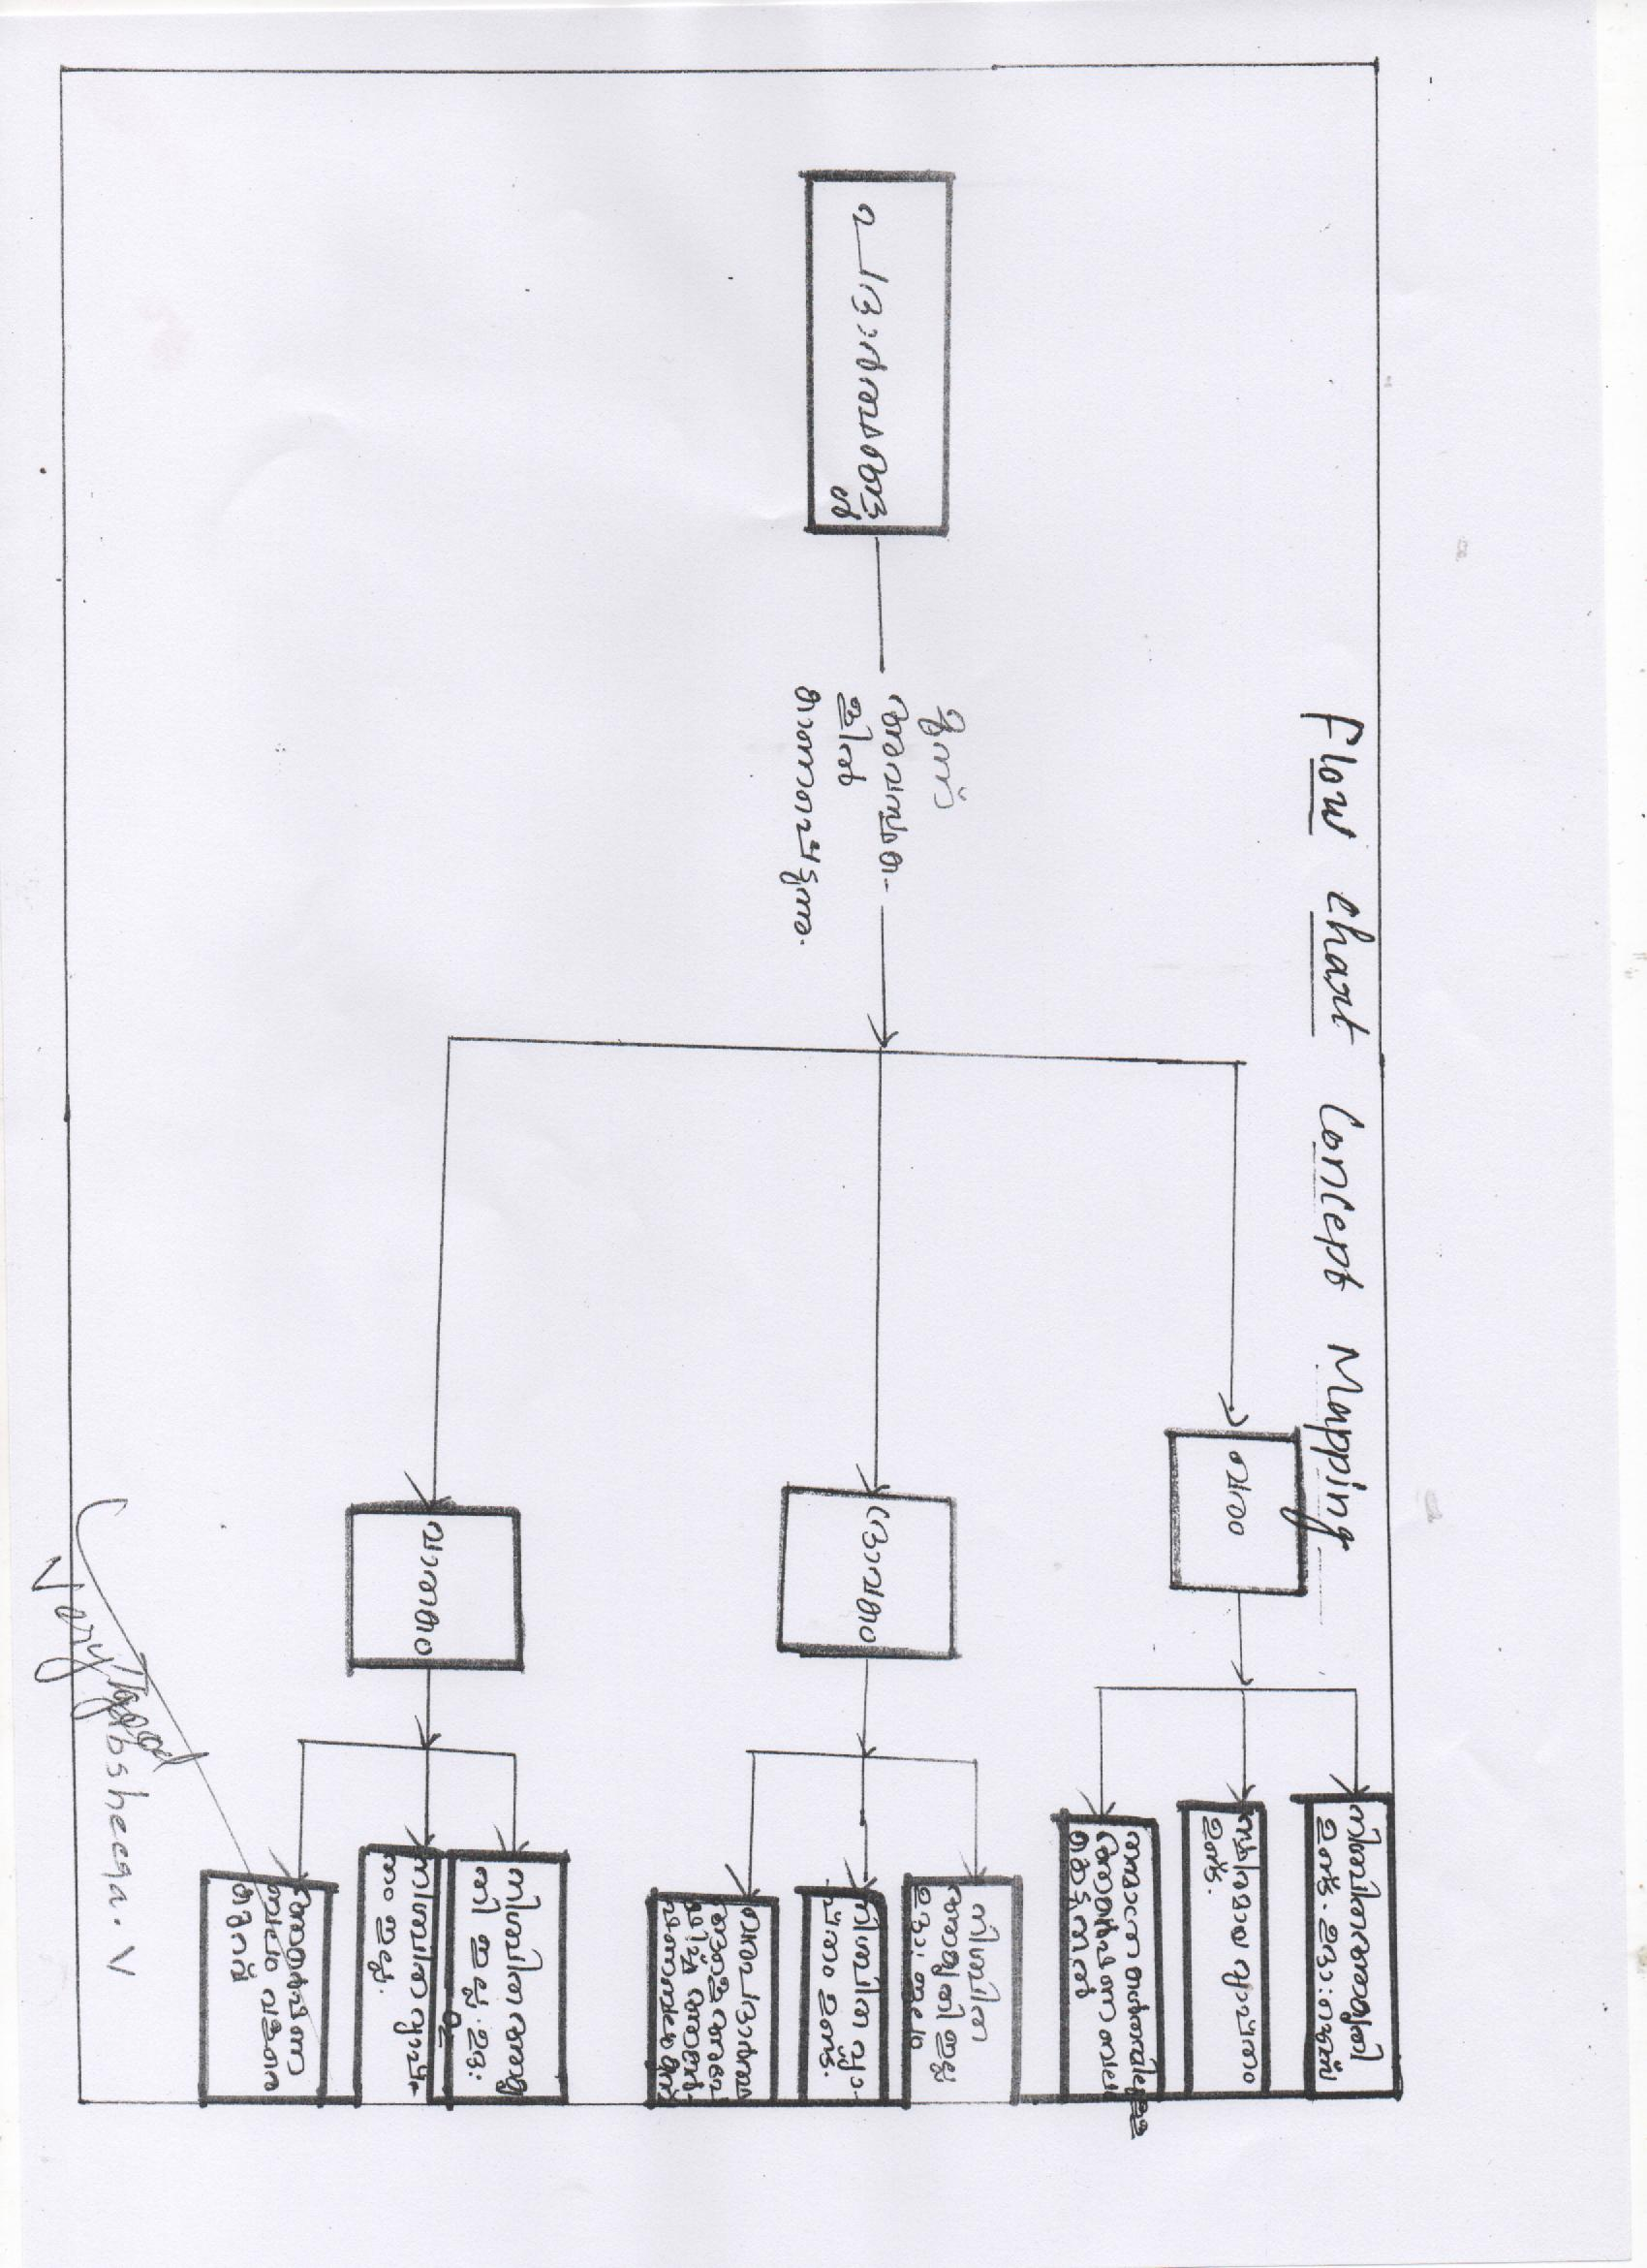

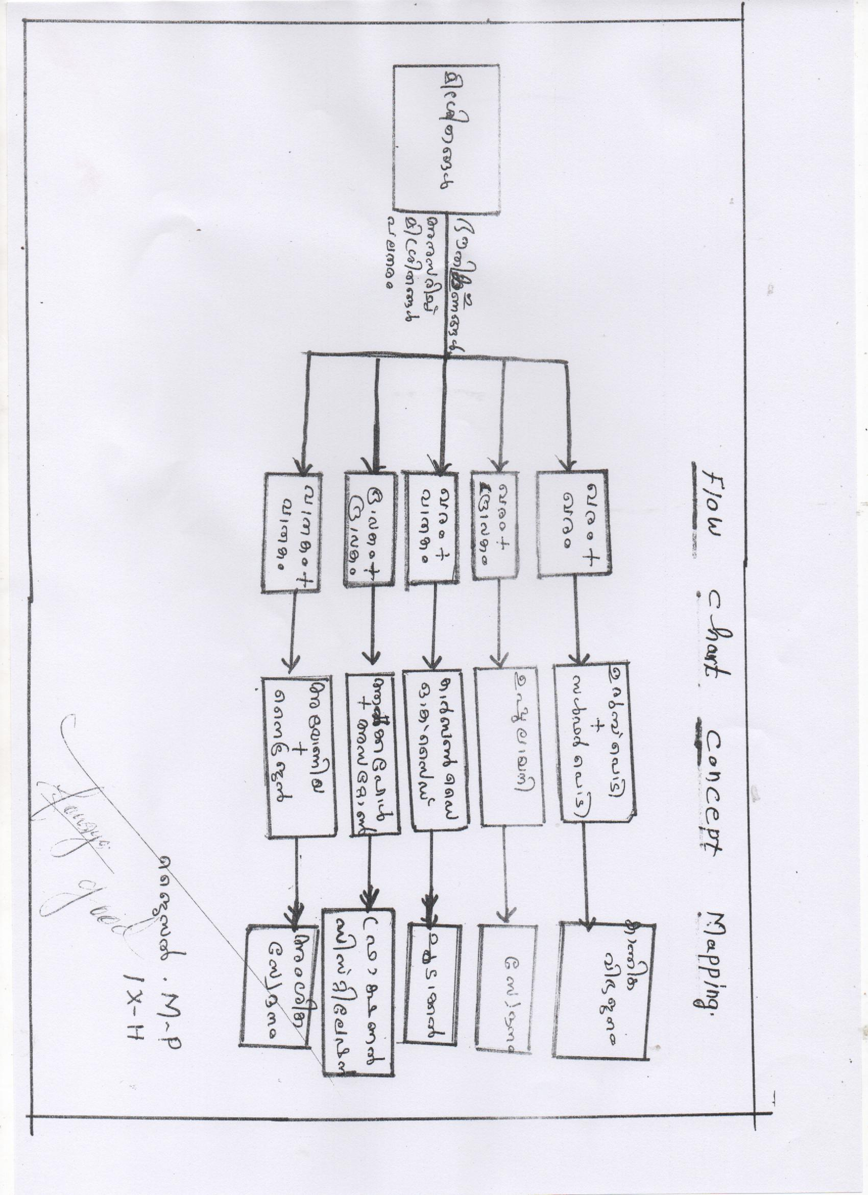

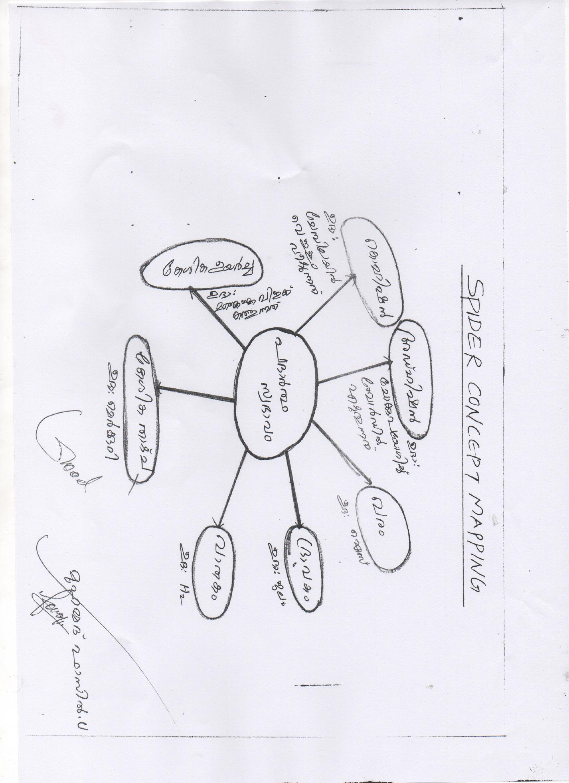

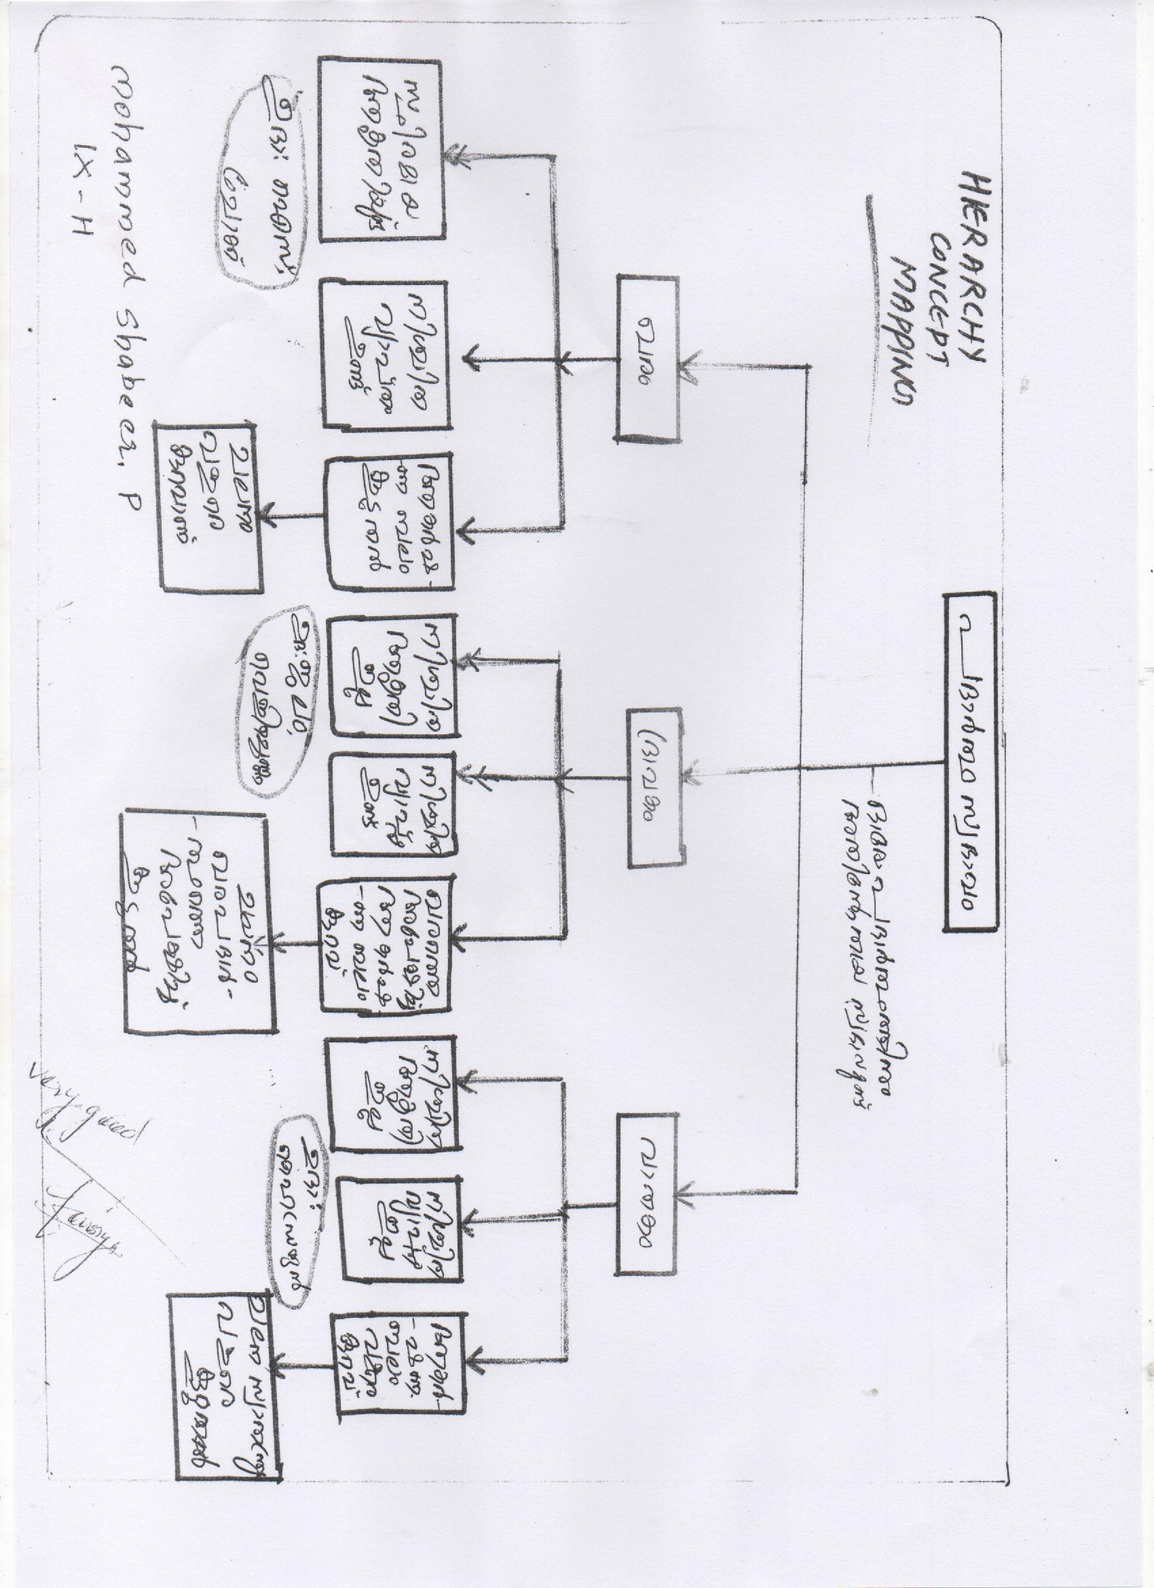

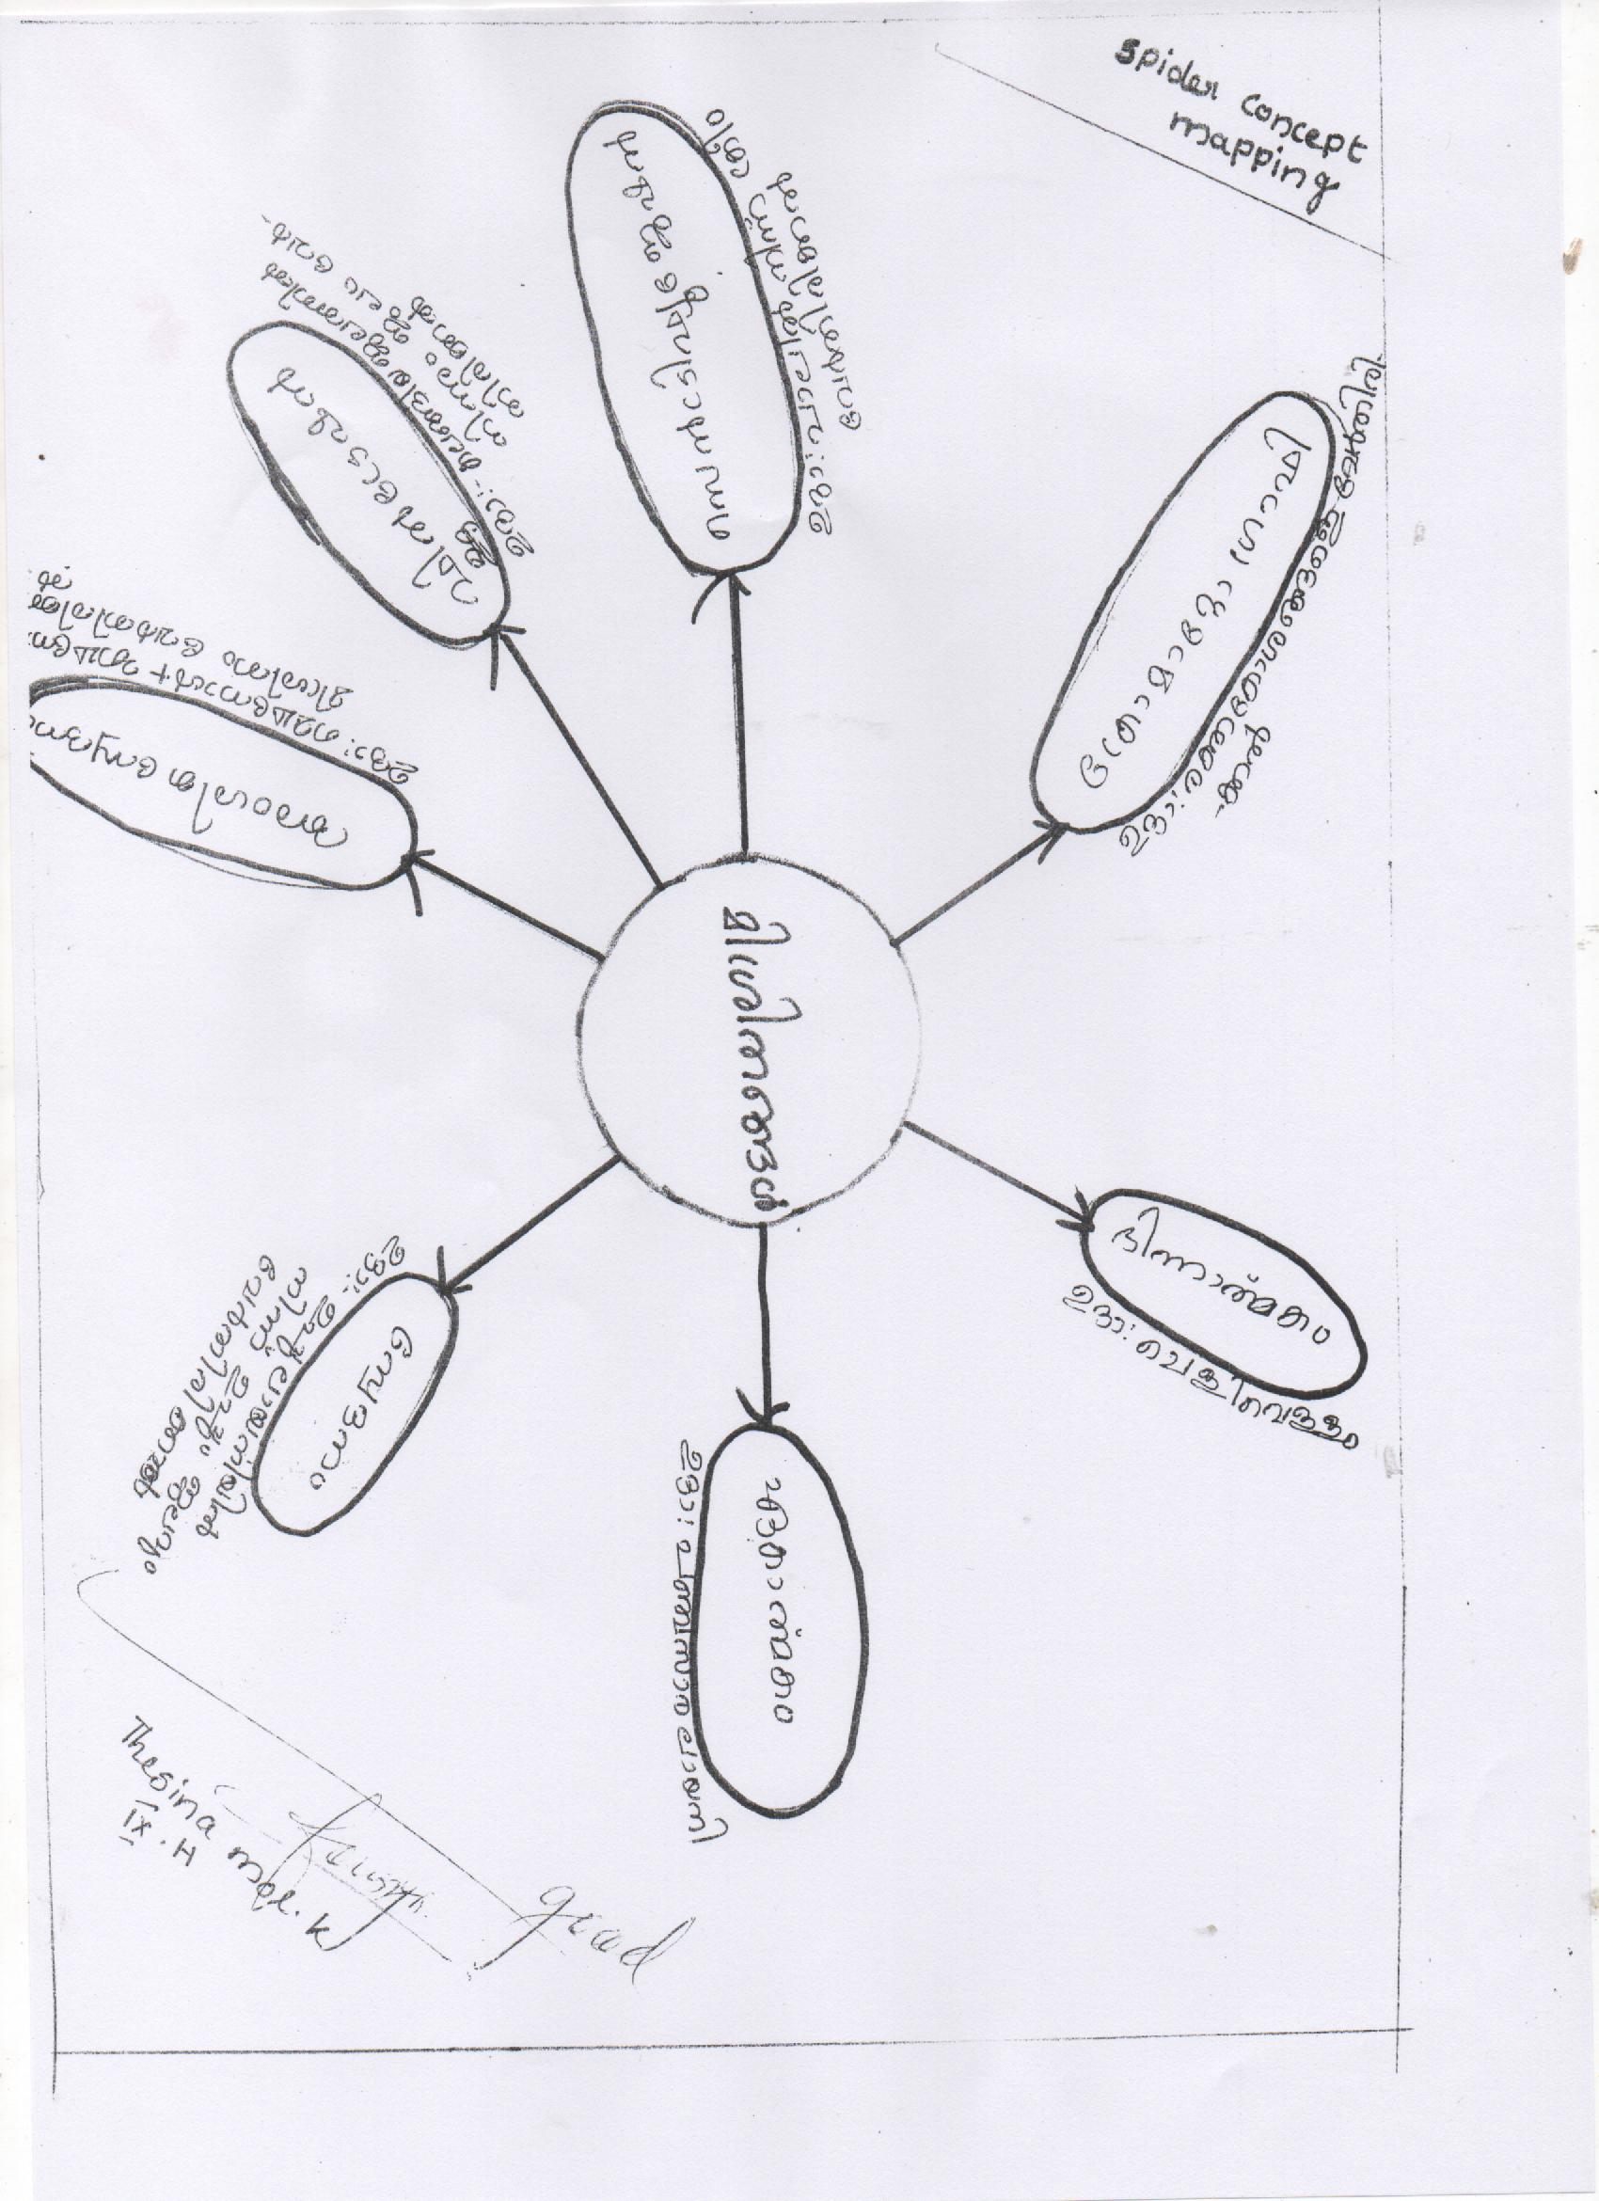

**APPENDIX VI**

**ACHIEVEMENT TEST IN CHEMISTRY – QUESTIONWISE ANALYSIS**

|  |  |  |  |  |  |  |  |
| --- | --- | --- | --- | --- | --- | --- | --- |
| **No.** | **Objective** | **Specification** | **Topic** | **Type of question** | **Difficulty**  **Level** | **Time** | **Marks** |
| 1 | Understanding | Interpret | Separation of mixtures | MCT | Easy | 0.5min | 1 |
| 2 | Understanding | Identify | Separation of mixtures | MCT | Easy | 0.5min | 1 |
| 3 | Understanding | Interpret | Separation of mixtures | MCT | Easy | 0.5min | 1 |
| 4 | Understanding | Identify | Nature of elements | MCT | Average | 0.5min | 1 |
| 5 | Understanding | Identify | Nature of elements | MCT | Average | 0.5min | 1 |
| 6 | Understanding | Identify | Separation of mixtures | MCT | Average | 0.5min | 1 |
| 7 | Knowledge | Recall | Separation of mixtures | MCT | Average | 0.5min | 1 |
| 8 | Application | Apply | Nature of elements | MCT | Average | 0.5min | 1 |
| 9 | Understanding | Identify | Separation of mixtures | MCT | Difficult | 0.5min | 1 |
| 10 | Understanding | Identify | Separation of mixtures | MCT | Difficult | 0.5min | 1 |
| 11 | Knowledge | Recall | Separation of mixtures | CT | Easy | 0.5min | 1 |
| 12 | Knowledge | Recognizes | Nature of elements | CT | Easy | 0.5min | 1 |
| 13 | Knowledge | Recall | Separation of mixtures | CT | Average | 0.5min | 1 |
| 14 | Understanding | Identify | Nature of elements | CT | Average | 0.5min | 1 |
| 15 | Knowledge | Recall | Separation of mixtures | CT | Average | 0.5min | 1 |
| 16 | Application | Apply | Nature of elements | CT | Average | 0.5min | 1 |
| 17 | Knowledge | Recalls | Separation of mixtures | CT | Average | 0.5min | 1 |
| 18 | Understanding | Interpret | Separation of mixtures | CT | Average | 0.5min | 1 |
| 19 | Application | Apply | Nature of elements | CT | Difficult | 0.5min | 1 |
| 20 | Application | Apply | Nature of elements | CT | Difficult | 0.5min | 1 |