LEARNING STYLE PREFERENCES AMONG TRIBAL AND NON-TRIBAL STUDENTS OF THRISSUR DISTRICT IN KERALA

APSARA. P. A.

Dissertation
Submitted in partial fulfillment of the requirements for the
Degree of
MASTER OF EDUCATION

DEPARTMENT OF EDUCATION
FAROOK TRAINING COLLEGE 2007 – 2008

DECLARATION

I, APSARA. P. A., hereby declare that this dissertation “LEARNING STYLE PREFERENCES AMONG TRIBAL AND NON-TRIBAL STUDENTS OF THRISSUR DISTRICT IN KERALA” has not been submitted by me for the award of a Degree, Diploma, Title of Recognition before.

Farook Training College APSARA.P.A
04 . 01. 2010

Mr. Afeef Tharavattath
Lecturer of Education
Farook Training College

CERTIFICATE

I, Mr. Afeef Tharavattath, do hereby certify that this dissertation “LEARNING STYLE PREFERENCES AMONG TRIBAL AND NON-TRIBAL STUDENTS OF THRISSUR DISTRICT IN KERALA” is a record of bonafide study and research carried out by Apsara.P.A under my supervision and guidance.

Farook Training College Mr. Afeef Tharavattath
04 . 01. 2010 (Supervising Teacher)

ACKNOWLEDGEMENT
The investigator is deeply indebted to her supervising teacher Mr. Afeef. Tharavattath, Lecturer of Education, Department of Education, Farook Training College. For the incessant encouragement, generous help and valuable suggestions in carrying out this study.

The investigator would her sincere thanks to other Members of Teaching Staff and Library Members of Calicut University and especially Mr. Abdul Rasheed T.T. of Farook Training College, for their co-operation extended to complete the present study .

The investigator is very much indebted to Arun Kumar and his Family Members who encouraged her in every venture of her life.

The investigator is obliged to the Head of institutions, Experts consulted and Teachers of various Schools especially Mr. Ajayan Thomas [Senior Superintend of Tribal Development Office, Thrissur] & Mr. Ravikumar [Model Residential School Nayarangadi] for their co-operation and help for the collection of data.

Finally the investigator wishes to record here her profound gratitude to Appu P.R., Abhilash P.A., Aparna Gopakumar,Padma Yadav & Shjnto for their infinite patience and enduring support.

All of these, the investigator is very much Grateful to her Beloved Mother N. M. Padmini.

Farook Training College APSARA.P.A
04. 01. 2010
CONTENTS

LIST OF TABLES
LIST OF APPENDIX

CHAPTER PAGES

- INTRODUCTION 1-25
- REVIEW OF RELATED LITERATURE 26-68
- METHODOLOGY 69-80
- ANALYSIS AND INTERPRETATION 81-111
- SUMMARY, CONCLUSIONS AND SUGGESTIONS 112-135

BIBLIOGRAPHY
APPENDIX

LIST OF TABLES
Table No. | Title | Page No.
3.1 | Break up of the sample | 74
3.2 | Break up of the final sample | 76
3.3 | Style elements of Learning Style Inventory | 76-77
4.1 | Details regarding the variable Learning Style Preferences among Tribal and Non-Tribal students (total sample and sub sample) based or Gender and Category | 82
4.2 | Details regarding the t-test for the Mean score of Learning Style Preferences among Tribal and Non-Tribal students based on the sub sample Gender. | 85
4.3 | Details regarding the t-test for the Mean score of Learning Style Preferences among Tribal and Non-Tribal students based on the sub sample SC and General students. | 87
4.4 | Details regarding the t-test for the Mean score of Learning Style Preferences among Tribal and Non-Tribal students based on the sub sample General and ST students. | 89
4.5 | Details regarding the t-test for the Mean score of Learning Style Preferences among Tribal and Non-Tribal students based on the sub sample SC and ST students. | 91
5.1 | Details regarding the Mean score and Standard Deviation of General Students. | 99
5.2 | Details regarding the Mean score and Standard Deviation of General Female and Male students | 101
5.3 | Details regarding the Mean score and Standard Deviation of ST students | 103
5.4 | Details regarding the Mean score and Standard Deviation of ST Female and Male students. | 105
5.5 | Details regarding the Mean score and Standard Deviation of SC students. | 107
5.6 | Details regarding the Mean score and Standard Deviation of SC Female and Male students. | 109
6 | Details regarding Learning Style Preference based on the mean scores of General , ST &SC Students | 116
7 | Details regarding Learning Style Preferences of General, ST and SC students based on Gender. | 119
8 | Learning Style- Description of Environmental Factors | 124

LIST OF APPENDIX

I. Questionnaire on the Learning Style Preferences among Tribal and Non-tribal students.

Chapter I

Introduction
- Need & significance of the study
- Statement of the problem
- Definitions of key terms
- Objectives of the study
- Hypotheses
- Methodology
- Scope and limitations of the study
- Organization of the report

INTRODUCTION
Education is an essential tool for improving communities and changing lives. Institutions secure society by partnering communities and fostering opportunities for life long learning. Education and learning indeed are corner stones of a democratic society. In the past two decades, several theories and measurement devices have been developed to explore how students learn and by extension, how we teach. Learning is an interactive process, the product of student and teacher activity with in a specific learning environment. These activities are central elements of the learning process, show a wide variation in pattern, style Quality (Keefe, 1987). Educators have for many years noticed that some students prefer certain methods of learning more than others. These traits referred to as Learning Styles. One of the major educational movements of the past 25 years has been the increased attention to student Learning styles (Lemire, 2000). Learning style refers to the consistent way in which a learner responds to or interacts with stimuli on the learning context (Loo, 2002)

A benchmark definition of “Learning style is Characteristic, Cognitive, Psychological behaviors that serve as relatively stable indicator of how learners perceive, interacts with and respond to the learning environments. In layman’s language, “learning is living and living is learning”. Stewark and Felicetti (1992) define learning styles as those “educational condition under which a student is most likely to learn”. Thus learning styles are not really concerned with “What” learners learn, but rather “how “they prefer to learn.

Learning styles are also known as Cognitive styles or Learning Preferences, are characteristic behaviors that indicate how students prefer to learn. Learning styles tend to be relatively stable over time, in other words are predictable, but are not static in that there can be some variation from day-to-day, week to week and as one ages (Ayeesman 1993; Davidson & Sevenye, 1992; Guild & Gargee, 1985; Price, 2004). To maximize students learning, it is important for instructors (Used as a general term that includes Teachers, Instructors, Professors, Lecturers….) to address the variety of learning styles where designing and delivering their lessons.

The idea that people learn differently is vulnerable and probably had its origin with the Ancient Greeks (Wretches, Morrison, Riley & Scheirton, 1997). All students are not equal; they come in different sizes, shapes & cultural backgrounds. They also are equipped with varied methods for learning. Some process information best through text, other requires visual support. Some readily integrate information individually, others work best in groups, some grasp information intuitively, others require time for reflection. There are probably as many ways to “teach” as there are to learn. Perhaps the most important thing is to be aware that people do not all see the world in the same way. They may have very different Preferences than for How, When, Where, & How often to learn.

Universities, colleges, Higher secondary and High schools are facing problems such as changing demographics, declining populations from which to gain students, increased competition high student dropout rates, and poor student Academic Performance. Catering to students by means such as matching teaching and learning styles is viewed as a way to attract and retain students. Individual differences are viewed by many as playing an important role in student’s success and failures. Learning styles has becomes a popular approach to understanding those individual differences.

Tribes are an excellent tool for new and experienced teacher. Much of our time in the classroom can be used on behavior managements rather than on learning. Too much time is wasted on reprimanding one or two students while the other students begin to shift in their seats becoming bored and annoyed. Often students misbehave in the classroom because they are scared and the material is too difficult for them. To know their problem solved instead of regurgitate information.

India is a land of varied Cultures, Religions and Peoples. “Unity in diversity” is the mantra of the land. The population of tribal people in India crosses 20 million. Almost all the states in India have significant presence of tribal people who constitute impressive portion of the population of the state. The tribal people in India have their own cultures and traditions which are is true agreement with the Indian Civilization and Culture. They are more or less homogeneous community having a common Government, a common dialect and a common nature. States like Assam, Tripura, Meghalaya, Manipur, Mizoram, Nagaland and Arunachal Pradesh have deep concentration of tribal peoples. Orissa is one of the Indian State which has “impressive” number of tribal class. There are smaller number of tribal people in Karnataka, Tamil Nadu, and Kerala, in Western India in Gujarat & Rajasthan and in the Union territories of Lakshadweep and the Andaman and Nicobar Islands. The totals of 645 District tribes are recognized by the Indian constitution. The term “ST” refers to specific indigenous peoples whose status is acknowledged to some formal degree by National Legislation. A collective term in use locally to describe most of this people “Adivasis” or “Vanavasis”. The constitution of India prescribes of certain safeguard for the tribes (along with SC s and other backward classes),either specifically of by way of general rights of the citizens. The objective of such safeguards is to promote the educational and economic interests of the tribal’s and other backward classes, and to remove their traditional social disabilities. SCs/STs together comprise over 24 % of India’s population, with SC at over 16 % and ST over 18 % as per the 2001 census.

The highest distribution of people belonging to Scheduled Castes is in Palakkad District (13.85%) followed by Thiruvananthapuram (11.87%), Thrissur (11.34%) and Kollam (10.34%). Nearly half of SC population of the state is distributed in the above four Districts.

The scheduled tribe population of Kerala State is 364, 189 as per 2001 census constituting only 1.14 % of the total population of the state. The state has a total of 35 scheduled tribes and all have enumerated at 2001 census. The Scheduled tribes are over whelming rural as 96.1 per cent of them reside in villages. District distribution of ST population shows that Wayanad district has the highest population of STs (17%) followed by Idukki (14 %) Alappuzha has the lowest proportion of STs (0.1 per cent) preceded by Thrissur, Kollam & Kozhikode (0.2 % each)

Out of 35 STs notified for the state, Paniyan is the most popular tribe with a population of 81,940 forming 22.5% of the total population of the state. Kurichchan is the second largest tribe having a number of 32,746 constituting 9% of the total ST population. Six other STs, namely Muthuvan, Kanikan, Irular, Kuruman, Marati & Malai Arrayan having a population ranging from 21,000 to 32,000 along with Paniyan & Kurichchan constitute 73.6% of the total tribal population. Seven tribes namely Malayan, Malaivedan, Mannan etc having 5,000-16,000 population amount for another 20% and the remaining 20 tribes along with the generic tribes constitute the residual 6.4% of the States Tribal population. Tribes having below 500 populations are eleven in number. Out of them, Kota, Kammara, Kochuvelan & Konda Kapus are the smallest groups each having less than 50 populations.

At the district level, Paniyan have the highest percentage of the total ST population in Malappuram (56.3%) & Kannur (54.9%) districts where as Kurichchan have their highest proportions in Kannur (40.2%). Among the other large tribes, Kanikan are primarily concentrated in Thiruvananthapuram (90.3%) & Malai Arayan in Kottayam (61.9%) district.

Thrissur is a city (located at 10.31 North & 76.12 East) in the central part of Kerala State, India. The name Thrissur is derived from the word “Tri-Shiva-Perur”, which Means the place with three famous Siva temples which are said to be, 1) The Vadakkunnathan, 2) Kottappuram Siva temple & 3) Pukunnam Siva Temple. The 2001 census reported that District includes 2974232 peoples. From which Males constitutes 1422052 & Females constitutes 1552180.

Thrissur is the fourth largest city in Kerala after Thiruvananthapuram, Kochi & Kozhikode. It is an important Cultural centre, & is known as the Cultural Capital of Kerala. It is famous for the Thrissur Pooram Festival, the most colourful & spectacular Temple Festival of Kerala. It has a large number of well known temples and two churches of note, the Our Lady of Lourdes Metropolitan Cathedral & Our Lady of Do love’s New church “Basilica” (The biggest in South Asia). The Kerala Police Academy (second largest in India) is situated in this city.

Hindus & Christians constitutes the bulk of the population of the city. Muslims are a monitory in the city. The Scheduled Castes & Scheduled Tribes also form a significant section among the Hindus of the city.

1.1. NEED AND SIGNIFICANCE OF THE STUDY

Learning styles are, simply put, various approaches or ways of learning. They involve educating methods, particular to an individual, that are presumed to allow that individual to learn best. It is commonly believed that most people favour some particular method of interacting with, taking in and proceeding stimuli or information. Based on this concept, the idea of individualized “Learning Styles” originated in the 1970’s and has gained popularity in recent years. It has been proposed that teaches should assess the learning styles of their students and adapt their classroom methods to best fit each student’s learning style. The Learning Style Inventory diagnosis an individuals preferences and needs regarding the learning process

- Allows students to designate how they like to learn and indicates how their responses are
- Provides computerized results which show the students preferred learning style and provide a foundation up on which teachers can build in interacting with students
- Provides possible strategies for accommodating learning style
- Provides for student involvement in the learning process
- Provides a class summary so students with similar learning styles can be grouped together.
Much pedagogical Research has focused on the concept of “Learning Styles”. Several authors have proposed that the ability to typify student learning style can augument the educational experience. As such instructors might tailor their teaching style so that is more congruent with a given student’s on class of students learning style. Learning style may become an increasingly relevant pedagogic concept as classes increase in size and diversity

To enhance learning, instructors and trainees must recognize that individuals learn and teach differently and what may be an optimal learning or training method for one may discourage another. Indeed, instructor and trainees should make sure that a variety of Training or learning opportunities are presented to students and trainees to increase the likelihood of advancing learning.

A learner is to be active. He can not afford to be passive in the desirable changes in behavior, in our habit, style of living adjustment of knowledge, skills etc. it aims at maximizing learning experiences besides methods are use various media and materials for maximizing the learning experiences of students.

“There is no good understanding of learning styles as it stands. But it certainly does not follow that we all learn the same way – the senses may well work in concert, but some senses work more or less well, Meaning that each individual may combine the senses differently” – Stephen Downes.

It seems at this point in time that learning styles are not really “Style”, but rather “Preferences” in that we do not learn best by using our style of learning. That is, we prefer one or more styles over others.

An initial review of related literature revealed that the number of studies conducted in this area found to be few. So the investigator selected this area for her research. The present study has its objectives to find out whether there is any significant difference and learning style preferences among tribal students, general students and Scheduled Caste students.

Chapter II

Review of Related Literature

- Theoretical overview of Learning Style
- Studies related to Learning Style.
- Conclusion

REVIEW OF RELATED LITERATURE
Review of the literature provides a background for the research project and makes the reader aware of the status of the issue. Familiarity with what is already known and what is still unknown and untested helps the researcher to eliminate the duplication of what has been done and provide useful hypothesis and helpful suggestions for significant investigation.

For any worthwhile study in any field of knowledge the research worker needs and adequate familiarity with the work, which has already been done in the area of her choice.

REVIEW OF RELATED LITERATURE

Review of related literature must precede any well planned research study. It allows the researcher to acquaint herself with current knowledge in the field in which she is going to conduct her research. It also helps the researcher to gather up-to-date information about what has been done in the particular area from which she intends to take up a problem for research.

The present study is the “Learning Style Preferences among Tribal and Non-Tribal Students of Thrissur District in Kerala”

2.1. Theoretical Overview
Learning style research has been carried out since 1894. While many different models have come out of this research every researcher agrees on one thing: that every individual has a way of learning that is unique that individual.

Therefore a simple definition of learning style is,
the way in which each learner begins to concentrate or, prides use and retains new and difficult information.

That interaction is different for everyone. We also need to remember that no learning style is better or worse than any other and each style encompasses similar intelligence ranges.

Ken & Rita Dunn began developing their model in 1970 and since this time they have developed and expanded the model through extensive research in the field. While much of that research has been done at St. John’s University, New York (the largest Catholic University in the USA), over 100 other institutions of higher learning having also carried out research on this model.

Every piece of research has shown consistently that when anyone is taught according to their individual learning style their Academic Achievement increases, as does their attitude, self-esteem, discipline and outlook towards the future. Even introducing one or two elements of the model in to a learning environment will have a beneficial effect on the individuals affected by those elements.

This is exciting data. It heralds a new era in education, one in which all children are able and willing to learn and become successful. The Dunn’s model can be seen as a stepping stone towards such as education systems, a welcome replacement for the present system that is only meeting the learning style needs of appearance of its uses.

The Dunn & Dunn learning Styles Model (1978, 1992 a,
1992 b, and Dunn, 1988)

The model consists of five strands with 21 elements. Only some elements will be important for each individual. They affect people most when learning something new and difficult.

Learners who have many strong preferences which affect their learning may only learn successfully when these are taken in to account. For example, learners who are ‘low auditory’ (i.e. have difficulty taking in & retaining information through listening) will not learn successfully through ‘chalk & talk’. Those who are kinesthetic learners may need to discuss & try out everything in order to learn. Those who are global will often have trouble with sequence but will be better able to learn then if they see how they fit in to the whole picture.

As learners become aware of their own learning preferences & needs, they can develop more effective & independent learning strategies.

The following is a summery of the elements to consider in planning & teaching.

Environmental
- Sound - background music or need for quiet
- Light - bright or dim (also fluorescent lights can affect some peoples concentrative badly)
- Temperature – warm or cool (when it affects concentration)
- Formal/Informal – example, sitting at a table or in an arm chair/on the floor

Emotional
- Persistence – i.e. like to finish one task before going on to another or like to change tasks & come to something
- Need for structure (example, step- by- step guidance) or self structured.
- Conformist – i.e. do things the way they are ‘normally’ done/as the teacher says, or non-conformist- i.e. needing to be treated as equal & have a say in what they do & how they do things.
- Motivation – self or other motivated (this will be strongly affected by both perceived relevance of the learning & their experience of success)

Sociological
- Learn best either alone/in pairs/in groups or team
- Learn best directly in interaction with the teacher
- Need variety

Physical
- Perceptual – how learners best take in & process new & difficult information.
- Visual – through pictures, diagrams etc & or through reading example, land outs, instructions, texts
- Auditory – through listening, tapes/videos
- Kinesthetic – through participation, example, discussion, role, play, games, personal involvement
- Tactile – through manipulating material, hands on experience, motor memory.
a) Time of day – most adults are best in early or late morning, some in the evening or at night.
- Need for intake – to eat & drink while tackling new learning on afterwards.
- Mobility – need to physically move around while learning or the need to sit in one place.

Psychological
- Global – need to see the whole picture before understanding the steps on details, learning through associative, after in random order, on analytic – Preferring things in sequence, logical order, learning step by step.
- Right /left hemispheric processors – right hemispheric learners tend to be visual – spatial thinkers & see patterns, where as left hemispheric thinkers tend to be verbal & sequential thinkers
- Impulsive – make decisions & answer/do tasks with out a lot of consideration or reflective – consider before making decision & are slower to answer questions or complete tasks.

Physiological dimension refers to the general strategies students use when attacking learning problems. Some attack them globally, looking at big picture, while others prefer to address individual elements of a problem separately. In a similar way, some students jump in to problems, figuring things out as they go along, while others are more reflective planning before beginning.

Learning Style is composed of biological & developmental characteristics that make the identical instructional environments, methods & resources effective for some learners & in effective for others. Several reliable & valid assessments that identity individual learning style performance have been developed some of the important tools for learning style are the following.

- Kolb & Fry’s Learning style Inventory(1975)
- Park’s Learning Style Inventory (1976)
- Kolb’s Revised Learning Style Inventory
- Torrance’s Inventory (1988)
- Dunn, R. Dunn, K. & Price Learning style Inventory.

Kumar et al developed another Learning Style Inventory based on theoretical construct proposed by Dunn & Dunn. This includes four major styles areas namely environmental, emotional, sociological & physical with their associated elements. In this Inventory Physiological area of Dunn & Dunn Model is excluded on the assumption that the processing styles are not tapped directly through items in inventory.

A lot of recent works on learning skills has stressed the element of personal choice about learning style & methods (Main, 1985). The concept personal stances in learning give paramount importance to the personal position of learners. A survey about obtained literature reveled that a number of investigation have developed and used instrument to measure learning style preferences, learning strategies & similar Physiological construct.

Modification of the Dunn & Dunn Learning Style Model in 2005
There is 21 element or component of the model. The model is divided in to five strands.
- Environmental
- Emotional
- Sociological
- Physiological
- Psychological

The Environmental Strands looks at,
- Whether you like to have sound present while you work or whether you prefer silence.
- How much light you need. The younger we are the less light we need, so young children can often in very dim light & will find reading with too much light difficult because the light hurts their eyes.
- What temperature needs you have- we tend to dress our children according to our own needs?
- And finally the design element- whether you like to sit on a formal or hard chair at a desk or whether you prefer to study more informally on the floor with cushion, a sofa or on your bed. We know that 40% of school students need normal design to be able to learn & this is often not readily auditable in our schools at present.

The Emotional Strand
The emotional strands look at,
- Motivation, which can fluctuate accordingly too many factors.
- Persistence- whether you like to concentrate on & finished one task at a time or whether you are gifted with the ability to do several things simultaneously and are unable to limit yourself to single task focus.
- The responsibility element refers to whether you are conforming or non-conforming.
- We go through three periods of non-conforming in our lives: the terrible twos: the teenage Years: the middle age crisis. However some of us are non-conformist for life & three ways of relating to us without offending or upsetting us.
- Structure - is the final element in this strand. It refers to whether you need precise information on exactly how to do something or not. In general as we grow older we have less need for structure.

The sociological Strands
The sociological strands examines to we like to learn,
- Alone
- With a friend
- In a group or a team learning situation
- With an adult or expert in the field present
- Or perhaps we have a need for variety doing it a different way everyday!

The Physiological Strand
In the physiological strands are find the element of
- Mobility – 50% of students need to move or order to be able to learn, only 25% like to sit& be passive.
- Intake – the need for food & drink often needed as frequently as every 45 mines in small children to keep the blood sugar levels up and the brain alert & able to learn new & difficult information. On the other hands there are prefer not to eat while the study.
- The time of day is another important element in learning. The best time for each of us to sit down & study can vary from early morning to those rights who only come alive at right & we need be to take that in to account in deciding or knowing when it is best for us to learn.
- Finally there is the matters if perceptual modes. This refers to the way in which we are able to take in information.

The Psychological Strands
The final strands in the model look at different proceeding styles.
- Analytical & global Processing Styles.
- Preferring left side of the brain (analytical) or use the right side of the brain (creative, the arts)
- Impulsive (calling out answers, talking to make sense of things) or are you reflective (need time to assess & determined the thing)

  - STUDIES RELATED TO LEARNING STYLES

Charkins (1985) reported about a study on “Linking Teaching Student’s Learning Style with Student’s Achievement and Attitudes” Findings disclosed that students Achievement and attitude at a college level might improved by a better match between teaching style of instructors and learning style of students.

Smith and Holiday (1986) investigated the differences in learning styles as measured by the learning style inventory (LSI). The subjects for the study were a sample of IVth, Vth and VIth Graders in a Mid-Western Elementary School. The findings were that the students do manifest significant variation in how they prefer to learn in a classroom setting. The average Achievers did not display a significant performance for a particular learning style, with the high and low achievers did.

Handpole (1988) conducted a study determine the relationship of learning style and reading Achievement of VIth grade students and found statistically significant relationship between learning style and total reading Achievement scores.

Cooper and Millar (1992) assessed learning style of 113 students and teaching style of 10 faculties within a college of business using Myers – Briggs Type Indicator (MBTI) and found that learning style - teaching style congruency was related to academic performance.

Carthey (1993) studied the relationship between learning style and Academic Achievement on 64 Second Year Lowa community college students. Findings suggested that instructors should consider testing their students to determine their learning styles so as to increase Academic Achievement.

Karen Hood (1993) conducted a study on “Exploring Learning Styles and Instruction”. This study focus certain benefits for students and tries new ideas and new teaching strategies.

Alie (1993) conducted a study on “Learning Styles and Learning Dispositions in Public Schools”. Some implications of preference. This study investigates the learning style of public school teachers and students who are studying to become teachers.

Ken Hyland (1998) reported a study on “Culture and Learning” a study of the learning style preferences of Japanese students. This article describes a replication of a study by Reid (1987) of learning style preferences of ESL learners in the US. The study concludes by discussing the implications of the results for Teachers working with Japanese students.

O’Brien (1994) assessed “Cognitive Learning Style and Academic Achievement in Secondary School” and confirmed concrete - sequential students having highest grade point averages out of performing male.

Alfred and Holiday (1995) studied a “ Brain – based approach to helping students reach their full potential in a South Carolina School.” Examination of faculty teaching style and student learning style revealed that only high achievers learning style matched their teacher’s fact based approaches.

Verma (1995) studied the Relationship between learning style and achievement motivation of 51 classes of IX students and found learning style to be independent of achievement motivation.

Lindvall (1995) described a programme employing the theory of multiple intelligences and individual learning style in order to make learning active. 17 Third grade students together classroom of an elementary school were surveyed. The results indicated that analyzing student’s needs and preferences and making accommodations to confirm to these needs in the classroom, encouraged students to be increasingly engaged in their learning.

Virginia Hartman (1995) conducted a study on “Teaching and Learning Style Preferences”. Transitions through technology focused in how learning style preferences can positively or negatively influence a student’s performance in both collaborative and individual classroom settings.

Preetha (1996) found that significant sex differences exist in learning style. High Mean scores for girls over Boys were noticed. In learning style revealed the superiority of girls over boys.

Sathy (1996) found that there exists a satisfactory significant relationship between achievement in Hindi and learning style for Boys and girls.

Hall and Hale (1996) examined the relationship between achievement and learning style of middle school students. Subjects were chosen from one urban middle school. Analyzing of data revealed that traditional classroom settings may not provide sufficient environmental options to enable students to recognize their learning style preference.

Harold Henke (1996) conducted a study on “Learning Theory Applying Kolb’s Learning Style Inventory with Computer Based Training”. The purpose of the paper to describe how an aspect of learning theory, specifically learning styles can be applied to the development of computer based training.

Kumar (1997) investigated the effect of learning style on achievement in secondary school biology on 650 students. Analysis of the data indicated that learning style has significant main effect on achievement in biology.

Balas and Mascazine (1998) reported a study on General biology students (N=24) in a college environment in the Columbus Ohio area. Comparisons are made between students learning style and perceptual modalities. The results revealed that student’s achievement increased with choice and the use of a variety of teaching techniques is beneficial to college science teaching.

Betin Lankard (1998) reported about a study on “Learning Styles and Vocational Education Practice”. This practice application brief examines the definitions, categories and characteristics of various learning styles describe the instrument used to assess learning styles and provide guideline to help vocational teachers use information on learning style to create effective learning environments.

Susan et al (1998) reported a study on “Student Learning Styles and Their Implications for Teaching”. This occasional paper will make the case that all faculty members, no matter the discipline, can put an understanding of learning styles to good use in their own teaching.

Yuliang Liu and Dean Ginther (1998) reported a study on “Cognitive Styles and Distance Education”. Five major dimensions cognitive styles are received in this study. These are field independence v/s field dependence, holist v/s analytic, sensory preferences, hemispheric preferences, and Kolb’s learning style model.

Gopalan (1999) conducted a study on “Sex and Local Difference in Learning Style of Secondary School Pupils” reveals that there is no significant difference between Urban Boys and Girls for environmental and emotional components where as in sociological and physical components of hearing style there exists significant difference between the urban boys and girls.

Melanie Hinson (1999) reported a study on “Dunn and Dunn Learning Style Synopsis”. This research shows that higher grade point averages are achieved when there is a close match between student’s learning styles and their teacher’s teaching styles.

Carle Varwilligen (1999) reported a study titled with “Learning Styles – A New Look to Education”. This paper gives educators a new way of reaching out to students.

Teresa Larkin – Hein (2000) investigated a study “Learning Styles in Introductory Physics: - Enhancing Student Motivation, Interest and Learning”. In this paper successful approach to teaching introductory Physics students using strategies developed from a comprehensive learning style model will be discussed. These approaches can easily be adopted for use by educators in other branches of science, and well as Mathematics, Engineering and Technology (SMET) education.

Wingerbach (2000) in a study found that students with a field independent learning style scored significantly higher than field – dependent students.

MC Shannon (2001) conducted a study on “The Effects of a Faculty of a Faculty Development Programme” offered to increase positive interaction between students and faculty of the effects of these interactions on student achievement and retention. Students enrolled in eight engineering classes (N=677) completed an interactive learning style instrument to show their preferred learning style. Results reported an average learning style is important because they are education relevant expression of the uniqueness of the individual (Joyce, et, al, 1992).

Drysdale, et al (2001) investigated the effects of cognitive learning style on first year academic performance in 19 university courses. Results revealed that Academic Performance based on learning style was significant in 11 courses. All learning style excelled in liberal arts and Social Sciences.

Steven, et al (2001) reported a study on “A Preliminary Analysis of the Influence of Learning Style Preferences on Student Success in Online V/S Face-To-Face Environments”. This study compared the relationship between learning style preferences and learner success of students in an Online Course with an equivalent face-to-face course. These findings suggest that students can be equally successful in face-to-face and online environments regardless of learning style preferences.

Leena and Charlenc (2001) reported a study on “Teacher’s Beliefs about Accommodating Student’s Learning Styles in Science Classes”. Results indicated attitude toward behavior and subjective norm influenced teacher’s intent to implement variety of instructional strategies to meet the needs of different learning styles.

Seung and Diane (2002) conducted a study titled with “Investigating the Relationship between Learning Style Preferences and Teaching Collaboration Skills and Technology: An Exploratory Study”. This study investigated how a workshop on collaboration and ICT was perceived by participants with different learning style preferences.

Heliberg and Tharp (2002) reported a study on “Theoretical Perspectives, Research Findings and Classroom Implications of the Learning Styles of American Indian and Alaska Native Students”. These findings suggest that even in classroom consisting exclusively of a single cultural group, as in the case on many reservation schools, teachers must use a variety of instructional strategies. Effective teaching requires teaching individuals.

Sabine, et al (2002) conducted a study titled with “Automatic Student Modelling for Detecting Learning Style Preferences in Learning Management Systems”. This approach is an approach for identifying all learning style preferences with in the active/reflective dimension, learning style preferences within the sensing / intuitive and visual/verbal dimension. For the sequential / global dimension, results of learning style preferences show only moderate precision.

Rita Dunn and Shirley Griggs (2003) reported a study on “Synthesis of the Dunn and Dunn Learning Style Model Research: Who, What, When, Where and So What”. This study conducted that teacher expertise difference in student academic achievement. When principals encourage the use of learning styles in their schools, measurable Academic gains occur.

Louise, et al (2003) reported a study on “Learning Style Preferences for Hong Kong GPS Recruited in a Distance – Learning Courses”. The predominant learning style of general practitioners in Hong Kong in this post graduate course was “reflective”. The life long learners may wish to consider their learning style preference when selecting future continuing medical education activities. Learning styles should be considered by course terms when revising instruction teaching methods and assessment.

Sharon (2003) conducted a study titled with “Learning Style Preferences and Learning Strategies in Intensive Care Nurse Education”. This study focused on the recognition of differences in individual learning styles and the importance of learning strategies to learning styles. The assessment of participant learning preferences in comparison with learning strategies used provides useful information for programme facilitation. Additionally, the use if learning preferences assessment as a way of improving student’s awareness of their own learning style, leading to an improvement in learning outcomes.

Kenneth and Robert (2003) conducted a study on “Learning Styles and Environment Finding the Right Match”. This study focus on the most effective learning environment and procedures for a given child.

Nafisah and Nurhaiza (2003) reported a study on “Learning Styles of Form Four Electrical Engineering Students in Three Technical Schools in Malaysia”. Research findings shows that the Form Four students of Electrical Engineering from three schools have dominant learning style, which is “reflector”. This research also shows that there is no relationship between the learning styles and the academic performance.

Damian and Gordon (2004) conducted a study on “The Nexus Explored: A Generalized Model of Learning Styles”. This paper surveys a number of different learning style models and it concludes there is a large degree of commonality between the different theories, which allows us to distil key or core learning style characteristics which point the way to a number of styles of teaching which should be addressed in every learning environment. A model of this core set of dimensions is presented which unifies the various learner styles presented by others.

Cheng – Yi Kelly Chang (2004) conducted a study titled with “The Relationship between Individual Learning Styles & Learning Strategies in Electronic Materials for Practicing EFL Learning”. This study shows that if their learning styles, the performance are usually better- when the learner learning styles are matched congenial with the instructional styles, their motivation, performances and attainments will be enhanced reported.

Thomas Power (2004) reported study on “A Review of Learning Style Research “. This study revealed that many of the instruments that exist to measure students. Learning styles are questionable reliability and validity & it is inconclusive whether matching teaching and learning styles results in increased student course satisfaction or improved students’ Academic Performance.

Kinshunk (2004) conducted a study on “Applications of Learning Styles Adapting in Mobile Learning Environments”. This paper explores how to improve learning process by adapting course content presentations to student learning styles in multiplatform environments. A framework has been developed to comprehensively model student’s learning styles and present the appropriate subject matter’s, including the content, format media type and so on, to suit individual students by their learning styles and access devices.

Tatyana (2005) presents an article on “The Importance of Learning Styles in ESL/EFL”. This article reminds the teachers of the need to be aware of individual learning styles and learner diversity. While the multiple intelligences theory of Howard Gardner is the most popular and readily used by Teachers (Currie, 2003), there are other ideas about learning styles, which also can be useful for EFL/ESL teachers.

Ann & Patric (2005) conducted a study on “Cultural Values & Student Learning Style Preferences, Implications for Course Satisfaction”. This paper presents results from two studies that have been conducted with higher education business students at Victoria University, Melbourne Australia.

Dyuti Bhattacharya (2005) reports a study on “Unearthing the Origin of the Vanishing Tribes”. This paper studied the complete DNA sequences of five onges and five great Andaman’s tribes of the Andaman Islands.

Sreelakshmi, et al (2005) reported a study on “Implications of Resource Use Paradigm in Sustainable Natural Resource Management”. An assessment of the Ecologic, Economic Linkage of the Natural Resources use by tribal Communities in Kerala. This study identifies instructional & policy failures as the major factors responsible for the natural resource degradation and poverty among tribal communities.

Zarina & Bandar (2006) reported a study titled with “The Learning Styles Preferences of Different Ethnic (Malay, Chinese & Indian) English Language Learners in a Secondary School”. It was proved that ethnic background does influence their learning style Preferences. Another contributing factor was student’s personalities, therefore, English language educators should be aware of the students differences in learning styles preferences especially, Malaysian context.

Zimmerman, et al (2006) investigated a study on “Comparison of Personality Types of Learning Styles of Engineering Students, Agricultural Systems Management Students, And Faculty in an Agricultural & Biological Engineering Department”. This research shows differences in learning styles and personality types among engineering students, agricultural systems management students and faculty in the department of agricultural & Biological Engineering at Persylvanic state University. Mean values for the GEFT for all three groups in study indicate a strong preference for the field independent learning style. There were significant difference in MBT I Type preferences between ABE students & faculty.

Peter fenrich (2006) conducted a study on “Getting Practical with Learning Styles in “Live” And Computer Based Training Settings”. Learning styles are relatively stable characteristics behaviors that indicate how students prefer to learn. To maximize student learning, it is important for instructors to address learning styles when designing their classrooms. In this presentation, through discussion and Demonstration, participants will be given practical suggestions for addressing learning styles in both traditionally-delivered lessons & computer based training applications.

Anil Kumar (2006) investigated on “Strategies to Enhance Students learning in a Cap Store MIS Course”. This paper high lights different strategies that can be used in a cap store MIS course to help students synthesize, analyze and apply knowledge acquired over different courses in the programme.

Lixin Xiao (2006) reported a study on “Bridging the Gap between Teaching Style & Learning Styles A Cross-Cultured Prospective”- this paper investigates the nature of the mismatch caused by culture based differences in perceptions and expectations of teaching and learning style Preferences between Irish English teachers & Chinese students.

Joyce, et al (2006) reported a study on “Learning Styles, Performance & Attitude towards Technology: Focus on Business Students”. This study clearly reports a shift in learning styles over the last twenty-plus years, the cause of that shift needs to be explored further. This study acts as a starting relationship between Technology, Learning Style and Performance.

Franklin & Linying (2006) reported a study on “Learning Style Trends and Laptop Use Patterns: Implications for Students in an IT School”. The findings confirming that the majority of the students are active, sensing and visual and regarding the effect of advanced technologies on learning enhancements.

Abdul Ghan Haji Abu (2006) reported a study on “Learning Style Preferences in the Comprehension of Literacy Texts”. The focus of this study was on the improved reading performance demonstrated by a higher score in short stories readily comprehension quizzes. The results of the experiment indicated that the performance of students who were inclined towards divergent/convergent learning styles in the experimental group was much better the comprehension quizzes than the students who proffered assimilative/ accommodative learning styles.

Gregory (2006) reported a study on “Learning Style & Personality Type Preferences of Community Development Extension Educators”. This study reveled that except for the youngest age group studied (24-34 years of age) extension community development Programme Professionals typically perceive in a global perspective formed by personal surroundings.

Stacy (2006) reported a study on “Assessing the Impact of Students Learning Style Preferences”. Students express a wide range of Preferences for learning environments. This article measures the manifestation of learning styles in various learning environments.

Sachu (2006) conducted a study on “Aspects of Tribal Studies”. The study encompasses a wide range of papers covering so many important aspects of tribal life but mainly devoted for the Santhal tribe of Jharkhand & Jaunsar Bawar tribe of Uttaranchal.

Thomas, et al (2007) conducted a study on “Psychometric Study of the Index of Learning Styles”. The work presented in this paper was conducted with two goals in mind to assess evidence for reliability and validity of the index of learning styles and to determine the effects of modifying the response scale in a way that the original version of the ILS generates data with acceptable levels of internal consistence reliability and that evidence for its construct validity from both factor analysis and student feedback is strong.

Lin Hong (2007) conducted a study on “Examples of Mismatches between Teaching & Learning Styles”. This article describes ways to make this matching feasible in real-life classroom teaching in East Asian & comparable contexts.

Neil & Pru (2007) reported a study on “Student Learning Style Preferences & Undergraduate Academic Performances at Two UK Universities”. The paper considers why Style Preferences & Where the LSI can be used as a pedagogical tool allowing undergraduates to assess their own learning style preference, which they could then adapt, to deal with different situations, hence improve their over all learning effectiveness.

Johncy & Francis (2007) reported a study on “Ethno-Botany of Finger Millet among Muthuvan Tribes of Idukki District”. The present investigation has brought out the Ethno- Botanical & Agro Ecological significance of eleucire coracana among the muthuvan tribes.

Elanchezhian, et al (2007) conducted a study on “Ethno-Botany of Shompens- A Primitive Tribe of Great Nicobar Island”. The primitive people living in the Great Nicobar include shompens & Nicobarese. They are considered two distinct ethnic groups. Shompense are the aboriginal inhabitants of Great Nicobar Island. They probably migrated in to this area, several hundred years ago from Malaysian regions and got administrated with Nicobarese tribes at later stages.

Naser (2007) reported a study titled with “The Influence of Learning Style on Learners in E-Learning Environments: An Empirical Study”. This study focused to compare the effects of e-learning versus those of traditional instructor-based learning, on student learning, based students with the Assimilator learning style and the convergent learning style achieved a better result with the e-learning (web-based) method.

Octavia & Shila (2007) conducted a study on “Examination of Pre-Service Teachers Learning Styles & Temperament Styles with in an Elementary Science Methods Course”. This study introduced Pre-service teachers to learning styles and temperament styles models. In the future, teacher’s preparation programs would be best served by assessing their methods courses to include learning styles and temperament styles as part of the styles and populations learn and behave can not be automatically assumed. Unlike knowledge requirements that previously found and with legislation such as the No Child Left behind Act (2002), teachers are expected to be met or exceed the established goals.
Donit Sasson (2007) reported a study on “Multiple Learning Styles: How Plan Lesson Plan & Learning Styles”. This article provides few tips to motivating students to learn. This also describes how plan lesson plan and different kinds of learning styles and methods adopted to learn it.

Cara & Dianne (2007) conducted a study on “Addressing Students Learning Styles Through Skeletal Power Point Slides: A Case Study”. This investigation reveled that the skeletal slides did not provide enough assistance to significantly increase exam scores when all course were combined. However, when looking at each type of course separately, significantly higher exams scores were found among the students who elected to use the PPT slides in the higher level coaching courses. Therefore future research measuring the impact of this technology among different levels and types of University courses id recommended.

Jill, et al (2007) reported a study on “Does Gender Influence Learning Style Preferences of First Year Medical Students”. The findings reveled that both males and females preferred multi model learning to similar degree, non significant variations between the genders more reveled up on further classifications based on the possible combinations of sensory modalities.
David & Minda (2008) reported a study titled with “One Size Not Fit All: Learning Style, Play & Online Interactions”. This research investigated that there is marked variations in the distribution of learning styles among children age 10-13 and in comparison to adults. Over two-third of all children are Active learners with a practical or social learning style. The activity preference and learning style are related, has been confirmed for adults. This relationship is weaker for middle school – age children presumably because their learning styles. It also found that activity preferences differ significantly between groups of children and adults.

Richard Tucker (2008) conducted a study on “Learning Style Drift: Correlation Built Environment Students Learning Styles & the Learning Styles of Their Teachers”. This paper focus on the result of a cross curriculum learning style survey conducted in an Australian school of Architecture & Building as part of an ongoing project aimed at resolving the learning difficulties of students collaborating in multi-disciplinary and multicultural team assignments.

Judie Haynes (2008) conducted a study titled with “Teach to Students Learning Styles”. It is always important for teachers to teach their students learning styles but this become crucial when teaching English Language learners. ELLS may be highly literate in their own language but experience difficulties when acquiring English because they are accustomed to learning through in the upper grades, teach to students with an auditory learning styles.

Murat & Seref (2008) conducted a study on “Pre-Service Elementary School Teachers Learning Styles & Attitudes towards Mathematics”. The purpose of this study was to investigate the differences of pre-service elementary school teacher’s attitude towards mathematics according to their learning styles. The study concluded that there were statistically significant differences found between the Attitudes of learners Convergent and Assimilator and that the Convergent learners had more positive attitudes towards mathematics than the assimilator learners.

Richard & Melanie (2008) conducted a study on “Modification of Classrooms Techniques to Fit Students Learning Styles”. This study was designed to see whether students with different personality types as measured by the Myers Briggs Type Indicator (MBTI) instrument would perform differently on different types of assessment instruments or material presented in different manners. The findings suggest that there is a limited significant difference among teach preferences groups, that MBTI offers a good method for discerning student learning style preferences.

Sabine & Kinshunk (2008) conducted a study on “Interactions between Students’ Learning Style, Achievement and Behavior in Mismatched Courses”. The results concluded that students with strong learning style preferences have more difficulties in learning in mismatched courses.

Smith (2008) conducted a study on “Learning of Preference, Sense of Classroom Community, Gender, Age & Previous Experience with In Computer- Mediated Instruction (CMI)”. The purpose of this study was to determine if differences existed in sense of classroom community for Computer – Mediated Instruction (CMI) student in terms of learning style. Differences in sense of social community were investigated, as well as differences in sense of learning community.

Smith Sinha (2008) conducted a study on “Cultural Conflicts in Non-Tribal Culture Based Tribal Education”. The study conducted that the tribal children finds it different to resolve the conflict situation with his non-tribal peers in the school. Interactions & communication decreases between them and a high degree of destruct exist between tribal with the non-tribal students.

Murugan, et al (2008) reported a study on “Socio Cultural Perspective to the Sacred Groves & Serpentine Worship in Palakkad District, Kerala”. Sacred groves are relicts from a past socio-cultural epoch, which served to transmit the cultural heritage generations from pre-historic time onwards. The changing lifestyles and rapid modernization are death traps for the age old conservative practice.

Reeja George, et al (2008) reported a study on “Animal Husbandry Information Sources and Vocational Preferences of a Re-Settled Tribal Community. Their study results points to a favorable attitude on the part of these families towards animal husbandry to explore the feasibility of such enterprises in the study area.

Geoff Normann (2009) reported a study on “When Will Learning Style Goout of Style”. This issue contains a beautifully designed and executed study looking at learning style and its potential interaction with learning.

Susan Carney (2009) reported a study titled with “Identifying Students Learning Styles”, people take in and process information’s is delivered, for students who show a clear performance, knowing their learning style in crucial. An awareness of a students learning style can help a teacher increases the Childs understanding in the classrooms and can help students make the most out of their educational experience using study strategies geared towards their particular strengths.

Almara, et al (2009) investigated “Perceptual Learning Styles of ESL Students”. This paper explores a spectrum of problems of challenges related to Perceptual Learning Styles (PLS) of students in English as second language situation (ESL) in Malaysia. Results revealed that the students preferred learning styles was Kinesthetic. They expressed minor preferences for visual, auditory and group learning, while on the other hand students expressed negative preferences towards individual and tactile learning styles.

David Pursell (2009) investigated “Adapting to Student Learning Styles: Engaging Students with Cell Phone Technology in Organic Chemistry Instruction”. This investigation found that students responded very favorably to engagement with cell phones used as educational technology in the Organic Chemistry Course. Students appreciated the convenience of cell phone flash cards and used then as one of several tools to help them learn Organic Chemistry.

Letty, et al (2009) conducted a study on “Gifted Achievers and Gifted Underachievers: The impact of learning style preferences in the classroom”. This article focuses on the learning style preferences of achieving and underachieving gifted middle school students. Both groups of participants revealed several learning style preferences that were quite similar.

David, et al (2009) Conducted a study on “Comparing Student Learning Styles in an Online Distance Learning Class and an Equivalent on Campus Class”. The present study compared Social learning styles between distance education and equivalent on-campus classes. Online students were more independent and on-campus students more dependent in these styles as learners.

Rosa Silva & Antonio (2009) conducted a study on “Development of a Web Application for Management of learning Styles”. The main contribution from the study is clear in the Computer Application for the Management of Leaning Styles (MLS), in so far as it leads students and teachers to be more aware of the importance of considering the individual differences when looking for strategies to learn and teach better.

Rence, et al (2009) Conducted a study and the purpose of the study was to compare the similarities and differences in learning style among three age Cohorts. Generation X, Baby Boomers and the Silent. The results indicated that two learning style preferences were significant for the gender variable: auditory –oriented and kinesthetic.

Samuel Navarro (2009) conducted a study on “Learning Style Preferences in Romance Languages”. The present study explored the learning styles of students studying a Romance language at a multi-cultured University in Canada. The results showed a tendency for students across the three languages to prefer experimental learning (Kinesthetic). More over, the results indicated that students favor learning individually rather than in groups.

Nidheesh (2009) reported a study on Strengthening tribal communities through tribal women’s self help groups in Kerala”. This article examined on an evaluation of tribal women’s Self Help Groups (SHGs) in an area of Kerala. Groups were evaluated, in terms of their success as in relation to their contribution to gender development. The study reveals that tribal women alleged changes in their identity towards working collective to pressure for change at the village and Panchayat levels.

  - CONCLUSION

The above review of related literature gives a wide perspective of the present problem under investigation. A detailed analysis of the literature reviewed above reveal that most of the studies in the area are pertaining to the Primary and Secondary level. Studies regarding the learning style preferences among Tribals and Non-Tribals are very limited and hence the necessity of the present investigation.

Chapter III

Methodology

- Variable of the study
- Objectives of hypotheses
- Tools employed for the collection of data
- Selection of the sample
- Data collection procedure and consolidation of data
- Statistical techniques used.

METHODOLOGY
This chapter presents the methodology adopted for the present study. Methodology enables the investigator to look at the problem in a meaningful and orderly way. Research being “The process of arriving at dependable solutions to problems through planned and systematic collection, analysis and interpretation of data”, the need for adopting the right method for carrying out a study is important (Mouley, 1970)

The worth whileness and effectiveness of any study depend up on the following factors namely:

- The tools used for collecting data
- The sample selected for the study
- Procedure for collection of data.
The present investigator is designed for identifying the “Learning Style Preferences among Tribals and Non-Tribals in Thrissur District of Kerala”.

3.1. Sample
The study was conducted on a sample of 823 High School pupils of Standard VIII to X. Adequately representing the strata namely sex and type of management.

  - Tools used
3.2.1. Learning style inventory (Kumar et al., 1996)

  - Statistical Techniques used
3.3.1. t test
3.3.2. Mean Difference analysis

3.4 Learning Style Inventory
Learning style inventory is a general tendency to adopt a particular learning strategy across different tasks and settings (Entwistle, 1981)

A learning style inventory was not available for the purpose of present study. So the investigator has to prepare a list for the High School Students of Thrissur.

This inventory was based on Dunn and Dunn model (Dunn et al., 1979) of learning style. Dunn and Dunn model of learning style theorized that the student posses biologically based Physical and Environmental Learning Preferences along with the Emotional and Sociological Preferences combine to form an individual learning style profile. Dunn Model includes five major style areas as Environmental, Emotional, Sociological, Physical and Psychological.As it is not easy to measure the Psychological elements. So It had been discarded from the present investigator. The style areas selected are given below.

Environmental
This shows the preferences of the learner to the aspects in the learning environment. They are learner preference to sound,light, temperature, seating arrangement etc. in the learning context. Eleven items are included in this dimension (Items 1 – 11 in the inventory)

Emotional
This style area includes learner’s motivation, persistence to learning task, responsibility in the learning situations and need for externally imposed versus, structure etc. (Items 12 – 23)

Sociological
The elements within this style area are learner’s preferences to nature of learning such as self or peer oriented learning in paces, or groups or with authorities and different ways of learning as preferred by learners (items 24 – 31)

Physical
The elements are the perceptual modalities preferred by the learner in learning such as auditory-learning by hearing, visual – learning by keeping the body movement and balance. The learning time preferred by the learner such as morning, afternoon, evening, need for intake of eatables and drinks during learning etc. included.

Psychological
This five the last dimension of the learning style includes global / analytical, processing styles, whether the learner is impulsive or reflective and the cerebral dominance of the learner –whether the learner is left or right brain oriented or not etc. It is very difficult to understand. So Psychological component is discarded in this study.

Table 3.1
BREAK – UP OF THE SAMPLE
 | General |  | Scheduled Caste |  | Scheduled Tribes |  | Total
 | Boys | Girls | Boys | Girls | Boys | Girls | Total
Govt  Private | 99  49 | 69  146 | 93 | 118 | 91 | 157 | 627  195
 | 148 | 215 | 93 | 118 | 91 | 157 | 822

3.5.1. DATA COLLECTION PROCEDURE
The investigator after fixing the sample contacted the heads of the concerned schools for obtaining permission for administering the tests. A data collection schedule was fixed. The tests were conducted during August – September 2009. The tools were administered with the co-operation of the respective class teacher. One or two divisions were selected from each school and two consecutive days were taken in each school.

Precise instructions as how to respond to the items in the learning style inventory given to the pupils. The inventory and response sheet administered to students and after completed materials were collected back from each student.

3.5.2. SCORING AND CONSIDERATION OF DATA
Scoring was done separately for all the response sheets collected from 12 sample schools. Separate scoring keys were used to score the learning style inventory.
The scoring of learning style inventory was scored separately for the four style areas namely, Environmental, Emotional, Sociological and Physical response sheets with incomplete data had to be rejected. Only those answer sheets, which were complete in all respect, were selected for the final analysis. So the investigator was then left with 822 subjects.
Learning style inventory consists of 45 items. All the items are prepared in 3 point – scale. The respondent has to respond to the statements by choosing any one of the 3 alternatives – always, sometimes, never. The scoring is 2, 1, and 0 for the alternatives – always, sometimes, and never respectively. In the case of negative items the scoring pattern is reversed. Thirteen items numbered 1,5,7,13,17,19,21,22,25,31,33,37 and 45 are –ve items. Copy of the learning style inventory and the response sheet are provided as Appendix.

Table 3.2
BREAK UP OF THE FINAL SAMPLE.
Sl. No. | Name of school | Type of school  (co- education) | Management | No. of boys | No. of girls | Total
 | Govt. East school, Chalakudy (GGHSS East Chalakudy) | Girls only | Govt |  | 143 | 143
 | Govt. Boys Chalakudy (GBHSS Chalakudy) | Boys only | Govt | 77 |  | 77
 | Model Residential School Nayarangadi | Girls ony | Govt |  | 78 | 78
 | GHSS Kodakara | Girls only | Govt |  | 48 | 48
 | GNBHSS Kodakara | Boys only | Govt | 95 |  | 95
 | GHSS Vettilappara | Boys only | Govt | 31 |  | 31
 | GHSS Pattikad | Boys only | Govt | 30
 | GHSS Peechi | Girls only | Govt |  | 30 | 30
 | GHSS Chaipankuzhy | Mixed | Govt | 43 | 68 | 111
 | SHCGHSS Chalakudy | Girls only | Private |  | 32 | 32
 | SNVVHSS Aloor | Mixed | Private | 49 | 22 | 71
 | GHSS Chembuchira | Mixed | Govt | 51 | 26 | 77
 | TOTAL |  |  |  |  | 822

3.5.3. CONSOLIDATION OF DATA
The tools scored. Then the scores of tool for each student were tabulated. During consolidation the important subgroups were kept in mind viz Gender, and Category. (General, SC and ST)

Table 3.3
STYLE ELEMENTS OF LEARNING STYLE INVENTORY.
Name : General / SC/ ST
Sex: M/F Govt / Private
Style area | Style element | Preference
Environmental | - Noise level  - Light  - Temperature  - Design | - Sound vs quiet  - Bright vs dim light  - Warm vs cool environment  - Informal (sofa, floor) formal (table, chair) seating arrangement

Emotional | - Motivation  - Persistence  - Responsibility  - Structure | - Desire to achieve  - Engaging in a task until complete or take breaks  - Conforming to expectation  - Specific direction vs latitude
Sociological | - Peers  - Authority  - Several ways | - Learning alone vs with others  - Direction from expert  - Varieties of methodologies or ability to cope with same
physical | - Auditory  - Visual  - Tactile  - Kinesthetic | - Learning by listening / hearing  - Learning by watching / reading  - Learning by hand on eg. Note taking  - Learning by certain involve-ment eg. Direct experiencing
 | - Intake  - Evening/ Morning  - Late morning  - Afternoon  - Mobility | - eating, drinking to help  - concentrations  - learning in the late morning  - learning in the afternoon  - Taking breaks vs able sit still for long periods.

- Environmental
Two illustrative items are:
a) I feel lazy in studying during cold seasons
b) I prefer studying in an open place, rather than in an enclosed room during day time.

- Emotional
Two illustrative items are:
- I find it difficult to complete my studies at a stretch.
- I strictly abide by the instructions of my teachers in study matters.

- Sociological
Two illustrative items are:
- When I study in the company of my friends, I understand the
defects in my study process.
- The study method of toppers influence me.

- Physical
Two illustrative items are:
- Taking rest for sometime during studies is found to be effective for my studies.
- I can study for long, if I am not handed by hunger.
3.5.4. VALIDITY & RELIABILITY
Validity and reliability of the inventory was established through t-test. The test of significance of difference between two Means is known as ‘t’ test. The test is used to find-out if there exists any significant difference in the learning style preferences between the relevant samples.

t - value = X₁ – X₂

σ1² σ 2²
+
N₁ N₂

X₁ - Mean of the Upper group

X₂ - Mean of the Lower group

σ ₁ - Standard deviation of the Upper group

σ ₂ - Standard deviation of the Lower group

N₁ - Sample size of the first group

N₂ - Sample size of the second group

(Garett,1981)

If the obtained critical ratio is greater than 2.58, the required value for significance at 0.01 levels of significance or 1.96 at 0.05 level of significance, the Mean difference is considered to be significant.

For the study the population selected is the General, scheduled tribes and scheduled caste students. Assessing this population as a whole within the stipulated time is difficult. Hence a representative part of the accessible portion of the population was selected and this sample consists of 359 general, 216 SC students and 247 ST students. These are selected by using stratified sampling techniques.

Chapter IV

Analysis & Interpretations

- Statistical analysis of the Learning Style Inventory
- Identification of Major Problems.

ANALYSIS
The main purpose of the study was to find-out the learning style preferences among tribal and non-tribal students in Thrissur District of Kerala. The collected and tabulated data were analyzed using the statistical techniques like Mean difference analysis and t-test.

Analysis of the data has been done, classified and presented under the following headings.

4.1. PRELIMINARY ANALYSIS
4.1.1. IMPORTANT STATISTICAL CONSTANTS.

4.1.2. LEARNING STYLE PREFERENCES FOR TOTAL SAMPLE AND SUB-SAMPLE.

4.2. MEAN DIFFERENCE ANALYSIS
4.1. PRELIMINARY ANALYSIS
The statistical constants of the variable in the study and investigation of learning style preferences among tribals and non-tribals were done and presented in this section of the study.

4.1.1. IMPORTANT STATISTICAL CONSTANTS
To know the nature of distribution of learning style preferences among tribal and non-tribal students, important constants such as Mean, median, mode, standard deviation, skewness and kurtosis were computed for the total sample and sub-sample. The statistical values are presented in table 4.1.

Important statistical constants of the variable Learning Style Preferences among Tribal and Non-Tribal students (total sample and sub samples based on Gender and Category)

Table 4. 1.
Learning Style Preferences among Tribal and Non-Tribal students based on Gender and Category.

 | Total sample | Gender | ST | SC
Mean  Median  Mode  SD  Skewness  Kurtosis | 61.3844  60.0000  60.0000  34.6782  -0.1529  -0.0592 | 61.2790  61.0000  60.0000  6.7682  -0.1732  -0.0236 | 59.2388  59.0000  56.0000  6.9799  0.0520  -0.2814 | 59.4717  60.0000  61.0000  6.51387  -0.4262  0.3025

Table 4.1. Reveals that the three measurer of central tending viz Mean, Median, Mode of Learning Style Preferences for the total sample are approximately equal. The extent of skewness of index of asymmetry for the variable learning style preferences among Tribal and Non-Tribal students is -0.15329. This shows that the distribution is slightly –vely skewed. The measure of kurtosis obtained as -0.0592, which shows that curve is Leptokurtic. (Kurt <0.263)

The extent of skewness of the variable of learning style preferences based on category follows slightly –ve skewness in general students (Skew -0.1732). The measure of Kurtosis is obtained as -0.0236, which shows that the curves are Leptokurtic.

In the case of another two categories, such as SC and ST students. The curves of learning style preferences of Scheduled Castes are Leptokurtic (kurt -0.2814), negatively skewed. But in ST students are platykurtic (Kurt 0.3025), positively skewed.

The extent of skewness of the variable Learning Style Preferences based on Gender follows slightly negative skewness. The obtained skewness is -0.00623 in females. Which shows that the curves are Leptokurtic (Kurt<0.263). Kurt -0.15819. In males, the extent of skewness of the variable learning style preferences the obtained skewness are -0.30364. The curves are Leptokurtic (Kurt = -0.04085).

4.2 MEAN DIFFERENCE ANALYSIS
In this part of the chapter Mean Difference Analysis is undertaken to compare the Mean score of Learning Style Preferences with respect to Gender and Category such as General students, ST and SC.

4.2.1. COMPARISON OF THE MEAN SCORE OF LEARNING
STYLE PREFERENCES WITH RESPECT TO GENDER.
To find-out if there exists any significant difference in the Learning Style Preferences among Tribal and Non-Tribal students with respect to Gender, test of significance of difference between Means was employed. The t-value obtained for the subsample Gender is presented in Table 4.2

TABLE 4.2.
Data and result of the t-test for the Mean score of learning style preferences among tribal and non-tribal students based on the subsample, Gender.
Sl. No. | Gender | Mean | Standard Deviation | N | t-value
1  2 | M  F | 59.7658  62.4867 | 7.11263  6.618992 | 333  489 | -10.9061*
*significant at 0.05 level.

Table 4.2 shows that the t-value obtained for the variable learning style preferences among tribal and non-tribal students with respect to gender is 10.9061 which is greater than 1.96, the required value of ‘t’ for significance a 0.05 level. This suggest that there is significant difference (at 0.05 level) between Male and Female students with respect to learning style preferences high Mean scores for girls over boys were noticed. This revealed that the learning style preference of girls is superior over boys.

Independent Samples Test
 | Levene’s Test for Equivalent of variances |  | t-test for equality of Means
 | F | Sig | t | df | Sig.(2-tailed) | Mean  Difference | Std. Error Difference | 95% confidence interval of the difference
 |  |  |  |  |  |  |  | Lower | Upper
LSP  Equal variances assumed  Equal variances not assumed | .554 | .457 | -10.9061  -10.9283 | 820  524.118 | .270  .186 | -2.72094  -2.72094 | 2.46353  2.05251 | -7.55651  -6.75310 | 2.11463  1.31122

4.2.2. COMPARISON OF THE MEAN SCORES OF LEARNING STYLE PREFERENCES WITH RESPECT TO CATEGORY SUCH AS GENERAL AND SC STUDENTS.

Test of significance of difference between Means was employed to find out if there exists any significant difference between General and scheduled caste students in their learning style preferences. The t-value obtained for the subsample, categories is presented in Table 4.3.

TABLE 4.3.
Data and results in the t-test for the Mean score of learning style preferences among tribal and non-tribal students based on the subsample SC and General Students.
Sl. No. | Category | Mean | Standard Deviation | N | t-value
1  2 | General  SC | 61.2790  59.4717 | 6.76819  6.51387 | 362  212 | 6.62*
*significance at 0.05 level.

Table 4.3 shows that the t-value obtained for the variable learning style Preferences among Tribal and Non-Tribal students with respect to category is 6.62, which is greater than 1.96, the required value of ‘t’ for significance at 0.05 level. This suggests that there is significant difference (at 0.05 levels) between General and SC students. Here high Mean score for general students are noticed. This shows that the learning style preference of general students is superior over SC students.

Independent Samples Test

 | Levene’s Test for Equivalent of variances |  | t-test for equality of Means
 | F | Sig | t | df | Sig.(2-tailed) | Mean  Difference | Std. Error Difference | 95% confidence interval of the difference
 |  |  |  |  |  |  |  | Lower | upper
LSP  Equal variances assumed  Equal variances not assumed | .946 | .331 | 6.621  6.662 | 572  4531 | .002  .002 | 1.80731  1.80731 | .57732  .57156 | .67338  .68408 | 2.94124  2.93054

4.2.3. COMPARISON OF THE MEAN SCORES OF LEARNING STYLE PREFERENCES WITH RESPECT TO CATEGORY SUCH AS GENERAL AND ST STUDENTS.

Test of significance of difference between Means was employed to find out if there exist any differences between general and scheduled tribe students in their Learning Style Preferences. The t-value obtained for the subsamples General and ST is presented in Table 4.4.

TABLE 4.4.
Data and results of the t-test for the mean score of Learning Style Preferences among tribal and non-tribal students based on the subsample General and ST students.
Sl. No. | Category | Mean | Standard Deviation | N | t-value
1  2 | General  ST | 61.2790  63.1734 | 6.76819  6.9799 | 362  248 | -7.1536*
*significant at 0.05 level.

Table 4.4 shows that the t-value obtained for the variable Learning Style Preferences among Tribal and Non-Tribal students with respect to category is 7.1536 which is greater than 1.96, the required value of ‘t’ for significance at 0.05 level. This suggests that there is significant difference (at 0.05 levels) between General and ST students with respect to Learning Style Preferences. High Mean score for ST students are noticed. This revealed that the Learning Style Preferences of ST students are superior over General students.

Independent Samples Test

 | Levene’s Test for Equivalent of variances |  | t-test for equality of Means
 | F | Sig | t | df | Sig.(2-tailed) | Mean  Difference | Std. Error Difference | 95% confidence interval of the difference
 |  |  |  |  |  |  |  | Lower | upper
LSP  Equal variances assumed  Equal variances not assumed | 2.419 | .120 | -7.16  -6.89 | 608  531 | .567  .634 | -1.89438  -1.89438 | 3.30396  3.97525 | -8.38293  -9.7349 | 4.59417  5.93473

4.2.4. COMPARISON OF THE MEAN SCORE OF LEARNING STYLE PREFERENCES WITH RESPECT TO CATEGORY SUCH AS SC AND ST STUDENTS.
Test of significance of difference between Mean was employed to find out if there exists any significant difference between SC and ST students in their learning style preferences. The t-value obtained for the subsample SC and ST students are presented in Table 4.5.

TABLE 4.5.
Data and results of the t-test for the Mean score of Learning Style Preferences among Tribal and Non-Tribal students based on the subsample SC and ST students.
Sl. No. | Category | Mean | Standard Deviation | N | t-value
1  2 | SC  ST | 59.4717  63.1734 | 6.51387  6.9799 | 212  248 | -39.9*
*significant at 0.05 level.
Table 4.5 shows that the t-value obtained for the variable Learning Style Preferences among Tribal and Non-Tribal students with respect to category is 39.9, which is greater than 1.96, the required value of ‘t’ for significance at 0.05 level. This suggests that there is significant difference (at 0.05 levels) between SC and ST students. High means score for ST students are noticed. This revealed that the Learning Style Preference of ST students is superior over SC students.

Independent Samples Test

 | Levene’s Test for Equivalent of variances |  | t-test for equality of Means
 | F | Sig | t | df | Sig.(2-tailed) | Mean  Difference | Std. Error Difference | 95% confidence interval of the difference
 |  |  |  |  |  |  |  | Lower | upper
LSP  Equal variances assumed  Equal variances not assumed | .946 | .331 | 6.621  6.662 | 572  4531 | .002  .002 | 1.80731  1.80731 | .57732  .57156 | .67338  .68408 | 2.94124  2.93054

Gender
Case Processing Summary

Gender | Cases
Gender | Valid |  | Missing |  | Total
Gender | N | Percent | N | Percent | N | Percent
LSP F  M | 489  333 | 100.0%  100.0% | 0  0 | .0%  .0% | 489  333 | 100.0%  100.0%

DESCRIPTIVE
 | Gender |  |  | Statistic | Std. Error
LSP | F | Mean  95%confidence interval for Mean  5% trimmed Mean  Median  Variance  Std. deviation  Minimum  Maximum  Range  Inter-quartile range  Skewness  Kurtosis | Lower bound  Upper bound | 62.4867  58.5272  66.4462  60.5193  60.0000  43.81105  6.618992  41.00  78.00  37.00  9.00  -0.00623  -0.15819 | 2.01516  .110  .220
 | M | Mean  95%confidence interval for Mean  5% trimmed Mean  Median  Variance  Std. deviation  Minimum  Maximum  Range  Inter-quartile range  Skewness  Kurtosis | Lower bound  Upper bound | 59.7658  58.9990  60.5325  59.8866  60.0000  50.590  7.11263  38.00  76.00  38.00  10.00  -.304  -.041 | .38977  .134  .266

Cat
Case Processing Summary

Cat | Cases
Cat | Valid |  | Missing |  | Total
Cat | N | Percent | N | Percent | N | Percent
LSP G  SC  ST | 362  212  248 | 100.0%  100.0%  100.00% | 0  0  0 | .0%  .0%  .0% | 362  212  248 | 100.0%  100.0%  100.0%

DESCRIPTIVE
 | Cat |  |  | Statistic | Std. Error
LSP | G | Mean  95%confidence interval for Mean  5% trimmed Mean  Median  Variance  Std. deviation  Minimum  Maximum  Range  Inter-quartile range  Skewness  Kurtosis | Lower bound  Upper bound | 61.2790  60.5794  61.0000  61.3468  60.0000  45.808  6.7682  38.00  78.00  40.00  9.00  -.173  -.024 | .35573  .128  .256
 | SC | Mean  95%confidence interval for Mean  5% trimmed Mean  Median  Variance  Std. deviation  Minimum  Maximum  Range  Inter-quartile range  Skewness  Kurtosis | Lower bound  Upper bound | 59.4717  58.5898  60.0000  59.6321  60.0000  42.430  6.51387  38.00  75.00  37.00  8.00  -.426  -.303 | .44737  .167  .333
 | ST | Mean  95%confidence interval for Mean  5% trimmed Mean  Median  Variance  Std. deviation  Minimum  Maximum  Range  Inter-quartile range  Skewness  Kurtosis | Lower bound  Upper bound | 59.2388  55.3751  70.9717  59.2590  45.430  6.9789  38.00  38.00  76.00  47.00  10.00  0.0520  -.2814 | .38977  .155  .308

Grp

Case Processing Summary

Gender | Cases
Gender | Valid |  | Missing |  | Total
Gender | N | Percent | N | Percent | N | Percent
LSP Gen  Tribe | 362  460 | 100.0%  100.0% | 0  0 | .0%  .0% | 362  460 | 100.0%  100.0%

DESCRIPTIVE
 | Gender |  |  | Statistic | Std. Error
LSP | Gen | Mean  95%confidence interval for Mean  5% trimmed Mean  Median  Variance  Std. deviation  Minimum  Maximum  Range  Inter-quartile range  Skewness  Kurtosis | Lower bound  Upper bound | 61.2790  60.5794  61.9786  61.3468  61.0000  45.808  6.76819  38.00  78.00  40.00  9.00  -.173  -.024 | .35573  .128  .256
 | Tribe | Mean  95%confidence interval for Mean  5% trimmed Mean  Median  Variance  Std. deviation  Minimum  Maximum  Range  Inter-quartile range  Skewness  Kurtosis | Lower bound  Upper bound | 59.2388  55.3751  70.9717  59.2590  59.0000  45.430  6.9799  38.00  76.00  47.00  10.00  0.0520  -.2814 | 2.14424  .155  .308

Using the learning style inventory (Kumar et al 1996), the investigator determined student’s Learning Style Preferences based on the four elements such as Environmental, Emotional, Sociological and Physical.

Table 4.6. Shows the Mean score and corresponding SD of General students (N= 362). From this, the General students show High preference for physical element (Mean 19.9198, SD 3.0090) and low preference for sociological element (Mean 11.6298 SD 2. 0209)

TABLE 4.6
MEAN SCORE AND Std. DEVIATION OF GENERAL STUDENTS.
Category | Style | Environmental | Emotional | Sociological | Physical
General students | Mean  SD | 12.7514  2.4025 | 16.9779  2.0209 | 19.6298  2.0209 | 19.9199  3.0090

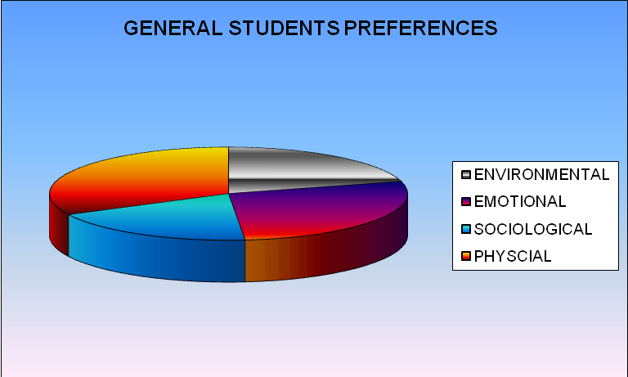

Figure 1. Pie diagram showing General student’s Learning Style Preferences.

TABLE 4.7.
In the case of general female and male students shows the Mean score and its corresponding SD. From this value, both Male and Female shows High Preference for Physical style (male: Mean 19.8590, SD 3.2237, Female: Mean 19.9624, SD 2.8564) and Low Preference for Sociological style (Male: Mean 11.2013, SD 2.0201, Female: Mean 11.9296, SD 1.9714)

TABLE 4.7
MEAN SCORE AND Std. DEVIATION OF GENERAL MALE AND FEMALE STUDENTS.
Category  Female | Gender | Style | Environmental | Emotional | Sociological | Physical
General students | Female | Mean  SD | 12.93  2.34 | 16.58  3.06 | 11.93  1.97 | 19.96  2.86
General students | Male | Mean  SD | 12.21  2.53 | 17.53  2.80 | 11.201  2.02 | 19.86  3.22

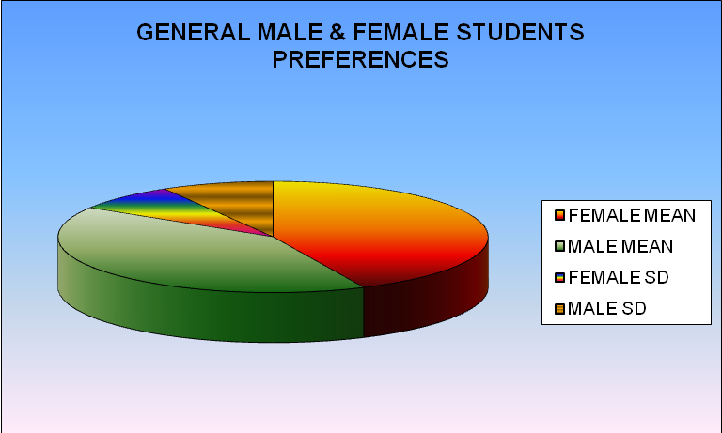

Figure 2. Pie diagram showing General Male and Female student’s Learning Style Preferences.

Table 4.8.
Shows the Mean score and corresponding SD of scheduled tribe students (N = 248). ST students are also show High Preference for Physical Style (Mean 18. 8340, SD 3.1534) and Low Preference for Sociological Style (Mean 11.5628, SD 1.9961).

TABLE 4.8
MEAN SCORE AND Std. DEVIATION OF ST STUDENTS.
Category | Style | Environmental | Emotional | Sociological | Physical
ST students | Mean  SD | 12. 4534  2.3263 | 16.3887  2.8404 | 11.5628  1.9961 | 18.8340  3.1534

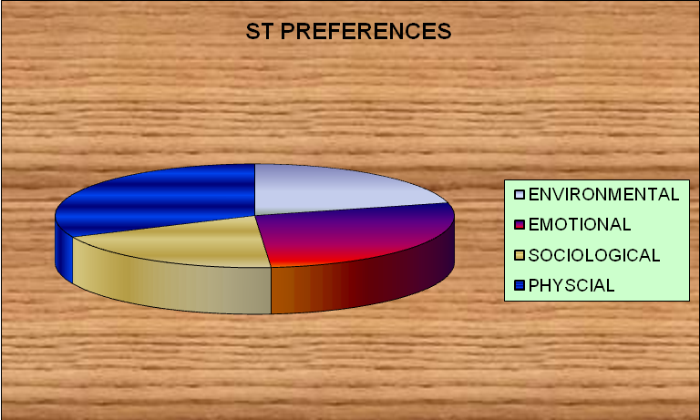
Figure 3. Pie diagram showing ST student’s Learning Style Preference.

TABLE 4.9
ST female and male students Mean and SD score are given in the table 4.9. from their values shows that they were High Preference in Physical Style (male: mean 18. 9451, SD 3. 1068, Female: mean 18. 5539, SD 3.535) and show Low Preference in Sociological Style (male: mean 11.3626, SD 2.1319, Female: mean 11.5450, SD 2.1115)

TABLE 4.9.
MEAN SCORE AND Std. DEVIATION OF ST MALE AND FEMALE STUDENTS.

Category  Female | Gender | Style | Environmental | Emotional | Sociological | Physical
ST students | Female | Mean  SD | 12.46  2.45 | 16.21  3.09 | 11.55  2.12 | 18.56  3.52
ST students | Male | Mean  SD | 12.30  2.53 | 16.37  2.92 | 11.37  2.14 | 18.95  3.11

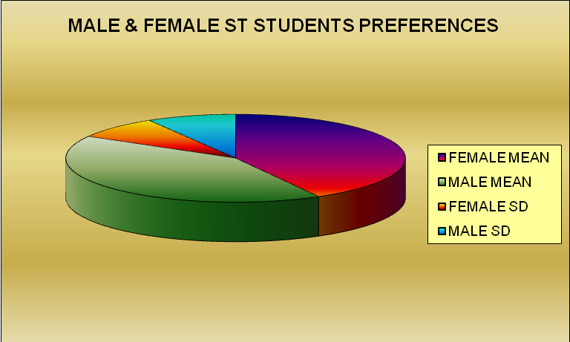

Figure 4. Pie diagram showing ST Male and Female student’s Learning Style Preferences.

TABLE 4.10.
Table 4.10 shows the mean score and corresponding SD of Scheduled Caste students (N = 212). The result is also same as that of general and ST students. SC students show high preference for physical style (Mean 19.1226, SD 2.8106) and low preference for sociological style (Mean 11.4764, SD 2.0010).

TABLE 4.10
MEAN SCORE AND Std. DEVIATION OF SC STUDENTS.
Category | Style | Environmental | Emotional | Sociological | Physical
SC students | Mean  SD | 12.07  2.23 | 16.81  2.77 | 11.48  2.02 | 19.13  2.82

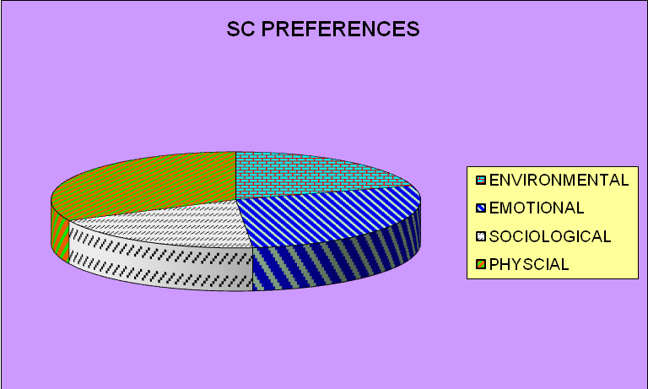

Figure 5. Pie diagram showing SC student’s Learning Style Preferences.

TABLE 4.11.
In the case SC female and male students table 4.11 shows the mean score and its corresponding SD. From this value obtained, both male and female shows high preference for physical style (Male: mean 18.7742, SD 3.1068, Female: mean 19.3917, SD 2.5873) and low preference for sociological style (male: mean 11.1398, SD 2.0504, Female: mean 11.6583, SD 1.9424)

TABLE 4. 11
MEAN SCORE AND Std. DEVIATION OF SC MALE AND FEMALE STUDENTS.

Category  Female | Gender | Style | Environmental | Emotional | Sociological | Physical
SC students | Female | Mean  SD | 12.39  2.1 | 16.83  2.66 | 11.65  1.94 | 19.39  2.59
SC students | Male | Mean  SD | 11.45  2.35 | 16.76  2.91 | 11.14  2.06 | 18.78  3.11

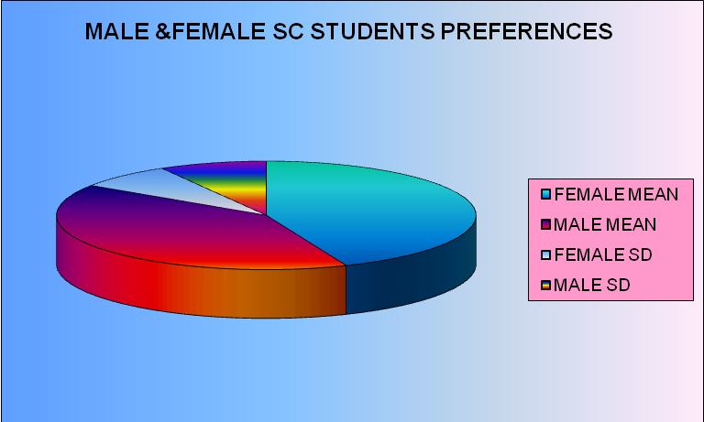
Figure 6. Pie diagram showing SC Male and Female student’s Learning Style Preferences.

The above analysis shows that all students such as General, scheduled tribes and scheduled castes mostly preferred the Physical style first; Emotional style second, Environmental style third and lastly had the low preferred style Sociological. Corresponding graphical representations such as Pie diagram were represented below the respective tables.

Chapter V

Summary, Findings and Suggestions

- Study in retrospect
- Variables
- Objectives
- Hypotheses
- Methodology
- Major findings of the study
- Educational implication
- Conclusion
- Suggestions for further resea

SUMMARY, FINDINGS AND SUGGESTIONS
This chapter provides a retrospective view of the study, major findings, educational implication and suggestion for further research in this area.

1.2 STATEMENT OF THE PROBLEM
The present study is entitled with ”learning style preferences among tribal and non-tribal students in Thrissur district of Kerala.”

1.3 VARIABLE
The investigator selected Learning Style Preferences as the variable.

1.4 OBJECTIVES
The objectives for the present study are as follows:
1.4.1. To find out whether there exists any significant difference in the Learning Style among SC, ST and General Students.
1.4.2. To find out the Learning Style Preferences among Male and Female SC, Male and Female ST and Male and Female General students.

1.5 HYPOTHESES
Following hypotheses set for the study.
1.5.1. There exists significant difference in the Learning Style among SC, ST and General Students.
1.5.2. There exists significant difference in the Learning Style Preferences among SC, ST and General students.
1.5.3. There exists significant difference in the Learning Style Preferences among SC, ST and General students based on the subsample Gender.

1.6 PROCEDURE
The procedures adopted for the present study are as follows:
1.6.1 Sample for the study
The study was conducted on a sample of 822 students of Thrissur District in Kerala. The sample was drawn by stratified random sampling technique giving due representation to General (N=362), SC (N=212) and ST (N=248) students.

1.6.2 Tool used for the study
For the present study “learning style inventory“ Kumar, et al (1996) was used by the investigator.

1.6.3 Statistical techniques used for analysis
The collected data were analyzed using the following statistical techniques
- t – test
- Mean difference analysis

1.6.3.1. t-test
The test of significance of difference between two Mean is known as ‘t’ test. The test is used to find out if there exists any significant difference is the Learning Style Preferences between the relevant samples.

t- value = X₁ – X₂

σ 1² σ 2²
+
N₁ N₂

X₁ - Mean of the Upper group

X₂ - Mean of the Lower group

σ ₁ - Standard deviation of the Upper group

σ ₂ - Standard deviation of the Lower group

N₁ - Sample size of the first group

N₂ - Sample size of the second group

(Garett,1981)
1.6.3.2. Mean Difference Analysis
Mean difference analysis was used to findout if there exists any significant difference in the Learning Style Preferences among the relevant subsamples.
1.7 MAJOR FINDINGS
The major findings of the study are the following:
LEARNING STYLES OF GENERAL, ST AND SC STUDENTS.
Forty five items were asked for every Learning Styles. Mean score of all elements of Learning Style was calculated to show the overall Learning Styles of student

Table 1. Learning style preferences based on MEAN SCORES OF GENERAL,SC,ST STUDENTS

Mean | General | ST | SC
Mean | 61.2790 | 59.2388 | 59.4717

FIGURE 1. SHOWS THE LEARNING STYLES OF GENERAL, ST AND SC STUDENTS BASED ON THE MEAN SCORES.

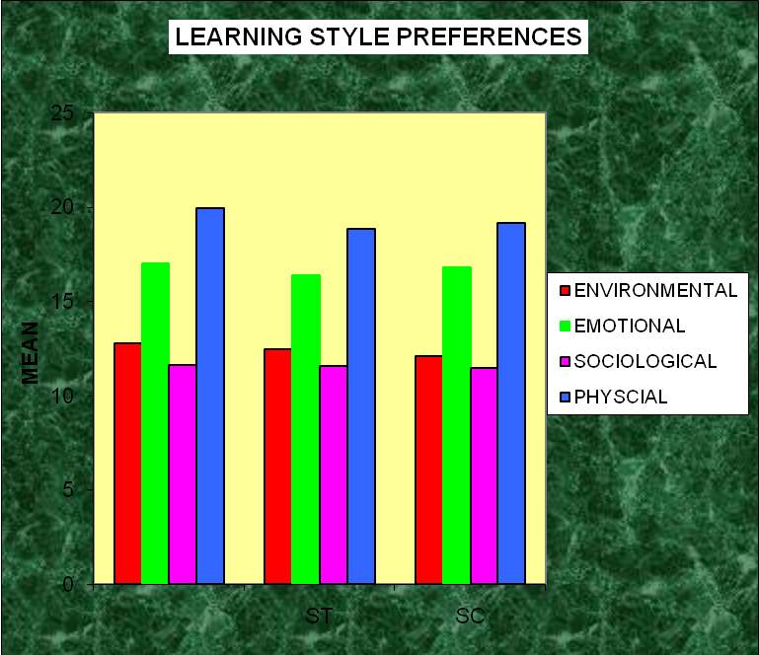

1.7.1. LEARNING STYLES OF GENERAL, ST, AND SC STUDENTS BASED ON MEAN SCORE.

The findings showed that all students such as General, ST, and SC seemed to exhibit all the four Learning Styles/ this supports Kolb and Fry (Tennant, 1988) an individual will go through the four elements while experiencing learning activities that are Environmental, Emotional, Sociological and Physical. The only difference is on the domination.
Physical Learning Style Preference was found the Highest and Sociological Preference was the least Mean value for every group. This result consistent with Hasan Koya (2002), Rasheeda Banu (2006) and Sathy (1996) findings where Physical element was the highest Mean value and Sociological the least. Using the norms, the General, Scheduled Tribe and Scheduled Caste students were found to have moderate Sociological, Environmental, Emotional and Physical.

1.7.2.. LEARNING STYLE PREFERENCES OF GENERAL, ST AND SC STUDENTS BASED ON GENDER

TABLE 2.
Learning style preferences based on Gender.
Category | Gender | Environmental | Emotional | Sociological | Physical
General | Female | 12.94 | 16.59 | 11.93 | 19.96
General | Male | 12.22 | 17.54 | 11.20 | 19.86
ST | Female | 12.46 | 16.22 | 11.55 | 18.56
ST | Male | 12.30 | 16.36 | 11.36 | 18.95
SC | Female | 12.39 | 16.83 | 11.66 | 19.39
SC | Male | 11.44 | 16.76 | 11.14 | 18.77

The results of General, ST and SC students concluding the following findings. General, Scheduled Tribe and Scheduled Caste female more preferred Environmental and Sociological than male students. General and ST males more preferred Emotional Elements than General and ST female. But SC females more preferred Emotional than SC males. General and SC females were more preferred Physical Element than males. But the ST males Physical Element than ST females.
FIGURE. 2. Learning Style Preference Based on Gender
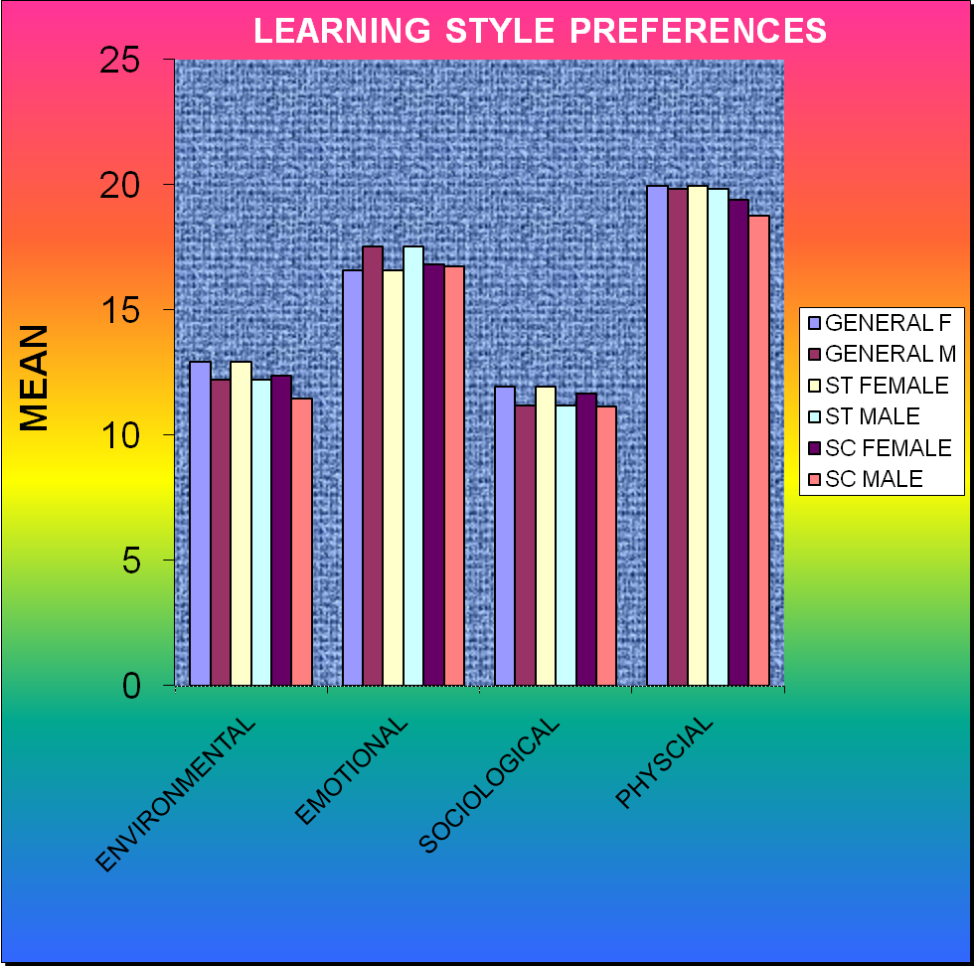

1.7.3. DIFFERENCES IN LEARNING STYLES BETWEEN CATEGORIES.

The result of independent samples t-test for every Learning Style showed significant differences in all the learning styles between the categories such as General, ST and SC students. The findings may be as follows.

- There are significant differences in all the Learning Style Preferences between Male and Female students. (t = -10.91, significant at 0.01 level)
- There is significant differences in learning styles between general and SC students (t=6.62, significant at 0.01 level)
- There is significant difference in learning style between General and ST students. (t = -7.16, significant at 0.01 level)
- There is significant differences in learning style between SC and ST students (t = -39.9, significant at 0.01 level)

1.8 TENABILITY OF HYPOTHESES
Based on the findings, the tenability of hypotheses of the study were examined.

1.8.1. The first hypothesis states that “there exists significant difference in the learning style among SC, ST and General Students. The findings of the study revealed that all the students in such category show significantly different. The first hypothesis is accepted.

1.8.2. The second hypothesis states that “there exists significant. difference in the Learning Style Preferences among SC, ST and General Students. The findings of the study revealed that there is no significant difference in the Learning Style Preferences among General, SC and ST students. The second hypothesis is rejected. All the students Highly Preferred the Physical style then Emotional, Environmental and had the Least Preference in Sociological style.

1.8.3. The third hypothesis states that “there exists significant difference in the Learning Style Preferences among SC, ST and General Students based on the subsample Gender. The findings of the study revealed that there exist significant differences in the Learning Style Preferences of Male and Female students. General, ST and SC females’ Preference Were Greater than Males. General and ST male’s Emotional component preference were greater than General and ST Female. But SC Males Preferred Emotional less than SC Females. General and SC Females were more Preferred Physical Elements than General and SC Males. But the ST Male’s Physical Preference is Greater than the Female ST students. Thus the hypothesis accepted.

1.9. SUGGESTIONS FOR IMPROVING EDUCATIONAL PRACTICE
Based on the findings, the investigator offers some suggestions which will be helpful to improve learning of students or their Achievements.
The best way for a person to learn depends on the person, of course. It is well know that people have different Learning Styles that work best for them. The best approach for an instructor to take is to address a variety of Learning Styles with their teaching place. It is also helpful to encourage students to understand their Preferred Learning Style. Teacher should make students aware of the various Learning Styles and encourage them to consider their preferred style as they complete their studies.
The study reveals that the Physical component of Learning Style is highly preferred than other components such as Emotional, Environmental, Sociological by all students. So it is suggested to consider the individual preference of the pupils in their Physical elements in the learning situations. The Preferences are auditory and visual elements can best be satisfied using certain audio – visual aids in the classroom. Richard Mayer (2009) who deserves Nobel Prize in educational research for his insightful research has recently done a brilliant job of teasing one apart. He and his colleagues’ reasoned that the notion of visual and verbal learners could be operationalized in at least different ways:
- The individual thinks of themselves as visual or verbal learners
- The individual thinks is given a choice between learning material that are visual or verbal, and prefers one or the other.
- The individual scores higher on a visual IQ [Mentarotaions] or verbal IQ (Vocabulary Test)
The students can be facilitated for learning considering their time preferences. While teaching, the teacher can make the learning more effective and interesting be ensuring the active participation of the pupils.
An environmental preference which is also preserves to be an influential factor as pupil’s learning. Instructions can be adjusted to the some discussions among the teachers and parents of the pupils. Certain arrangements can be made according to pupils style elements viz., Noise level, light, temperature and design both in the home as well as in the schools. The infrastructure of the classroom should be made quite comfortably for the students. The classroom environment can also have a big effect on the amount of learning that occurs. Here again, people are different and have different Environmental Preferences. Nevertheless, understand what effects the learning process is important to know. Some of the common Learning Styles and Environmental factors that should be considered when attempting to create the best learning conditions are listed below:-

Table – 3
This following information’s was adapted from: Moore, Carol (1992). Learning styles – class room adaptation <based primarily on Carbo learning style>.
LEARNING STYLES

ENVIRONMENTAL FACTORS | DESCRIPTION
Formal vs. Informal | A formal setting would be the traditional desk and chair or possibly a table. An informal setting would be the floor, a couch, a beanbag, etc. Every student’s brain will not function the same in the same postural positions. So when you see a students slouching in as traditional desk or chair, it may simply mean that they would learn better in more of an informal setting.
Noise vs. Quiet | Some students find sound distracting and some find it calming. It may be beneficial to have several study area as established. One where the noise level is kept to a minimum and one where background noise is present.
Temperature | Room temperature also plays a key role in learning. If a student is too cold or too hot, they will have more of a hard time concentrating on what their learning task is.It is recommended that the classroom temperature be cool if possible. This way those who do not like being cold can simply wear another layer of clothing and be comfortable.
Bright vs. Dim | Everybody’s eyes react differently to light. So me students may need to sit by a bright reading lamp while others may get a headache when too much light is present. A light level that all students find comfortable should be sought.
Kinesthetic | Some people need to have continuous movements as they are studying, such as tapping there fingers or foot on the floor, fooling with their hair, using a stress ball, or chewing gum. These are absolutely natural but if they are not alone studying, make sure they do not distract others.
Mobility | The human body is built to move and it does particularly like to sit still for long periods of time. Have students to stands stretch, and take short breaks as needed during studying. It is good to study in20 – 30 minute increments with a brief break between each block of time. Research has shown that it only takes 30 seconds to rest and recharge the brain

1.10. EDUCATIONAL IMPLICATION
The present study was to find out the learning style preferences among tribal and non-tribal students in Thrissur district of Kerala. Learning style is very recent in education. The study revealed that there is no significant difference among tribal and non-tribal students for learning style preferences. But genders differentiate it in various mean scores.

In National Committee of Inquiry in to Higher Educations (1997) the UK Governments report on the impact of technology on teaching and learning endorsed Learner – centered approaches to learning and said that each learner should know their learning style, they can begin to understand that they will have to vary their teaching style in order to help their students learn. We use the results to make which better fit the most recently preferred learning styles. We strive to enhance students learning by providing students the most appropriate opportunities for learning.

1.10.1. IMPLICATIONS FOR TEACHING AND LEARNING.
Several major implications are apparent from these data:
- To enhance learning, instructors and trainees must recognize that individuals learn and teach differently and that may be an learning or training method for one may discourage another. Indeed instructors and trainees should make sure that a variety of training or learning opportunities are presented to increase the likelihood of advancing learning.
- Most of our students learn differently than we do.
- Each of our students learns differently from our other students
- No one teaching method will effectively reach all of our students.
- We can not address all of our student’s learning styles all of the time.
To address these different learning styles, effective teachers use a variety of teaching style. Bernnett (1995) identifies some steps that teachers can take to make learning a success for all students regardless of their cultural backgrounds.

- Know our own teaching and learning styles.
- Determine how far we can stray from these strengths and preferences and still be comfortable.
- Begin with a few students, those who are having difficulty in our classes
- Know the learning style patterns that see to characteristic various ethnic groups.
- Building classroom flexibility slowly, adding one new strategy at a time.
- Use all modes (visual, auditory, tactile and kinesthetic) learning patterns.
- Create a supportive emotional climate
- Extend the learning environment beyond that in the learners’ immediate focus.
- Incorporate awareness and reflection as part of the learning process.
- Draw up on the personal world of the learner to expand memory functions
- Create in learners a state of relaxed alertness
- Use a multifaceted approach to teaching that allows for uniqueness.

1.11. FUTURE RESEARCH
As our world more globally and advanced technology is made available to all our students, knowing how the incoming-student processes and learners information will be vital to Public and Private educations. A variety of teaching and learning styles will have to be utilized by both teachers and students. On- going research in to learning styles will be needed to track and ascertain the needed changes in our educational systems. Learning style research needs to produce a common language of terms and seek to produce more uniform instruments. We will do this of ST and SC and also in General students and hope to expand it to include higher secondary students and graduate students.

Instructors should remember that:

- In general, each learning style is equal in terms of Achievement.
- Matching learning style with instructional design can lead to increased Achievement and better attitudes.
- No one single teaching method or medium is perfect for all.
- Learners promote learning environment that developed flexibility at the individual student level.
- However some questions require future research. For example, how, what extend and does the culture of learning affect all learners.
- How much the components if learning style are co-related and their percentages of each component.
- Should the teacher attempt to match instructional learning environments to each student, or teach students to adapt their learning styles to match different learning situations?

1.12. CONCLUSION
The findings help in getting a deeper understanding about different learning style preferences. Acknowledgement of students individual learning styles can play an important role in the learning process. The mean score of students with different categories such as general, ST, SC indicate that a strong preferences for Physical component. There were no significant differences among style preferences. But there is significant difference in the Mean scores of component exists among students based on Gender.

The findings of the study revealed that there exist significant differences in the Learning Style Preferences of Male and Female students. General, ST and SC females’ Preference Were Greater than Males. General and ST male’s Emotional component preference were greater than General and ST Female. But SC Males Preferred Emotional less than SC Females. General and SC Females were more Preferred Physical Elements than General and SC Males. But the ST Male’s Physical Preference is Greater than the Female ST students.

Many factors influence students Achievement at all level. The result of the research has shown the importance to determine Learning Styles and that difference exist in Learning Styles among the students of different Gender. The research suggests that students should be made aware of their Learning Style Preferences. Students may take for granted that their Learning Styles are habitual. They may not even be aware of their Learning Style Preferences. Students may take for granted that their learning styles other students. The awareness of their Learning Styles may encourage them to realize the Importance of Learning Styles and that it plays crucial role in their learning. According to Pask (1976),”Knowing ones Learning Styles is Important in Learning”.

Development Research suggests the following trends in terms of Learning Styles. [Dunn & Dunn: School Based Learning Styles, 1978, 1986, 1992]

- When children come to school they are basically parent/adult motivated.
- Thirty years ago students become more peer motivated by the seventh grade. Studies shows that students today move towards being motivated by third or fourth grade. By ninth or tenth grade students move towards being self-motivated.
- Underachievers tend to remain peer motivated even in to their late teen.
- Most young children are kinesthetic and become more tactual in or about the first grade.
- Auditory and visual skills develop during the early elementary years.
- Time of day preferences changes overtime. The time of day can have an impact. As stated by Dunn and Bruno (1985), “No matter when a teacher is teaching, it is the wrong time of day for at least one-third of that class”.

Research has not concluded that there is only one way to categorize students with respect to learning styles. In other words, research has supported many learning styles classification systems.

BIBLIOGRAPHY

Brown , B . L . (1998). Learning Style & Vocational Practice. ERIC Clearing House on Adult, Career & Vocational Education, Ohio State University.

Schaller , D . T & Brown , M . (2008) . One Size Does Not Fit All: Learning Style, Play and Online Interactive. Franklin Institute, 1-12.

Zakaria , Z . A . , & Nilai , B . B . (2006). Learning Styles Preferences of English Language Learners in a Secondary School. Faculty of Major Languages, Islamic University College of Malaysia.

Zimmerman , A . P . , Johnson , R . G . , Hoover , T . S . , Hilton , J . W . , Heiremann , P . H . , & Buckmaster , D . R . (2006). Comparison of Personality Types and Learning Styles of Engineering Students, Agricultural Systems Management Students, and Faculty in an Agricultural and Biological Engineering Department.

Wetzig , S . M . (2003). Learning Style Preferences & Learning Strategies in Intensive Care Nurse Educator. Princess Alexandra Hospital.

Henke , H . (1996). Learning Theory: Applying Kolb’s Learning Style Inventory with Computer Based Training.

Bastrom , R . P . , Olfman , L . , & Sein M . K . (1993 March). Learning Style & End-User Training: A First Step, MIS.

Manochehr , N . N . (2007). The Influences of Learning Styles on Learners in E-Learning Environments: An Empirical Study, Vol. 18, 10-14.

Langone, K . G . & Glickman R . M . (2003). Learning Styles & Environment: Finding the Right Match. Child Study Journal, Vol. 7.

Kamariah, N . & Wahab, N . A . (2003). Learning Style of Form Four Electrical Engineering Students in Three Technical Schools in Malaysia. Science Learning Centre Koly University Technology Tun Hussein Onn, 1-113.

Tripp, L . O . & More, S . D . (2007). Examination of Pre-Service Teacher’s Learning Styles and Temperament Styles With In an Elementary Science Methods Course. Auburn University, Institute for Learning Style Journal, Vol. -1, 23 – 33.

North, L . Y . (2009). Understanding Learning Styles: - Creating Learning Connections, The Outcomes Primer Learning Organization, 1-12.

Sasson, D . (2007). Multiple Learning Styles: How to Plan Lesson Plans and Learning Styles, http://www.facebook.com/share. php? u= http://newteachersupport.suit101.com/ Articles Cfm/ Student Learning Styles

Sidman, C . L . & Jomes D . (2007). Addressing Student’s Styles through Skeletal Power Point Slides: A Case Study, Vol.3, No.4, MERLOT Journal of Online Learning and Teaching, 448 – 459.

Tucker, R . (2008). Learning Style Drift: Correlation Between Built Environment Students Learning Styles And The Learning Styles Of Their Teacher. Journal for Education in the Built Environment, Vol. 3, Issue 1, 68- 79 (12, ISS N: 1747 – 4205 (Online).

Soleste, H . R . , & Roland, G . T . (2002). Theoretical Perspectives, Research Findings and Classroom Implications of the Learning Styles of American Indian and Alaska Native Students. ERIC Digest.

Gordon, D . , & Bull, D . (2004). A The Nexus Explored: Generalized Model of Learning Styles. Dublin Institute of Technology.

Neoman, G . (2009). When Will Learning Style Go Out Of Style? Mc Master University, 1-4.

Chang, C . K . (2004-2005). The Relationship Between Individual Learning Styles And Learning Strategies In Electronic Materials For Practicing EFL Listening. 364 – 396.

Hartman, V . F . (1995). Teaching and Learning Style Preferences: Transitions through Technology. VCCA Journal, Vol. 9, 1995. 18-20.

Gordon, D . & Bull, D . (2004). The Nexus Explored: A Generalized Model Of Learning Styles, Dublin Institute Of Technology.

Broxer, B . L . (1998). Learning Styles and Vocational Education Practice. Clearinghouse on Adult, Career and Vocational Education, Ohio State University.

Hein, T . L . (2000). Learning Styles in Introductory Physics: Enhancing Student Motivation, Interest and Learning. International Conference on Engineering and Computer Education, Sao Paulo, Brazil. 1-6.

Graf, S . , Viola, S . , R . & Kinshunk (2002). Automatic Student Modellng For Detecting Learning Style Preferences in Learning Management Systems. Austrian Federal Ministry for Education, Science and Cultural and the European Social Fund (ESF) Under Grant 31. 963/46-VII/9/2002.

MC Call, L . , Klein, B . , Piterman, L . & Lam, T . (2005). Learning Style Preferences For Hong Kong GPs Recruited In A Distance Learning Course. The Hong Kong Practitioner, Vol.27, Original Article, 261- 267.

Kumar, P . S . & Noushad, P . P . (2006). Social studies in the class room, trends and methods. Calicut University

Good, C . V . (Ed.) (1973) Dictionary of education. New York: Mc Graw Hill Book Company.

Sleter, J . A . , Lujan, H . L . & Dicarlo, S.E. (2007) Does gender influence learning style preferences of first year medical students. Department of Physiology, Wayre State University School of Medicine, Detroit, Michigan.

Haynes, J . (2008). Teach to student’s learning styles: www.everythingESL.net.

Peker M . & Mirasyedioglu, S . (2008). Pre-service Elementry School Teacher’s Learning Styles and attitudes towards Mathematics. Eurasia’s journal of mathematics, science and technology education, 4(1), E-ISSN : 1305-8223, www.ejnste.com, 21-26.

Carney, S. (2009) Identifying student’s learning styles. http://youth deve-lopment.suit101.com/article. Cfm/identifying students learning styles #ixzzos18RWTTO.

Sidek, H . J , Noor, S . M . & Jusoff, K . (2009). The social Interaction LearningSstyles of Science and Social Science Studies. Asian social science, Vol.5, No. 7, www.ccsenet.org/journal.html 58 - 64.

Fenrich , P. , (2006) Getting practical with learning styles in “live” and computer based traning settings. British Columbia institute of technology, Burnaby, Canada, Vol.3, 233 – 242.

Kumar, A . (2006) Strategies to enhance student learning in a capstone MIS course. Central Michigan University, Mt. Pleasant. MI, USA, Vol.-3, 327 – 332.

Brown, T. , Cosgniff, T . , & French, G . (2008). Learning Style Preferences of Occupational Therapy, Physiotherapy and Speech Pathology students: a comparative study. The internal journal of allied Health Science and Practice. July 2008, vol. 6, No.3.

Xiao, L . (2006).Bridging the gap between teaching styles and learning styles: A cross-cultured perspective. The internet TESL journal. Vol 10, No. 3, December 2006. 1-15.

Dunn, R . , & Griggs, S . A . (2003). Synthesis of the Dunn and Dunn learning style model research; who, what, when, where and so what? ISB St. John’s University Centre For the Study of Learning Teaching Styles. 239 - 246.

Mulalic, A . , Shah, P . M . , & Ahmad F. (2009). Perceptual learning styles of ESL students. European Journal of Social Science, Vol. 7, No.3, 101-113

Pursell, D . P. (2009). Adapting to student learning styles: engaging students with cell phone technology in organic chemistry instruction. School of Science and Technology, Georgia Gwinnet College, Lawrenceville, GA 30043; dpursell@ggc.usg.edu. Vol. 86, No. 10, 1219-1222.

Rayneri, L . J . , Gerber, B . L . , & Wigley, L . P. (2009). Gifted Achievers and gifted underachievers; the impact of learning style preferences in the classroom.

Melis, E . , & Monthienvichienchai, R . (2005) They Call it Learning Style But It’s So Much More. Institute of Education, University of London.

Aragon, S . R . , Johnson, S . D . , & Shaik, N . (2001). A preliminary analysis of the influence of learning style preferences on student success in online vs face to face environmental. Learning for the future, proceedings of the learning conferences 2001, University of Ilinois at Urbana – Champaign, 1-18.

Joost, R . & Young, M . (2008). Modification of Classroom Techniques To Fit Student Learning Styles. University of Tennessee. Martin.

Njoroge, J . , Senteza, J . , & Suh, I . (2006). learning styles, performance, and attitudes towards technology: Focus on business students. Drake University, Vol – 5, 47-60.

Graf, S . , & Kinshuk . (2008). Interactions between student’s learning styles, Achievement and Behavior in mismatched courses. LADIS international conference on cognition and exploratory learning in digital age, ISBN: 978-972-8924-69-0, 223-230.

Montgomery, S . M . , & Groat, L . N . (1998). Student learning styles and their implications for teaching. The centre for research on learning& teaching. University of Michigan, No. 10.

Bernstein, B. (1960). Languages and Social class. British journal of Sociology, 11, 217-276.

Sinha (2008). Cultural conflicts in non-tribal culture based Tribal education. Berhampur University, Vol.8, 25, EDUTRACKS.

Bhattacharya, D. (2005). Unearthing origin of the vanishing tribes. Current Science, Vol.89, No.3, 437-438.

Manithottam, J. & Francis, M . S . (2007). Ethno-botany of finger millet among Muthuvan tribes of Idukki district Kerala. Indian Journal of Traditional Knowledge, Vol. 6 (1), 160-162.

Elanchezhian, R . , Kumar, R . S . , Beena, S . J . , & Surynarayanan, M . A. (2007). Ethno-botany of Shompens- a primitive tribe of Great Nicobar Island. Indian Journal of traditional knowledge. Vol. 6(2), 342-345.

Murugan, K . , Ramachandran, V . S , Swarupanandan, K . , & Ramesh, M . (2008). Socio-cultural perspectives to the Sacred Groves and Serpentine Worship in Palakkad District, Kerala. Indian journal of traditional knowledge Vol. 7(3), 455-462.

Nolan, M . (2005). The Dunn and Dunn learning style model. Australia.

Hinson, M . B . (1999). Dunn and Dunn learning style synopsis. London: David Fulton Publishers.

Rudolph, S . D . (2008). Leraning Style preferences, Sense of classroom Community, Gender, Age, and Previous Experience within computer-Mediated instruction. 167

Sreelakshmi, K . , & Muraleedharan, P . K . (2005). Implications of Resources use paradigm in sustainable Natural Resource Management. An assessment of the Ecologic, Economic linkage of the natural resources use by tribal communities in Kerala. JEL Classifications: Q1, Q2, Q23.

Lowery, C . A . (2009). Adapting to student learning styles in a first year electrical/electronic engineering degree module. Vol. 4 Issue 1 2009 Engineering Education.

Navarro, S . (2009). Colloquium: learning style preferences in Romance Languages. UBC French, His panic and Italian studies.

Marriott, N . & Marriott, P . (2007). Student learning style preferences and undergraduate Academic performance at two UK Universities, Glamorgan University Business school.

Wakefield, A . P . (1993). Learning styles and learning dispositions in public schools: Some Implications of performance journal article, Education, Vol.113.

Cambiano, R . L , Vore, J . B . , & Harvey, R . L . , (2009). Learning style preferences of the Cohorts: Generation X, Baby Boomers, and the silent Generation. Cambiano.

Liu, Y . & Ginther, D . (1998). Congnitive styles and Distance education. Department of Psychology and Sepecjal education,Texas A & M University-Commerce.

Davis, G . A . (2006).Learning Style and Personality Type Preferences of Community Development Extension Educators.Ohio State University. Journal of Agricultural Education 90 Vol.47,No.1.
Hong , L . (2007). Examples of mismatches between Teaching and Learning Styles. The internet TESL Journal, Vol.7, No.7.

Mitsiss , A . , & Foleys , P . (2005). Cultural values and student learning style preference : Implications for course satisfaction. Victoria University.
Abu , A . G . (2006). Learning style preference in the comprehension of Litteracy text. Senate University of Putra , Malaysia, 1- 355.

Silva , R . , & Andeade , A. (2009). Development of a Web Application for management of Learning styles. Journal of Universal Computer Science, Vol. 15 , No.7.
Prascod , F . , & Dong , L . (2006). Learning style Trends and Laptop Use Patterns : Implications for student in an IT Business school. Ryerson University, Toronto, Vol.23, 1-10.
Litzinger, T . , A . , Lee, S . H . , Wise, J . C. , Felder, R. M. (2007).A Psychometric of the Index of learning styles. Journal of Engineering education. 96(4), 309-319.
Kim, S . L . , & Sonrewald, D . H .(2002). Investigating the relationship between learning style Preferences & Teaching study.University of North Carolina at Chapel Hill, 1-11.
Hood, K.(1993). Exploring learning style s and instructions EMT 705.
Putintseba, T. (2005). The Importance of learning styles in ESL. Koryo International college, Nishin, Japan.
Lin, K. T. (2004). Applications of Learning styles Adapting in Mobile Learning environments. Massey University, Palmston North, New ZeaLand.
Diaz, D . P . Cortnal, R . B . ,(2009). Comparing students learning styles in an online distance Learning class. Cuesta University college.. College teaching 47(4), 130-135.
Ballone, L . M . , Czerniak, C . M . (2001). Teachers beliefs about According student’s Learning styles in Science classes. Electronic Journal of Science education, vol.6, No.2, 1-41
Mohamad, S . T . (2009). The learning styles of early adult students from different cultural Background in Malaysia. Distance education Centre UITM, Malaysia.
Power, T . (2004). A review of learning styles research. Memorial University of Newfoundland, 1-33.
Nidheesh, K . B . (2009). Strengthening tribal communities through tribal women’s self help groups in Kerala. International journal of sociology and anthropology. Vol. 1 (3) 77-081.

George, P . R . , Radhika, C . , Simon, S . & Kesavan, R . (2008). Animal husbandry information sources and vocational preferences of a re-settled Tribal community. Stud Tribes Tribals, 6(2), 99-81.

APPENDIX

APPENDIX I
District-wise population of Scheduled Castes and Scheduled Tribes – Kerala
District | Scheduled Castes |  |  |  | Scheduled Tribes
District | Male | Female | Total | %to total SC population | Male | Female | Total | % up to total ST population
Trivandrum | 167251 | 176188 | 343439 | 11.90 | 7860 | 8321 | 16181 | 5.04
Kollam | 150894 | 154833 | 305727 | 10.59 | 1943 | 1941 | 3884 | 1.21
Pathanamthitta | 77821 | 80212 | 158033 | 5.48 | 3459 | 3463 | 6922 | 2.16
Alappuzha | 93926 | 96429 | 190355 | 6.59 | 1407 | 1394 | 2801 | 0.87
Kottayam | 67675 | 68201 | 135876 | 4.71 | 8902 | 9094 | 17996 | 5.61
Idukki | 78607 | 78315 | 156922 | 5.44 | 25512 | 24757 | 50269 | 15.66
Eranakulam | 120194 | 121525 | 241719 | 8.37 | 2551 | 2390 | 4941 | 1.54
Thrissur | 162962 | 171562 | 334524 | 11.59 | 1990 | 2061 | 4051 | 1.26
Palakkad | 184850 | 193698 | 378548 | 13.11 | 17927 | 17538 | 35465 | 11.05
Malappuram | 126097 | 129634 | 255731 | 8.86 | 5213 | 5342 | 10555 | 3.29
Kozhikode | 91547 | 93073 | 184620 | 6.40 | 2654 | 2753 | 5407 | 1.69
Wayanad | 14192 | 13643 | 27835 | 0.96 | 57386 | 57583 | 114969 | 35.82
Kannur | 45418 | 45805 | 91223 | 3.16 | 9167 | 9076 | 18243 | 5.68
Kasargod | 41180 | 40790 | 81970 | 2.84 | 14841 | 14442 | 29283 | 9.12
Total | 1422614 | 1463908 | 2886522 | 100 | 160812 | 160155 | 320967 | 100

APPENDIX II

LEARNING STYLES MODEL
Designed by Dr. Rita Dunn and Dr. Kenneth Dunn

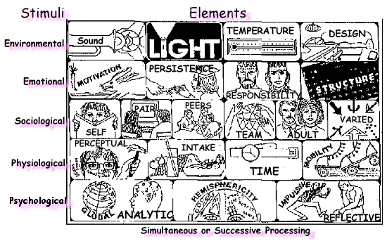

APPENDIX III
INTRODUCING LEARNING STYLES IN TO YOUR CLASSROOM 1. Introduce students to learning styles:
- The Dunn & Dunn model
- Their individual learning style profile, and what elements are significant for them
- How learning through their learning style can help them
- Introduce one strategy at a time
Best strategies to begin with are those that respond to individuals’
- Environmental, mobility and tactile or kinesthetic needs
- Global thought processing patterns
- Time of day energy level
- Establish classroom rules for using learning styles on a chart (both graphic and written)
- Discuss these so that each student understands
- Apply firmly but reason
- Experiment with a range of resources and learning activities and teach students to make their own resources to help them learn and review

- Evaluate regularly with the students and keep notes on the effectiveness and impact on learning, achievement, attendance and motivation for individual students

